
I-stem?

M+F

-looks the same in Nom sg and Gen sg OR

-stem ends on 2 consonants

N
Rete, calcar, cochlear, animal

Consonant stem?


-the rest

DOSIS?

-sis/-xis/-osis (only feminines)
+ febris, tussis, pertusis, sitis

3rd declension example word?
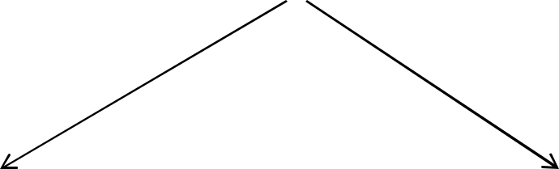

I-STEMS CONSONANT STEMS
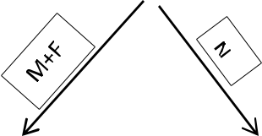
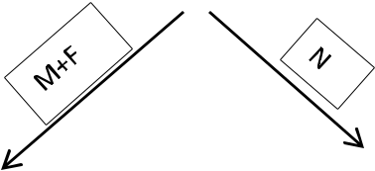

PELVIS, IS, F.

RETE, IS, N.


DOLOR, ORIS, M. CORPUS, ORIS, N.



Sg

- pelv-is G pelv-is
Ak pelv-em Abl pelv-e

Pl

- pelv-es

G pelv-ium Ak pelv-es Abl pelvibus

Sg

- rete

G ret-is Ak rete Abl ret-i

Pl

- ret-ia

G ret-ium Ak ret-ia Abl ret-ibus

Sg

N dolor

- dolor-is Ak dolor-em Abl dolor-e

Pl

- dolor-es
G dolor-um
Ak dolor-es
Abl dolor-ibus

Sg

- corpus

G corpor-is Ak corpus Abl corpor-e

Pl

- corpor-a
G corpor-um Ak corpor-a
Abl corpor-ibus

Exceptions:

- os, ossis, n. (bone) – G pl. ossium
- vas, vasis, n. (vessel) – pl. like septum (2.decl – vasa, vasorum, vasa, vasis)

