# Evaluation of nutritional state

## Key words:

Structural and storage fat, lipolytic hormones, active body mass, bioimpedance, metabolic syndrome, relation of

overweight with diabetes and overweight with hypertension; define “healthy lifestyle”

## aim:

To learn how to evaluate the nutritional state with methods used in clinical practice.

## Equipment:

Personal weight, height meter, measuring tape, calliper, calculator, Body Fat Monitors

## Procedure:

### Indexes calculated from anthropometric parameters

The simplest way how to determine the recommended (also ideal) body mass is the use of **Broca´s index.** Ideal body mass is calculated:

|  |  |  |  |
| --- | --- | --- | --- |
| For men: | [height (cm) – 100] | or | [height (m)] 2  23 |
| For women: | height (cm) – 100 – 10 % | or | [height (m)] 2  21.5 |

other calculations:

* % of ideal body mass is given by ratio: actual body mass/ideal body mass  100
* body surface (m2): [body mass (kg) ]0,425  [height (cm) ]0,725 / 139,32

Four degrees of obesity can be classified according to % of ideal body mass (Table 18):

|  |  |
| --- | --- |
| **Obesity degree** | **% of ideal body mass** |
| Mild | 115 –129 |
| Middle | 130 –149 |
| Heavy | 150 –199 |
| Morbid |  200 |

*Table : Obesity classification according to Broca’s index*

nowadays, it is much more common to use ***Quetelet’s index which is better known as body mass index (BMI)*.**

*weight (kg) BMI = ———————*

*[height (m)]2*

Based on BMI, we can determine following categories :

|  |  |  |
| --- | --- | --- |
| **BMI (kg.m-2)** | | |
| **Category** | **men** | **Women** |
| Underweight | < 20 | < 19 |
| normal weight | 20 – 24.9 | 19 – 23.9 |
| overweight | 25 – 29.9 | 24 – 28.9 |
| obesity | 30 – 39.9 | 29 – 38.9 |
| Pathological obesity | > 40 | > 39 |

*Table : Obesity classification according to BMI*

However, BMI does not comprehend physiological differences in body fat distribution between men and women.

Following measurements were introduced in order to solve this problem:

Measurement of ***Waist circumference:*** Simple and very easily accessible value.

|  |  |  |
| --- | --- | --- |
| **Waist circumference (cm)** | | |
| **Category** | **men** | **Women** |
| normal value | ≤ 94 | ≤ 80 |
| necessity to decrease body mass | 95 – 102 | 81 – 90 |
| Medical assistance during decreasing of body mass is necessary | > 102 | > 90 |

*Table: Body mass categories according to waist circumference*

Determination of ***Waist to hip ratio (WHR)****:*  recommended value for women: WHR < 0.80 recommended value for men: WHR < 1.00

Clinical note: In case you will need to calculate energetic expenditure to set up proper nutrition for obese patients, use the value of Broca´s index and not the actual weight!

### Body fat measurement by calliper

Thickness of subcutaneous fat layer informs us about the energy balance of the organism; however, it is does not reflect possible differences in distribution of subcutaneous and visceral fat. The simplest method widely used in the clinical practice to determine the skinfold thickness is the measurement with callipers over the triceps brachii muscle (Fig. 35B). The measurement is conducted in sitting position on hanging non-dominant upper limb. Skin- fold thickness is measured in the middle of the back of the arm. Physiological values are showed in Table.

|  |  |  |  |
| --- | --- | --- | --- |
| **skinfolds in the population** | **Physiological range (mm)** | **Light to middle loss of body fat (mm)** | **Marked deficiency**  **(mm)** |
| Women | > 16.5 | 10 – 15 | < 10 |
| Men | > 12.5 | 7.5 – 11 | < 7.5 |

*Table : Skinfold thickness values over the triceps muscle*

**note:** When evaluating skinfold thickness it is much better to perform at least 3 measurements and calculate

the arithmetic mean.

Figure 1A represents the most often used places that are used to measure skinfold. For the purposes of our prati- cal we will determine the skinfold thickness over the triceps brachii muscle (Fig. 1B) and also under the scapula (Fig. 1C) 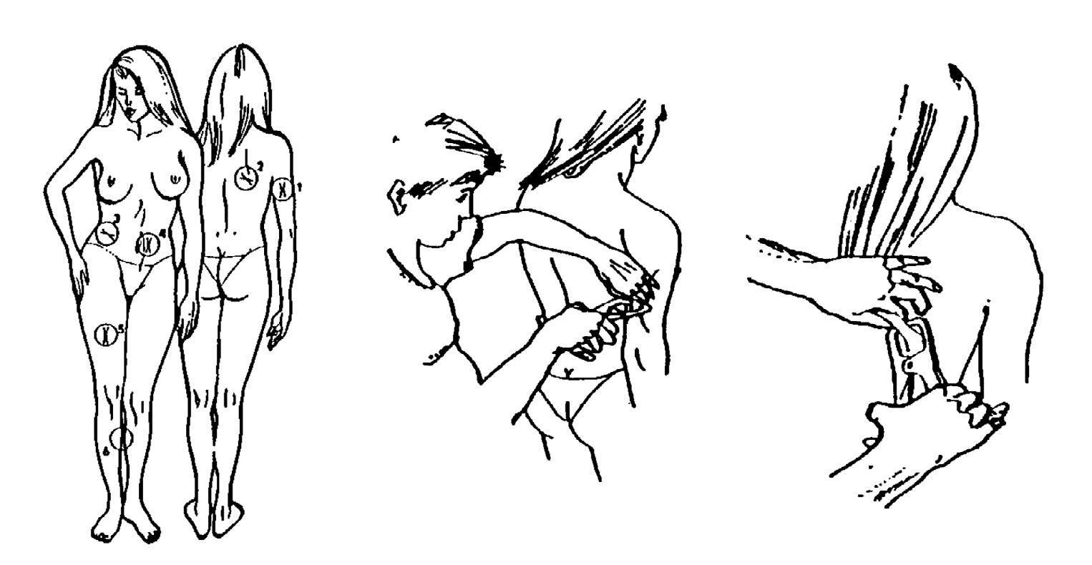

*Figure 1A Figure 1B Figure 1C*

*Legend: A: Scheme of six standard regions where skinfold thickness is measured (1 – over the triceps muscle, 2 – under the scapula, 3 – over the iliac spina, 4 – on the abdomen, 5 – on the thigh, 6 – on the calf).*

*B: Measurement over the triceps brachii muscle C: Measurement under the scapula*

*How to measure with calliper:*

When measuring with the calliper, the skinfold is grasped with the thumb and index finger and pulled up from the underlying muscle. Using the other hand put the measuring facets of the calliper to the skin behind the top of the folding (about 1 cm from the fingers), and then release the calliper arms in order to apply a constant force to the skin. The skinfold thickness should be read within 2 seconds and the measurement should be repeated to increase the exactness of your measurement.

From the skinfold thickness values, you are then able to determine the portion of the fat mass in the organism (just approximately). Use following **nomogram** (input values for skinfold thickness over the triceps (ArM) and under the scapula (BACK)).

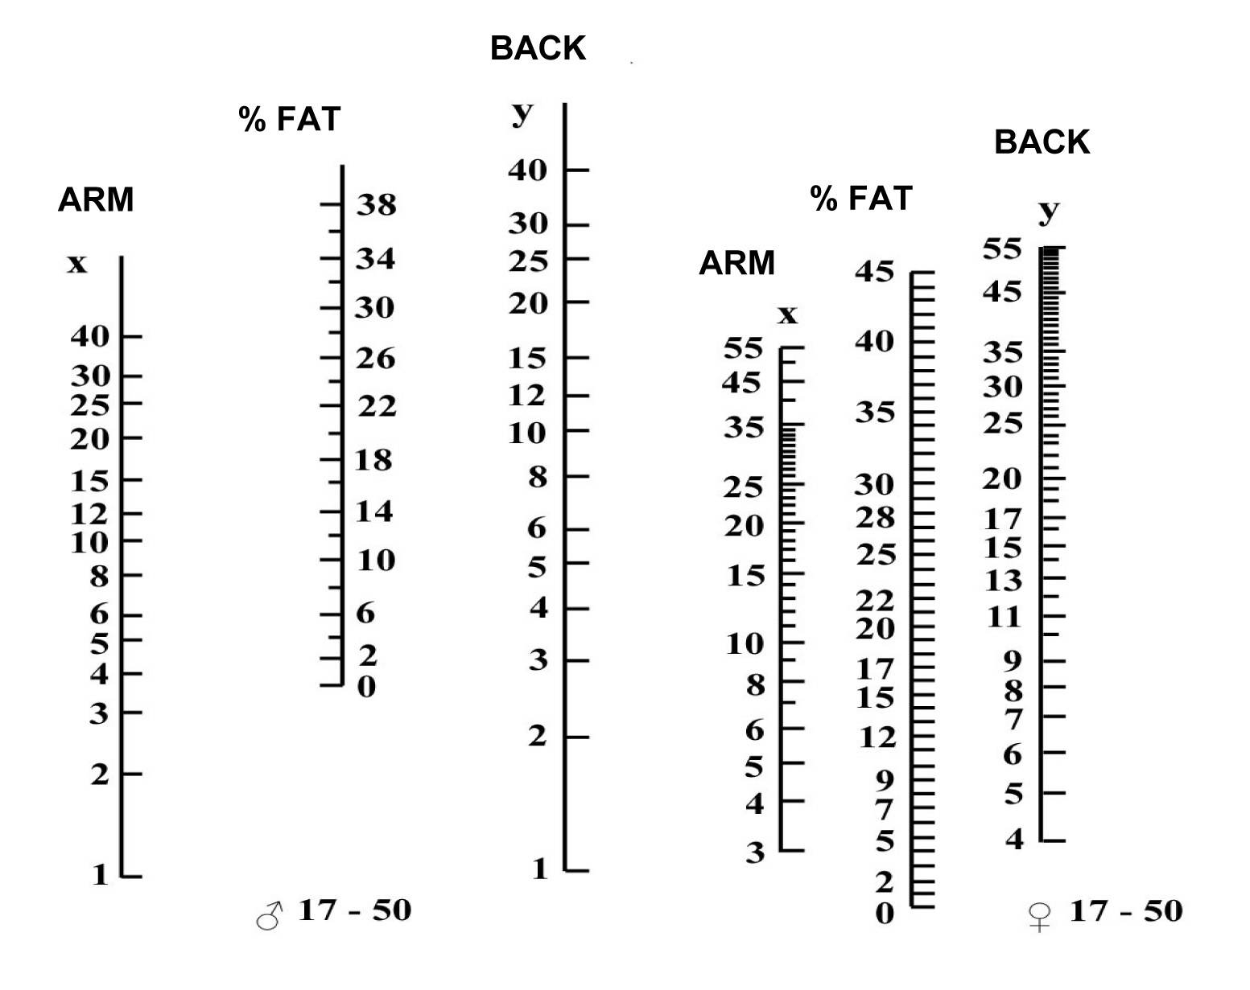

*Nomogram for fat percentage estimation (males and females, 17–50 years): connect the values (in mm) of skinfold thickness on arm and back (axis x and y, respectively)*

### Body fat measurement by bio-impedance method

*Principle:*

All devices used in practical used the method called BIA, i.e. bioelectrical analysis if the impedance. During the measurement, devices use extremely low alternating electrical current (5V, 25 kHz) passing through our body. Tis- sues rich in water (e.g. skeletal muscles) are easy to pass, however, when the fat tissue is being passed, electrical current had to overcome its resistance (bioelectric impedance) since the fat has almost no electric conductivity. This enables us then to determine the ratio between the fat and other tissues.

However, it is important to realize, that the results of this measurement are affected by the amount of water in non-fatty tissues, i.e. they are affected by hydration status. That is the reason why measured values may fluctuate over the time and when non-standard conditions are used (e.g. immediately after meal, after bath, after increased consumption of alcoholic beverages). Values are different also in patients suffering from the diseases accompanied by water loss and also in women during menses.

*Procedure (device OMRON TBF-551):*

* 1. Set the personal data of your experimental subject into the memory of the device: press the button SET and choose always one from the offered parameters that are being displayed in the bottom part of the screen as dif- ferent figures: adult (child, sportsman), man (woman), height of the experimental subject.
  2. After setting zero on the display, the experimental subject stands (without shoes and socks) on the Body Fat Monitor. After a while the values of weight in kg and body fat in % appear. Write down the values and use the cloth with disinfection to disinfect the device.

#### Warning! step very carefully on the Body Fat monitor, always with bare foot. Be careful on the cover of the display (do not destroy it!).

*Procedure (device OMRON BF300):*

1. Turn the device on using button ON/OFF. For the first few seconds, display test is running and then zero values

are shown. Proceed by pressing following buttons:

* + HGT: input the height of the examined person in centimetres using numerical buttons (in case you make a mistake when inputting the data, just press the HGT button and repeat)
  + WT: enter the body weight in kg
  + AGE: enter the age in years (interval is 10-80 years)
  + M/F: pressing this button changes gender; press it as many times you need to set up proper gender of exam- ined person

After all values are entered, press SET. After a short while, the device will beep a display rEADY on the screen.

1. For proper measurement, it is important to grab the device properly: wrap the middle finger around the groove on the handle, securely grasp the upper part of the electrode with the thumb and index finger, wrap the ring finger and little finger around the lower part of the electrode and press the palm firmly against the electrode. Stand with both feet slightly apart and hold the arms out straight at 90 ° to the body without bending the elbows. Don´t move during the measurement!
2. Use the right thumb to press the START button. After pressing the button, return the thumb where it belongs. When the measurement is completed the device emits a single beep and the result is shown on the display: percentage and the amount of body fat in % and kg respectively.
3. Turn off the device.

|  |  |  |
| --- | --- | --- |
| **age** | **< 30 years** | **> 30 years** |
| Women | 17 – 24% | 20 – 27% |
| Men | 14 – 20% | 17 – 23% |

*Body fat in the population – average normal values*

### Measurement of amount of muscle tissue

More complex view of nutrition can be obtained when together skin-folds, amount of body fat and amount of mus- cle tissue are measured. In the clinical practice, circumference of arm muscles (CAM, cm) and corrected surface of arm muscles (c-SAM, cm2) are used most often.

*Circumference of arm muscles (CAM):*

#### Procedure:

Measure the circumference in the middle of non-dominant hanging arm using measuring tape. Be careful not to press the arm! obtained value has to be corrected:

CAM = CA – 3.14 × skinfold on the arm

CA and skinfold thickness of the arm need to be entered in cm. Compare the corrected values with the physiologi- cal values from the following table.

|  |  |  |  |
| --- | --- | --- | --- |
| **muscle tissue loss** | **not present** | **middle** | **Heavy** |
| Women | > 23.2 cm | 14 – 23.2 cm | < 14 cm |
| Men | > 25.3 cm | 15 – 25.3 cm | < 15 cm |

*Muscle tissue estimation*

*Corrected surface of arm muscles (c-SAM)*

The value of the circumference of the arm (CAM) is corrected to under-skin tissue; however, it is not corrected to

the bone. From this reason, c-SAM value is used.

#### Procedure:

Using following formulas, calculate corrected surface of arm muscles:

For women:

For men:

### (CAM − 𝜋 ∙ skinfold of the arm)2

*c-SAM* = ––––––––––––––––––––––––––––––––––––––––––––––––– − 6,5

### 4 . 𝜋

(CAM − 𝜋 ∙ skinfold of the arm)2

*c-SAM* = ––––––––––––––––––––––––––––––––––––––––––––––––– − 10

### 4 . 𝜋

Calculated values (in cm2) can be compared to the values in the following table:

|  |  |  |  |  |
| --- | --- | --- | --- | --- |
| **Deficiency** | **not present** | **Light** | **middle** | **Heavy** |
| Women | > 36,3 | 29.1 – 36.3 | 25.5 – 29 | < 25.4 |
| Men | > 40,9 | 32.8 – 40.8 | 28.7 –32.7 | < 28.6 |

*Estimation of corrected surface of arm muscle*

## Protocol:

Define the keywords and the aim of the exercise. Briefly describe the principle of bioimpedance method. Arrange

all the values obtained from all experimental subjects **into a table.**

## Interpretation and conclusions:

Evaluate the nutritional status in all members of your study group individually and even of the whole group as a one subject.