I. Complete the correct name of the organ:
pancreas rectum duodenum sigmoid colon mouth appendix
liver ileum descending colon cecum gall bladder anus
stomach transverse colon jejunum ascending colon esophagus

1. _______________ - a large organ located above and in front of the stomach. It filters toxins from the blood, and makes bile (which breaks down fats) and some blood proteins.
2. _______________ - a small, sac-like organ located by the duodenum. It stores and releases bile (a digestive chemical which is produced in the liver) into the small intestine.
3. _______________ - a sack-like, muscular organ that is attached to the esophagus. When food enters this organ, it is churned in an acid bath.
4. _______________ - an enzyme-producing gland located below the stomach and above the intestines. Enzymes from this organ help in the digestion of carbohydrates, fats and proteins in the small intestine.
5. _______________ - the opening at the end of the digestive system from which feces (waste) exits the body.
6. _______________ - the first part of the digestive system, where food enters the body. Chewing and salivary enzymes in the mouth are the beginning of the digestive process (breaking down the food).
7. _______________ - the lower part of the large intestine, where feces are stored before they are excreted from the body.
8. _______________ - a small sac located on the cecum.
9. _______________ - the long tube between the mouth and the stomach. It uses rhythmic muscle movements (called peristalsis) to force food from the throat into the stomach.
10. _______________ - the part of the large intestine that runs upwards; it is located after the cecum.
11. _______________ - the part of the large intestine that runs downwards after the transverse colon and before the sigmoid colon.
12. _______________ - the part of the large intestine that runs horizontally across the abdomen.
13. _______________ - the first part of the large intestine; the appendix is connected to this organ.
14. _______________ - the last part of the small intestine before the large intestine begins.
15. _______________ - the long, coiled mid-section of the small intestine; it is between the duodenum and the ileum.
16. _______________ - the first part of the small intestine; it is C-shaped and runs from the stomach to the jejunum.
17. _______________ - the part of the large intestine between the descending colon and the rectum.

II. Label the picture:

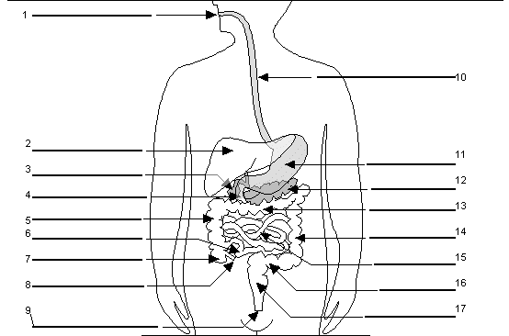

III. Translate into English:
střevo –
slepé střevo –
tenké střevo –
tlusté střevo –
krvácení do střev –
výplach střev –
vyprazdňování střev –
operace slepého střeva –
zánět slepého střeva –
dát si operovat slepé střevo –
střevní chřipka –
střevní nemoci –
střevní potíže –
průjem –
zácpa –
bolesti břicha -
způsobit komu žaludeční nevolnost –
je mi špatně od žaludku –

