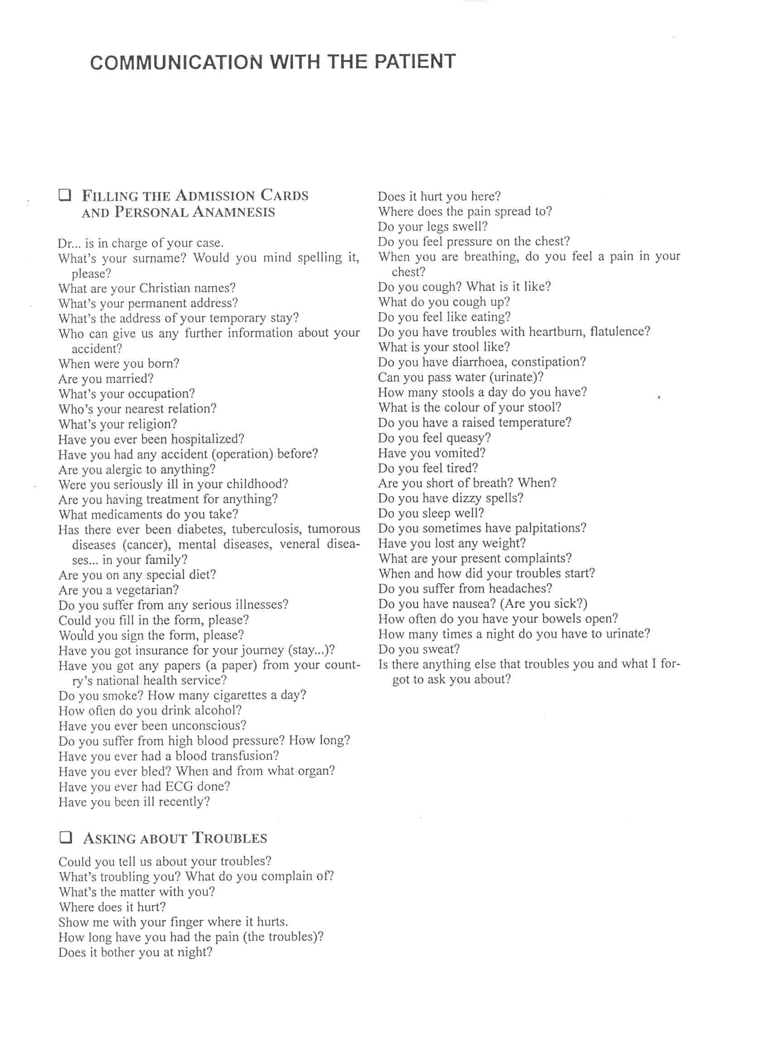

Source: Buldov, S.V., Maxerová M. English for Nurses. Praha: Informatorium, 2003.

