PATHOLOGICAL CONDITIONS OF THE SKELETAL SYSTEM

Arthritis
Arthritis is a general term meaning an inflammation of a bone joint. More than 100 diseases have symptoms of joint inflammation or injury. This condition—the body's response to tissue damage—can cause pain, swelling, stiffness, and fatigue. Since the areas most commonly involved are the hands, arms, shoulders, hips, and legs, any action requiring movement of these parts becomes difficult. Arthritis is usually a chronic condition, meaning it persists throughout a person's life. In all its forms, arthritis is the most widespread, crippling disease in the United States.
Osteoarthritis and rheumatoid arthritis are the two most common forms of the disease. Osteoarthritis occurs as a result of aging or injury. Rheumatoid arthritis is an autoimmune disease, meaning that the body produces antibodies (proteins normally produced by the body to fight against foreign substances in the body) that act against its own tissues.

Osteoarthritis is the deterioration of the cartilage covering the bones in the joints of the body. It is most often seen in people who are forty years of age or older. Causes of osteoarthritis include wear and tear due to aging or overuse, injury, hereditary factors, and obesity. The wearing away of the cartilage results in the bones scraping against each other, causing the development of bony spurs and the deep joint pain characteristic of this disease.
The joints most commonly affected by osteoarthritis are those of the knees, hips, and fingers. Other areas can be affected by injury or overuse. The condition can cause minor stiffness and pain, or it can result in severe disability. Treatment of osteoarthritis includes the use of anti-inflammatory drugs such as aspirin to reduce pain and swelling; supportive devices such as a brace, walker, or crutches; massage; moist heat; and rest.
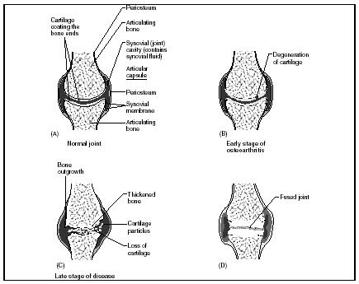

The progression of osteoarthritis. One of the most common forms of arthritis, osteoarthritis is the deterioration of the cartilage covering the bones in the joints of the body. (Illustration by Hans & Cassady )

Rheumatoid arthritis is one of the most crippling forms of arthritis. It is characterized by chronic inflammation of the lining of joints. It also affects the muscles, tendons, ligaments, and blood vessels surrounding these joints. Deformities can result from the deterioration of bone, muscle, and tissue, impairing function and affecting mobility. Rheumatoid arthritis can occur at any age but usually appears between the ages of thirty and sixty. Three times more women than men are stricken with this disease.
The cause of the chronic inflammation of rheumatoid arthritis is not known. Scientists believe that a bacterial or viral infection may trigger an autoimmune response in genetically predisposed people. People with rheumatoid arthritis produce antibodies that attack their own body tissues. This sets off an immune response that results in the body's release of chemicals that produce inflammation.
Treatment of rheumatoid arthritis includes aspirin therapy to reduce inflammation and relieve pain, application of heat to joints and muscles, rest, and physical therapy. In some cases, surgery may be required to reconstruct joints that have been destroyed.
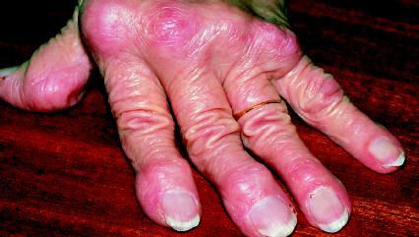

Rheumatoid arthritis is one of the most crippling forms of arthritis. It is characterized by chronic inflammation of the lining of joints. (Reproduced by permission of Science Photo Library/Photo Researchers, Inc.)

Osteoporosis
Osteoporosis (which literally means "porous bones") occurs when a body's blood calcium level is low and calcium from bones is dissolved into the blood to maintain a proper balance. Over time, bone mass and bone strength decrease. As a result, bones become dotted with pits and pores. Weak and fragile, they break easily. Even a sneeze or a sudden movement can cause a fracture in someone with severe osteoporosis.
About 28 million people in the United States are affected by this disease, which causes about 1.5 million fractures each year. Any bone can be affected, but common locations include the hip, spine, and wrist. Osteoporosis occurs in nearly half of all people over the age of seventy-five. However, women are five times more likely than men to develop the disease. After a woman goes through menopause (period in a woman's life when menstrual activity ceases), her body stops producing estrogen, a hormone that helps maintain the health and density of a woman's skeleton.
Other factors besides age can lead to osteoporosis. These include a diet low in calcium and protein, a lack of vitamin D, smoking, excessive alcohol drinking, and insufficient weight-bearing exercises to stress the bones.
There is no cure for osteoporosis, but drugs are available that stop further bone loss and even help build new bone. For some people, though, these drugs may not help build enough bone to replace that already lost in the body. The best way to prevent osteoporosis is to maintain a healthy lifestyle throughout one's life: adhering to a diet with the proper amounts of calcium and vitamin D, avoiding smoking and heavy alcohol drinking, and exercising regularly.
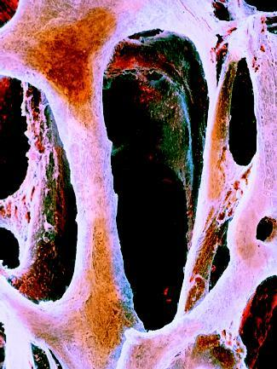

An electron micrograph scan of spongy bone in an osteoporosis patient. Osteoporosis occurs when a body's blood calcium level is low and calcium from bones is dissolved into the blood to maintain a proper balance.
(Photograph by P. Motta . Reproduced by permission of Photo Researchers, Inc.)

Rickets
Rickets is a disease in young children that is brought about by a deficiency of vitamin D (the disease is also called vitamin D deficiency). When the deficiency occurs for a period of many months in children whose bones are still developing, softened bones and other bone defects occur.
While some vitamin D is supplied by the diet, most of it is made in the body from the Sun's rays. In the lower layers of the epidermis (thin, outer layer of the skin), cells contain a form of cholesterol or a fatlike substance produced by the liver that is an essential part of cell membranes and body chemicals. When exposed to UV radiation from the Sun, that cholesterol changes into vitamin D. The body then alters vitamin D to produce a hormone that keeps the concentration of calcium at a constant level in the bloodstream by stimulating the absorption of calcium from digested food in the intestines.
When there is a vitamin D deficiency, though, the calcium level in the blood is too low to help create hardened bone. The result is soft bone.
The symptoms of rickets include bowed legs and arms. The bowed appearance is due to the softening of the bones and their bending if the bones are weight-bearing (such as the legs). Other symptoms include a distorted sternum (which produces a protruding pigeon breast), bony bumps on the ribs, and knock-knees. Seizures may also occur because of reduced levels of dissolved calcium in the bloodstream.
Rickets is almost always treated with oral supplements of vitamin D. Children suffering from the disease are also encouraged to play outside with their faces exposed to sunlight for at least twenty minutes a day. This type of treatment heals rickets promptly. Bone abnormalities generally disappear gradually over a period of three to nine months.
Foods that are good sources of vitamin D include cod liver oil, egg yolks, butter, and oily fish. Some food, including milk and breakfast cereals, are also fortified with synthetic vitamin D. Food fortification (the adding of vitamin to food by the manufacturer) has almost completely eliminated rickets in the United States.

Scoliosis
Scoliosis is a sideways curvature of the spine or vertebral column. Normally, the spine has a set of front-to-back curves. When viewed from rear, a normal spine usually appears straight.
A small degree of lateral (sideways) curvature in the spine does not cause any medical problems, but larger lateral curves can cause imbalance and lead to muscle fatigue and pain. More severe scoliosis can interfere with breathing and lead to arthritis of the spine.
Approximately 10 percent of all adolescents have some degree of scoliosis. Fewer than 1 percent, however, have curves that require medical attention. Scoliosis is found in both boys and girls, but a girl's spinal curve is much more likely to progress. The cause behind 80 percent of scoliosis cases is unknown. Some cases can be linked to birth defects, while others are caused by a loss of control of the nerves or muscles that support the spine. Scientists do know that scoliosis is not caused by poor posture, diet, or carrying a heavy bag exclusively on one shoulder. There is no known way to prevent scoliosis.
Treatment for scoliosis depends on the degree of curvature. If the curvature is moderate, a brace may be worn. Bracing cannot correct curvature, but may be effective in halting or slowing the progression of the curve. Surgery is often required if the curvature is severe, if the curve has progressed despite bracing, or if there is significant pain. During surgery, the spine is straightened as much as possible, then vertebrae are fused together to prevent further curvature. Spinal fusion leaves the involved area of the vertebral column permanently stiff.

Spina bifida
Spina bifida is the common name for a range of birth defects caused by problems with the early development of the vertebral column or spine. The main defect of spina bifida is an abnormal opening somewhere along the vertebral column due to a failure of the vertebrae to wrap completely around the spinal cord. This leaves the spinal cord unprotected and vulnerable to either injury or infection.
In North America, spina bifida is much more common among whites than African Americans. It occurs in 1 of every 700 births to whites, but only in 1 in every 3,000 births to African Americans. Scientists are unsure of the reasons for this difference.
Different levels of the spinal cord control different functions in the body. Therefore, the location and size of the defect in spina bifida will determine what kind of disabilities an individual will experience. Most will have some degree of weakness in the legs. Depending on the condition of the spinal cord, that weakness may lead to paralysis. The higher up in the spine the defect occurs, the more severe the disabilities. These may include problems with bladder and bowel function, abnormal curves in the spine (scoliosis), clubfeet, hip dislocations, and water on the brain (a condition called hydrocephalus).
Treatment for spinal bifida is aimed first at surgically closing the spinal defect to prevent infection. Further operations are often necessary to repair the hip dislocations, clubfeet, scoliosis, or other conditions that accompany spina bifida. The success of treatments is still dependent on the severity of the original spinal defect. Current care for children with spina bifida usually enables them to live into adulthood.
Adapted from: http://www.faqs.org/health/Body-by-Design-V2/The-Skeletal-System.html

