Topic J02: Microscopic Demonstration of Bacteria II

Gram´s staining

Materials for study (from textbooks, internet etc.): Gram staining. Study also your own protocole from the first week.

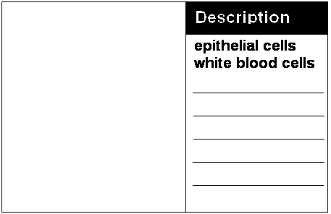
Task No 1 Observing a preparation prepared from an infective material stained according to Gram
Observing the prepared slides in microscope (use the oil-immersion objective, power 100 ×, e. g. total magnification 1000 ×). Work in such a way not to damage the lens. After finishing the work, clean carefully the lens using gaze, and the remaining parts of microscope using paper. Use „benzín“, too, it there is too much oil. Notice the cells from the macroorganism. Draw and describe the results of your observations – not only bacteria, bul also WBCs, epitheliae etc.

Task No 2 Gram´s staining
Make a heat-fixed smear like in Topic J01, task 3, but instead of simple staining, stain it according to Gram.
Gram stain: Flood slide with crystal violet (Gram I) after 30 seconds rinse with Lugol iodine solution. After 30 seconds remove Lugol and rinse with tape water. Decolorize with alcohol for about 15 seconds (until most crystal violet is removed) and rinse with tape water. Counterstain with safranin for 60 seconds and rinse with tape water. Dry using filtration paper and examine the slide using the oil immersion objective. Draw and describe the results of your observations (strains A, B, C, D, E to following windows respectivelly):
Strain | A | B | C | D | E
Picture

Description

Task 3 Capsullar demonstration according to Burri
For microscopical observation of bacterial capsulla we use negative staining. In this case we use no fixation. For our purposes we use Burri negative staing (background is stained by ink, so you can see the capsulla).
bacteria
capsulla
Draw a result of Burri staining from your slideshow.

Check-up questions
1. List the name of solutions and their incubation times when staining according Gram
solution

time

2. Write names of at three bacteria that do not Gram stain or stain poorly. Explain the reason.

3. After the Gram staining, gram-negative bacteria are of____________________.colour. Explain why.

4. Name at least two more diagnostic staining methods. (Find in textbooks or using internet finder.)

5. Write how human cells (epitheliae, WBCs) stained in Gram stain.

