Topic J04 Identification of bacteria according to biochemical activity
To study: Biochemical activity of bacteria, identification of bacteria
From other subjects: enzymatic reactions, lactose splitting, Schiff reagent (chemistry and biochemistry)

Task No 1 Catalase test
Transfer the colony of the test microorganism to a clean glass slide, add one drop of 3% H₂O₂, and observe for an immediate development of bubbles, a positive test for catalase.
Draw the result and fill in the label of the stains.
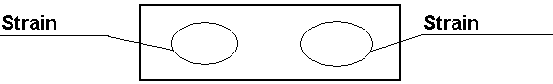

Task No 2 Oxidase test (test of production of cytochromoxidase)
Take a reagent-impregnated filter paper strips, press it on the colonies of the tested strain, and place it onto cultivation medium with colonies imprints facing upwards. Evaluation
Positive | development of dark-blue colour within 30 seconds
Delayed positivity | development of dark-blue colour until 2 minutes
Negative | no change even after two minutes
Draw the results and interprete:


Task No 3 O-nitrophenyl-β-D-galactosidase (ONP) test
Prepare saline solution of the tested strain. Put in reagent-impregnated (reagent = o-nitrofenyl-β-D-galaktopyranosid) filter paper strips to the suspension, and incubated in 37 °C. Examine tubes for development of a yellow colour after 4-hour incubation, that indicate the positivity.
ONP-positive strains are:
Strain→ | 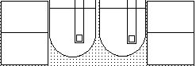 | ←Strain
Result→ |  | ←Result

Task No 4 H₂S production, gas fermentation and saccharide fermentation in agar according to Hajna
The H₂S production and CO₂ production, and fermentation of carbohydrates are detected in Hajna medium. This medium contains protein, glucose, lactose, sucrose, a sulphur source (thiosulphate), an H₂S indicator (ferric ammonium sulphate) a pH indicator. H₂S gas is produced as a result of the reduction of thiosulphate. H₂S is colourless gas and can be detected only in the presence of the indicator. H₂S combines with the ferric ions of ferric ammonium sulphate to produce the insoluble black precipitate ferrous sulphite. Gas production (CO₂ and hydrogen) is detected by the presence of crakes or bubbles in the medium. These are formed when the accumulated gas escapes. Bacteria that ferment glucose produce a variety of acids, turning the colour of the medium from red to yellow. Large amounts of acid are produced in the butt of the tub (fermentation) than in the slant of the tube (respiration).
Draw and write results of your observation:
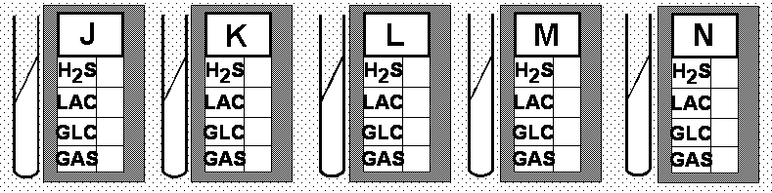

Task No 5 Demonstration of motility, indol formation, and urea breakdown (MIU)
The studied strains were inoculated by stubbing into a combined diagnostic medium. Motile bacteria growth diffusely around the line of inoculation.
To demonstrate the formation of indole, add two drops of Kovacs reagent directly to the broth culture and observe for development of red colour in the upper alcohol layer.
Phenolphthalein is an indicator of urea breakdown dependent pH shift. Observe for a red colour change in the medium.
Write the scheme of chemical reaction of urea breakdown

Determine characteristics of tested strains. Draw and write results:
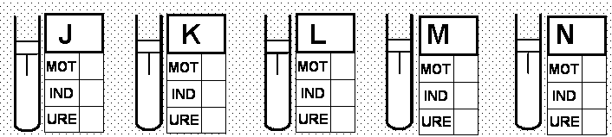

Task 6 Read carefully results (from tasks 4 and 5) again and try to identify approximately tested strains according to the enclosed table. Write results:
Strain | Result | Strain | Result
J |  | M
K |  | N
L |  | Notes:

Task No 7 Using of commercial biochemical systems for identification of bacteria
Many commercial biochemical identification systems for identification of bacteria are available. These systems are simple, rapid and relatively inexpensive. Bacteria are determined to the species according to biochemical characteristics.

7a) Prepare of commercial biochemical identification system
Prepare bacterial suspension – mix several colonies in saline in a test tube. Inoculate 0.1 ml of the suspension into all microwells. After inoculation overlay the following tests with paraffin oil: micro wells H, G, F. Insert the strips into a polyethylene bag. Incubate the inoculated plate at 37 °C for 24 hours.

7b) Reading of results of commercial biochemical identification system.
Evaluate biochemical activity of tested strains and identify them. Read the reactions in accordance with the table of results. Results of each reaction write into protocole. Besides name of a microbe write also percent of probability for a given taxon and typicity index for a strain. For the first strain evaluation is already done – use as a pattern for other strains. In not-sure result write possible results, eventually try to find the result using teacher’s help.

 | ONPG | 1H | 1G | 1F | 1E | 1D | 1C | 1B | 1A | 2H | 2G | 2F | 2E | 2D | 2C | 2B | 2A
Strain  P | + | - | + | + | + | - | - | - | - | - | - | - | - | + | + | + | +
Strain  P | 1 | 2 | 4 | 1 | 2 | 4 | 1 | 2 | 4 | 1 | 2 | 4 | 1 | 2 | 4 | 1 | 2
Strain  P | 5 |  |  | 3 |  |  | 0 |  |  | 0 |  |  | 6 |  |  | 3
Strain  P | Code: 530 063 |  |  |  |  |  | Identification Escherichia coli |  |  |  |  |  | % of prob. 99,89 |  |  | T index 1,00

 | ONPG | 1H | 1G | 1F | 1E | 1D | 1C | 1B | 1A | 2H | 2G | 2F | 2E | 2D | 2C | 2B | 2A
Strain
Q

Strain  Q | 1 | 2 | 4 | 1 | 2 | 4 | 1 | 2 | 4 | 1 | 2 | 4 | 1 | 2 | 4 | 1 | 2
Strain  Q | Code: |  |  |  |  |  | Identification |  |  |  |  |  | % of prob. |  |  | T index
 | ONPG | 1H | 1G | 1F | 1E | 1D | 1C | 1B | 1A | 2H | 2G | 2F | 2E | 2D | 2C | 2B | 2A
Strain
R

Strain  R | 1 | 2 | 4 | 1 | 2 | 4 | 1 | 2 | 4 | 1 | 2 | 4 | 1 | 2 | 4 | 1 | 2
Strain  R | Code: |  |  |  |  |  | Identification |  |  |  |  |  | % of prob. |  |  | T index
 | ONPG | 1H | 1G | 1F | 1E | 1D | 1C | 1B | 1A | 2H | 2G | 2F | 2E | 2D | 2C | 2B | 2A
Strain
S

Strain  S | 1 | 2 | 4 | 1 | 2 | 4 | 1 | 2 | 4 | 1 | 2 | 4 | 1 | 2 | 4 | 1 | 2
Strain  S | Code: |  |  |  |  |  | Identification |  |  |  |  |  | % of prob. |  |  | T index

Check-up questions
1. Give the names of several oxidase-pozitive bacterial genera

2. Give one catalase-positive and one catalase-negative bacterium.

3. Give one ONP-positive and one ONP-negative bacterial genus.

4. Why the media acidify upon the break-down of carbohydrates?

5. Explain the diagnostic function of Endo selectively diagnostic medium.

6. Which selectively diagnostic media are use for the cultivation of intestinal bacteria?

7. Describe the starting point of substrate, enzyme and indicator reaction at biochemical identification microtests. When do we not need indicator?

8. Explain the difference between aerobic respiration and fermentation. Does every utilization of sugar mean its fermentative splitting?

9. Do you know any example from, when two species differ from each other by ability (or inability to produce any enzyme?

