Topic J06: Determination of susceptibility of bacteria to antimicrobial drugs, assessments of resistance factors
For study: textbooks, www, keywords e. g. „Diffusion disc test“; „E-test“; „dilution mikromethod“; „minimal inhibition concentration“
Bacterial susceptibility to antimicrobial drugs may be tested qualitativelly (diffusion disc test) or quantitativelly (assessment of minimal inhibitory/bactericidal concentration). Important is detection of eventual bacterial rezistance af a given strain.

Task 1: Preparing of a diffusion disc test
Take two colonies of Escherichia coli from Endo agar using a loop and suspend in saline with glucose. With a cotton swab, suspend densely to the Mueller-Hinton agar. Then rotate the agar plate to 90° and inoculate once more. After drying, place clock-wise the following set of discs
 | Abbr. | Name of antibiotic |  | Abbr. | Name of antibiotic
1. |  |  | 4.
2. |  |  | 5.
3. |  |  | 6.
Look also at a dispensor, that serves to quick placing of disc sets in case of often used discs.
The plate should be incubated overnight at 37 °C. The antibiotics difund to surroundings of the discs. When the bacterium is susceptible, a zone of growth inhibition is formed.

Task 2: Qualitative test of antibiotic susceptibility (diffusion disc test), comparison of susceptibility of Gram-positive and Gram-negative bacteria
In diffusion disc test we compare eventually found susceptibility zones with reference zones.
When the zone is larger than reference limit, we say that the strain is susceptible to given antibiotic. Sometimes the zones are so large that it is not possible to measure them. Obviously in such cases, too, we describe such result as „susceptible“.
When the zone is smaller than the reference limit, or we cannot find any zone at all, we describe such result as „resistant.
Sometimes we have also borderline cases (the zone is just the same as limit zone). Such results are usually described as „D“ (dubious, borderline, query, unsure, „plus-minus“).
The zone is larger than reference limit. We can evaluate such result as „S“ (stain is susceptible to given antibiotic) | 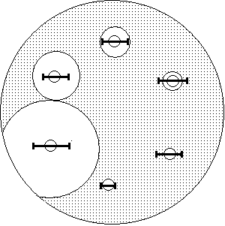 | The susceptibility zone is present, but is is smaller than the limit. so the result of the strain is reported as „R“ (the strain is resistant to given antibiotic)
The zone is so large that it cannot be measured, but it does not matter, it is obvious that the strain is susceptible („S“) |  | There is no visible zone here, so it is obvious that the strain is resistant, „R“

We use various sets according to tested bacteria. Sets for gram-negative bacteria contain mostly antibiotics effective againts gram-negative bacteria, sets for staphylococci or streptococci contain rather antibiotics with supposed effectivity against such bacterial genera.
Read, to what antibiotics two given bacterial strains are susceptible. At inhibition zone diameter larger than referrence limit sign S (susceptible), in smaller zone or no zone at all write R (resistant).
Set for grampositive bacteria (write names, NOT abbreviations) | Staphylococcus aureus (a G+ coccus) | Escherichia coli (a G- rod)
Set for gramnegative bacteria (write names, NOT abbreviations) | Staphylococcus aureus (a G+ coccus) | Escherichia coli (a G- rod)
„Širokospektrý“ broad-spectre set (write names, NOT abbreviations) | Staphylococcus aureus (a G+ coccus) | Escherichia coli (a G- rod)

Task 3: Assessment of susceptibility of urinary tract infections
For the urinary tract infections (UTI), we use specific antibiotics, that concentrate in urinary bladder. Some of them (nitrofurantoin, norfloxacin) concentrate sufficiently only in urinary bladder; such antibiotics can be only used for cystitis, as in case of pyelonephritis a sufficient concentration in tissues is also required.
In practice, we use „test for enterobacteria from urine“, „test for staphylococci from urine“ etc., but also a „universal urine set“ that is exploited e. g. for children’s policlinic.
You have such „universal urinary set“ here. Evaluate susceptibility to its antibiotics for given strains of Escherichia coli (G–) and Enterococcus faecalis (G+):
„močový test“ (universal set for urinary specimens) | Escherichia coli | Enterococcus faecalis

Task 4: Assessment of MIC using the dilution micromethod
The dilution micromethod (microdilution test) is a quantitative way of testing antibiotic susceptibitlity of bacteria. Each well contains a substrate and some concentration of an antibiotic – the antibiotic is diluted by a geometric row. The growth is seen as turbidity (eventually a dot made of sedimented bacterial cells), inhibition of growth is indicated by a clear well. The lowest concentration of an antibiotic that is inhibitory for bacterial growth is the minimal inhibitory concentration (MIC).
- Encircle all clear wells (wells that are not turbid and with no visible dot inside).
- Double encircle the lowest clear well (= minimal inhibition concentration)
- For each antibiotic, compare the MIC with the breakpoint (marked as >X<) and judge, whether the strain is susceptible (S) or resistant (R) to given antibiotic
- If there are no clear wells for a certain antibiotic, do not encircle anything and write „R“. The MIC is higer than the highest value mentioned in the table
- If there are no turbid wells for a certain antibiotic, encircle all of them and double encircle the lowest one, although the MIC value might be even lower. Obviously, such strain is „S“.
- Write full names of all given antibiotics, write to which group they belong (penicillins, cephalosporins) and what are their side effect for treatment (according to guides on your tables)
Antibiotic | AMP | AMS | CZL | CRX | CXT | GEN | COT | COL | OXO | OFL | TET | AZT
Concentrations (mg/l) | 32 | 64 | 64 | 64 | 64 | 32 | 128 | 32 | 64 | 16 | 32 | GC
Concentrations (mg/l) | 16 | 32 | 32 | 32 | 32 | 16 | >64< | 16 | 32 | 8 | 16 | 64
Concentrations (mg/l) | >8< | >16< | 16 | 16 | 16 | >8< | 32 | >8< | >16< | >4< | 8 | 32
Concentrations (mg/l) | 4 | 8 | >8< | >8< | >8< | 4 | 16 | 4 | 8 | 2 | >4< | >16<
Concentrations (mg/l) | 2 | 4 | 4 | 4 | 4 | 2 | 8 | 2 | 4 | 1 | 2 | 8
Concentrations (mg/l) | 1 | 2 | 2 | 2 | 2 | 1 | 4 | 1 | 2 | 0.5 | 1 | 4
Concentrations (mg/l) | 0.5 | 1 | 1 | 1 | 1 | 0.5 | 2 | 0.5 | 1 | 0.25 | 0.5 | 2
Concentrations (mg/l) | 0.25 | 0.5 | 0.5 | 0.5 | 0.5 | 0.25 | 1 | 0.25 | 0.5 | 0.125 | 0.25 | 1
S/R?
GC = growth control (should be allways turbid, no antibiotic present)
Explantion of antibiotic abbreviations
Abbr. | Full name | Group | Unwanted side effects (if any)
AMP

AMS

CZL

CRX

CXT

GEN

COT

COL

OXO

OFL

TET

AZT

Task 5: Evaluation of the MIC using the E-test
Although principially similar to the diffusion disc test, E-test is a quantitative test. The concentration values are written direcly on the strip. The site where the margin of the zone crosses the strip shows us the MIC value.
Read an E-test for a given strain. Draw and evaluate the result.
 | Tested strain
 | Tested antibiotic / antimycotic
 | MIC value
 | Breakpoint:
 | Conclusion (strain is susceptible/resitant to given antibiotic)

Task 6: Test for common beta-lactamase production using nitrocephin strip method
Draw the result of beta-lactamase test from the slideshow.
Positive beta-lactamase | Negative beta-lactamase

Task 7: Detection of the extended-spectrum beta-lactamases (ESBL)
Draw and evaluate result of tests showing production of ESBL (extended-spectrum beta lactamases) in two given bacterial strains according to your teacher and slideshow. For negativity, fill upper and lower arm of a „+“ by black ink or black pencil, making so a „–“ of it.

a) DDST (double discs synergy test)
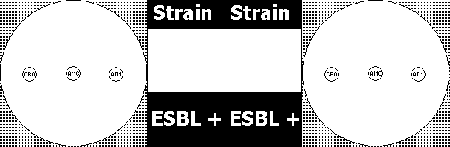

b) CLSI test (susceptibility test to 2 antibiotics, each with/without β-lactamase inhibitor)
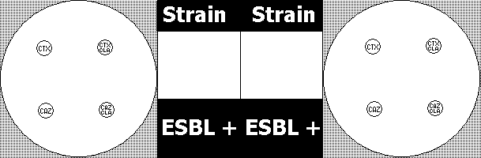

Check-up questions
1. Explain the difference between use of disinfectants and use of antibiotics

2 What type of drugs are used for treatment of
mycoses

heavy viroses

TB treatment

local treatment

3. Explain the term „breakpoint“

4. What groups of antibiotics belong to beta-lactam antibiotics?

5. In what group of antibiotics MIC and MBC values are nearly identical? In primary bactericidal, or primary bacteriostatical? Explain, why.

