Topic J08: Complementfixation test (CFT) and a follow-up of titres
To study: Web-search: Complement, amboceptor, anticomplementarity

Task No. 1 Examination of function of indicator systém fot the CFT
Complement causes hemolysis of sheep erytrocytes in complex whit amboceptor (= rabbit antibodies against sheep erythrocytes). Absence of any of needed components leads to absence of haemolysis.
Pipette into tubes individual parts of reaction according to the table. Wash your pipette allways carefully three times by saline to avoid contamination. Incubate 1hour in a thermostat. Finally evaluate the results.
Note: All amounts are in mililitres (ml)
tube | saline | sheep  ery | amboceptor | comp-lement | rabbit  ery | Haemolysis (encircle) | In case of no haemolysis, explain, why it is absent
1 | 0.2 | 0.2 | 0.2 |  |  | yes – no
2 | 0.2 | 0.2 |  | 0.2 |  | yes – no
3 |  | 0.2 | 0.2 | 0.2 |  | yes – no
4 |  |  | 0.2 | 0.2 | 0.2 | yes – no

Task No. 2 Assessment of proper amount of complement to be used in CFT (titration)
CFT uses exactly measured amount of guinea pig complement, given in hemolytic units (patient‘s conplement is inactivated by heating of serum). Hemolytic unit is the exact amount of complement which causes hemolysis of given volume of RBC (in complex with amboceptor).
In four tubes, guinea pig serum is diluted 1:32, 1:36, 1:40 and 1:44. Serum was incubated with working volume of sheep erythrocytes with amboceptor.
Write, in which dilution is 1 hemolytical unit of complement. It is 1 : _______

Task No. 3 Schematic analyse of course of CFT, including anticomplementarity testing
In following schemes judge where free complement remains free after the fist phase of reaction (encircle what is true, cross, what is wrong) and add verbal description of the result (haemolysis, sedimentation of RBCs).
Note: all schemes describe use of CFT for antibody detection.

LAB Ag = laboratory antigen
PATIENT Ig = patient antibody
C = complement
Ery = sheep red blood cell
Amb = amboceptor (rabbit antibody against sheep red blood cells)
ANTICOMPLEMENT = anticomplementarity causing component

Description of situation | Phase 1 | Complement  after Phase 1 | Phase 2 | Result | Result  description
Course of a  positive CFT |  | free – bound |  | 
Course of a  negative CFT | 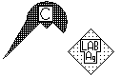 | free – bound |  | 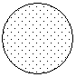
Anticomplementarity  testing, serum is  anticomplementary |  | free – bound*  *or inactivated
Anticomplementarity  testing, serum is OK |  | free – bound*  *or inactivated

Task No. 4 Assessment of complementfixation antibodies to the most frequent causative agents of respiratory diseases
Read the titres of CFT in individual patients. Remark anticomplementarity controls in the wells of the first collumn. CFT starts from the second well with 1:5 dilution. Draw your result, write titre values (in positive patients) and try to interprete results.
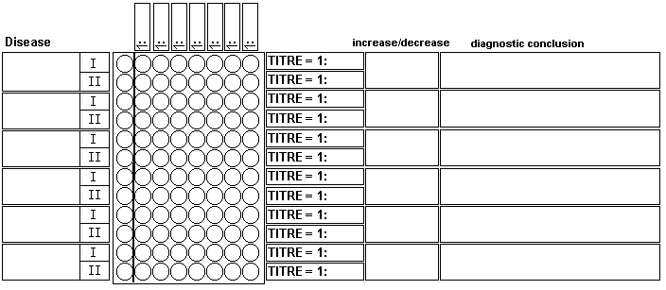

Task No. 5: Assessment of complementfixation antibodies to tick-born encephalitis
Read CFT titres in pair samples of patients. The first dilution is 1:4 in geometric series. Carefully evaluate controls of anticomplementarity. Draw a result, write titer and try to interpret results.
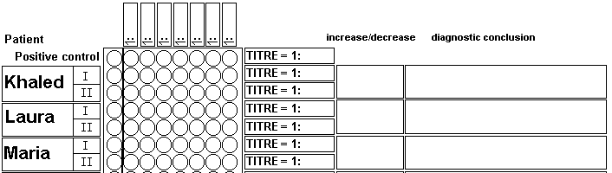

Task No. 6 Assessment of complementfixation antibodies in toxoplasmosis
Read CFT titres in sera of patiens with suspected infection caused by Toxoplasma gondii. The first dilution is 1:8 in geometric series. Carefully evaluate controls of anticomplementarity. Draw a result, write titer and evaluate only as „positive“ / „negative“ / „anticomplementary
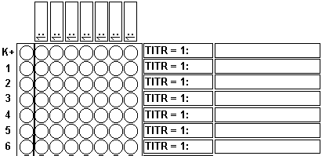

Check-up questions:
1. Why patients own complement is not used for CFT and guinea pig complement is used instead?

2. What is the metod used for patient serum inactivation?

3. Which type of errors is caused by

a) anticomplementarity of serum?

b) too big amounts of used complement?

4. Why 2-fold increase of titre cannot be considered significant? (Think abour error of measuring.)

5. Why it is recomendable to use pair sera when using reactions like CFT?

6. What is meaning ot the term „seroconversion“? What can be considered more significant, seroconversion of 4-fold increase of titre? Explain.

7. How would result of Task No. 4 influence decision about starting antibiotic therapy? (Answer during the practical session)

