Topic J09: Neutralisation (ASO, HIT, VNT)
To study: Search WWW for: ASO, rheumatioid fever, accute glomerulonephritis, viral haemagglutination
Neutralisation reactions are based on inhibition of specific influence of antigen by antibodies.

Task No. 1 ASO – a proof of antistreptolysin O
Principle: Antibodies prevents hemolysin (streptolysin O – i.e. antigen) to hemolyse rabbit RBC.
ASO levels increase after beta-hemolytic streptococci group A (less commonly also other groups) caused infections. In risk for late sequelaes, ASO increase over 200 I. U. (international units) is seen.
On your serological panel, read ASO values of positive control and seven patients.
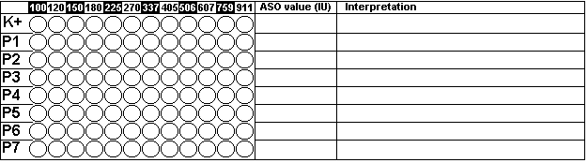

Task No. 2 HIT – hemagglutination inhibition test
Principle: Antibodies prevents virus to agglutinate erythrocytes. Serum samples taken from patiens with suspect tick-born encephalitis are examined. Read, draw results and make a clinical conclusion.
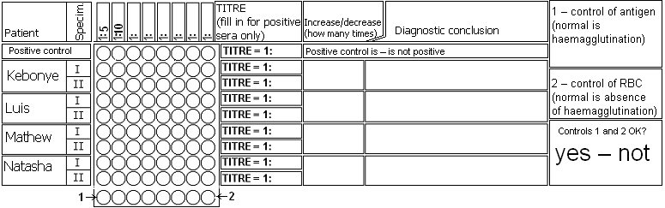

Task No. 3 VNT – virus neutralisation test
Principle: Antibodies present virus to kill cells of a cell culture growing in a microtitration plate.
A cell culture of monkey kidneys was cultivated in a microtitration plate and then various Coxsackievirus B serotypes and serum from a patient suffering from myocarditis were added. Medium get red in wells in which virus kill cells. On the contrary, if antibodies neutralise virus, cells stay alive and medium get yellow by products of cell metabolism. – Draw the result and try to interprete findings.
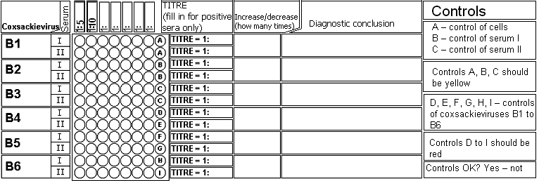

Check-up questions:
1. In which clinical situations ASO diagnostics is rational?

2. Why it is not suitable to classify ASO as „indirect diagnostic reaction for microbial detection“, althougth it is a method of antibody detection?

3. Some viruses are unable to agglutinate RBC – how does the fact influence HIT diagnostic?

4. Which is a Czech abbreviation for ASO?

5. Why neutralisation reactions are rare in bacteriology?

6. A bonus question for clever students: Try to find an arrangement for HIT, if it should be used for antigen detection.

