Topic J10: Immunofluorescence, ELISA, immunoblotting
To study: Immunofluorescence, ELISA, radioimmunoassay, immunoblotting, Western blott

Task No. 1 Direct and indirect immunofluorescence – comparison
Evaluate a picture of direct immunofluorescence in diagnostics of syphilis and a picture of indirect immunofluorescence in diagnostics of syphilis, which is called FTA-ABS, and answer following question:

Is there any difference in appearande between direct and indirect immunofluorescence? _______________

Task No. 2 Direct and indirect immunofluorescence – principles
Add labes to schemes of direct and indirect diagnostics. Colour in individual components. Use red color for components derived from the patient and blue colour for components added by the laboratory.
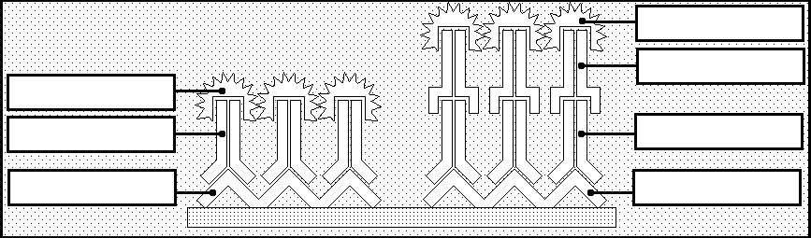

Task No. 3 ELISA in a proof of antigen (detection of Helicobacter pylori antigen in stool)
In all ELISA reactions we use a reader (spectrophotometer) to evaluate optical density of individual wells. So we measure absorbance of patient wells, but also of controls, eventually blank etc.
In process of assessment of positivity or negativity of results, we evaluate the reaction so that we compare absorbance values of the patient wells with so named cut off value. Cut off value is either counted as average of special wells, labelled usually „c. o.“ (as „cut off“), or as average of negative controls + constant. The details may differ for individual sets.
In this type of ELISA, we count cut off value as the average of negative controls (in wells A1, B1 and C1) + constant (0.050). All absorbance values higer than cut off value are considered as positive, all values lower than cut off are considered negative.
Read ELISA in a proof of Helicobacter pylori antigen from stool. Check positivity / negativity of first 10 patients. Add labels to schematic principle of the reaction. For substrate, write „substrate – changes colour“ or „substrate – no change“. Also colour in individual components. Use red color for components derived from the patient (missing in negative reaction) and blue colour for components added by the laboratory.
Cut off = (A1 + B1 + C1)/3 + 0.050  Cut off = | 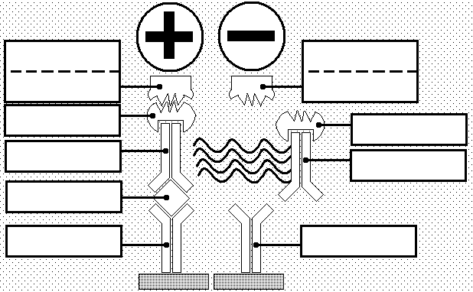
Positive patients:

Task No. 4 ELISA in a proof of antibodies against Helicobacter pylori in serum
In proof of antibodies, we use to assess presence of antibodies againts IgM (typical for fresh infection) and IgG antibodies. In some cases, nevertheless, we assess IgA antibodies instead of IgM class.
In this type of ELISA, we count cut off value as the average of negative controls (in wells B1and C1 for IgA, in wells B3 and C3 for IgG) + constant (0.320). All absorbance values higer than 110 % of cut off value are considered as positive, all values lower than 90 % of cut off are considered negative. Values between 90 % and 110 % of cut of vallue are considered borderline.
Read ELISA in a proof of IgA and IgM antibodies to Helicobacter pylori from serum. Check positivity / negativity of first 10 patients. Add labels to schematic principle of the reaction. For substrate, write „substrate – changes colour“ or „substrate – no change“. Also colour in individual components. Use red color for components derived from the patient (missing in negative reaction) and blue colour for components added by the laboratory.
IgA  Cut off = (B1 + C1) / 2 + 0.320  Cut off = ______________ | 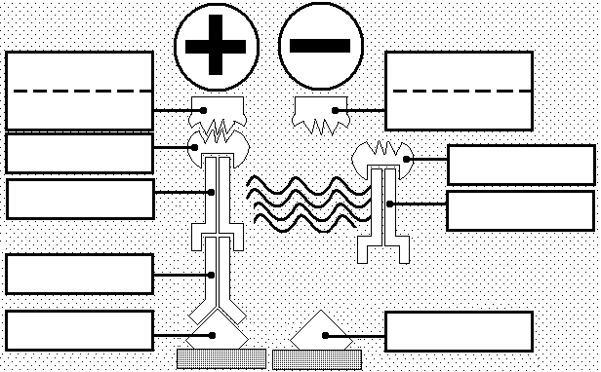
Positive patients:

Borderline patients:

IgG
Cut off = (B3 + C3) / 2 + 0.320

Cut off = ______________
Positive patients:

Borderline patients:

Task No. 5: Westernblotting
Read strips according to teacher’s instructions in order to assess antibodies to Borrelia afzelii in serum. Draw a scheme of positions for all important antigens according to a given pattern; chose one negative and one positive patient and draw their findings into a bottom strip. Evaluate a result and write it into the protocol.

Pattern:

Positive patient (choose any of positive patients):

Negative patient (choose any of negaative patients):

Result: Positive patients are those with numbers ______________________________

Check-up questions:
1. What diagnostic value could be a finding of antigen using ELISA in comparison with a finding of antibodies using the same method? (generally)

2. Which clinical sample is usually taken for a proof of antibodies and which should be suitable for a proof of antigen? (generally; in concrete situations it is necessary to think about pathogenesis of infection)

3. Compare similarities and differencies in ELISA and westernblotting.

4. Why dilution in geometric series usually is NOT used for a proof of antibodies using ELISA?

5. Which is a diagnostic importance of various subclasses of immunoglobulins? Why aren’t individual subclasses detectable by “traditional” serological methods (e.g. agglutination, CFT, neutralisation)?

