Theme No. J13 Clinical virology II (isolation of viruses in a chicken embryo, HIT, KFR)
To study: Repeat your notes from J03, J08 and J09.

Task No. 1: Determination of the hemagglutination unit of influenza virus in amnion fluid (Hirst´s test)
When a virus is isolated in amniotic fluid, the result is not visible. So it is not clear, whether the isolation was positive or not. One of ways, how to check the presence of virus in amniotic fluid is connected with the ability of many viruses to agglutinate red blood cells in vitro. This property of viruses is also used in HIT (see J109). Before HIT, it is necessary to titrate the virues to measure its „power“. We measure it in so named haemagglutination units. A haemagglutination unit is the smallest quantity of virus which can agglutinate a given quantity of erythrocytes.
Pipette 0.2 ml of saline into each of 8 wells in one row of a perspex panel. Add 0.2 ml of the virus to the second well, mix, and transfer 0.2 ml to the third well. Continue in this fashion until reaching dilution of 1:128 (well 8), pipette the excess fluid into 2% chloramine. Add 0.2 ml of chicken erythrocytes suspension to each well. The first well serves as the control for the red blood cells. Incubate the place for 90 minutes at room temperature.
Draw the results, and write, what dilution corresponds to 1 haemagglutination unit (1 HU).
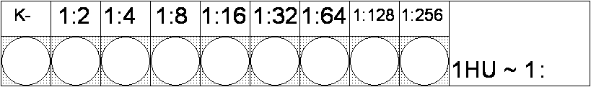

Task No. 2 Isolation of viruses in chicken embryo
In picture a), add labels to individual structures of the egg to the first collumn. To the second collumn write NOT USED for structures not used for viral isolation, USED for those used and USED – POCKS for the structure, where pocks might be visible in case of some poxviruses and herpesviruses.
Now concentrate to your fertilized egg.
Put an egg into the ovoscope (laying) and outline the edge of the air bubble in pencil. Then wet the shell at the site of the air bubble with tincture of iodine, and cut the shell in place of the air bubble, keeping cca 2 mm difference between line of your cut and the line signifying the edge of the bubble. Using sterile forceps, remove the shell top, without breaking or disturbing the uderlying membrane.
Place a few drops of alcohol on the „paper“ membrane to make it transparent, and examine the inside of the egg over the ovoscope (now standing). Draw the observed structures to Picture b).
Now try to inoculate the amnionic cavity with a „virus“ (for didactic puprose, ink is used instead). Using the ovoscope for illumination, insert a needle as if you woud have inentnion to inoculate inside the eye of the embryo, and inject 0.1 – 0.2 ml of ink.
Now the egg woud be re-closed, the cut would be filled by parafin and the egg would be incubated. Instead of that we will observe our results.
Using sterile forceps , break off the shell as far as the edge of the air bubble, nad then tear both the outer and the chorioallantoic membranes. Empty the contens of the egg into the dish. Try to identify the structures and draw your result to Picture c).
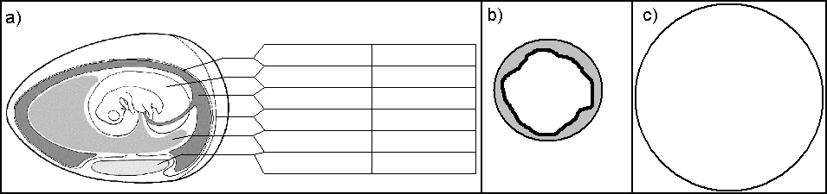
Structure Used for is.?

Task No. 3 Assesing tissue cultures
Using a microscope at low magnification (10x objective) examine Roux-bottles or test tubes containing tissue cultures. Draw the about 10 cells from each type of culture. In which vessels do you see a cytopathic effect?
CPE yes – not | CPE yes – not | CPE yes – not

Task No. 4 Demonstration of the shell vial assay (rapid detection of viruses)
Observe the vial and the „shell“. Read the princip of the procedure and answer following questions.
The shell vial technique is a variation on standard tissue culture in that it takes advantage of using a living cell system and enhances viral recovery by centrifuging the clinical sample onto the monolayer. In this technique a small bottle (vial) with a removable round glass cover slip is used to grow the cells as a monolayer on the cover slip.
Nowadays mixed cell types can be put in a single monolayer providing a variety of cell types for the virus to infect in a single vial. Once these monolayers are ready to be inoculated, the growth medium is removed from the vial and the clinical sample placed directly on the monolayer. The vial is then centrifuged, the clinical sample is removed and fresh growth medium is then added to the vial. Although the vials can be kept until CPE occurs the CPE can't be seen unless the cover slip is removed from the vial. Usually it is possible, using this technique, to identify the presence of a virus before CPE occurs. A description of how a clinical sample might be handled using the shell vial method could go something like this. Let's say that the sample is from someone suspected of having a respiratory virus infection. Three shell vials would be set up. After 48 hours of incubation, two of the vials would be used. The supernatants would be pipetted off and saved. The glass cover slips would be washed gently and then fixed. One of them would be stained with a single reagent containing influenza A and B.. Differentiation between A and B would be done by tagging the antibodies with different fluorescent dyes. The other cover slip would be stained for respiratory syncytial virus. The third vial is saved for staining at 72 hours for parainfluenza viruses. If the cover slip stains positive for say influenza A the report is sent out as influenza Avirus isolated. The supernatant from the original vial (which should contain live virus, can then be re-inoculated into a fresh vial which is then sent off for typing of the influenza A virus.
(www.lhsc.on.ca/lab/MICRO/virology/vir_cult.htm)
What procedure is used to make the viruses from the clinical sample colonize the cells of the tissue culture?
How can you differenciate between influenza A, influenza B and respiration syncitial virus?

Task No. 5 Determination of complement-fixation antibodies against the most common causative agents of respiratory infections
The plate contains pairs of the sera from patients with pneumonia. In firs collumn there are controls for serum anticomplementarity. The dilution in the secon well is 1:4. Draw the results of reaction, write date of colletions and evaluate results. In case of titre increase/decrease write also how many times the titre changed.
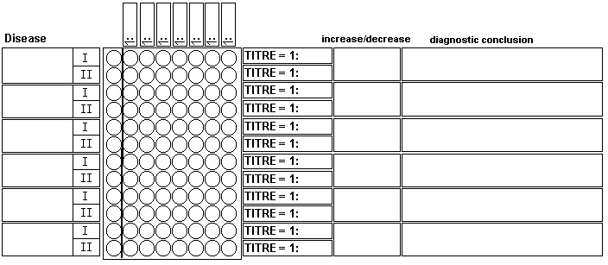

Task No. 6 Determing the titre of antibodies against the virus of the tick-borne encephalitis using the hemagglutination inhibition test (HIT).
The plate contains pairs of the sera from several patients with suspected tick-borne encephalitis. The las row contains the controls for antigen and for the red blood cells. Draw the results, recordthe dates of sampling in the table, and evaluate the finding. The highest dilution which prevents hemagglutination is considered the titer. In the first well the is 1:4.
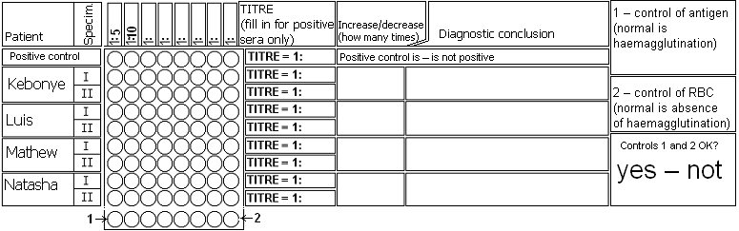

Check-up questions:
1. How electronoptic and optic microscopy can be used in virology?

2. What do mean terms „tissue culture“ and „cytopatic effect“?

3. What pathogenic agents (including non-viral) can be grown in chicken embryos, and what is the site of inoculation?

4. What viruses can be demonstrated in animals? What animals can be used?

5. What specimens and what methods are used in the virological diagnosis of influenza?

6. What methods for detection of viruses require two specimens and what is the ideal tie between taking the first and the second?

