Topic P05–06: Diagnostics of G– bacteria other than those from P04
To study: Haemophilus, Pasteurella, Pseudomonas, G– non fermenters, Neisseria, Moraxella, Legionella, Bordetella, Brucella, Francisella (from textbooks, WWW etc.)
From spring term: Microscopy, culture, biochemical identification, antigen analysis, antibody detection

Table for major results of Task 1 to Task 5 (to be filled step by step):
Strain |  |  | K | L | M | N | P | Q | R | S | T | U | V | W
Gram stain – Task 1

Cul-ture Task 2 | Growth on BA (Y/N#)
Cul-ture Task 2 | Growth char. on BA (ChA*)
Cul-ture Task 2 | Endo agar  (–/L-/L+)
Cul-ture Task 2 | MH agar (colour)
Task 3a Satelite phenomenon (+/–)
Task 3b Factor test (X, V, X + V)
Task 3c Capsullar type Haemophilus
3d Susc. test |  | Penic.
 |  | Vanco.
Glc fermentation
Task 4 (Hajna)
Oxidase test
Task 5a
NEFERMtest 24, NEISSERIAtest and INAC (Task 5b+c)
FINAL CONCLUSION
*Use ChA (Chocolat agar) for bacteria not growing on BA (blood agar)
#For a strain not growing on BA, but growing on BA+, write „+ only“

Task 1: Microscopy of suspicious strains
There are letter-labelled strains on the table. Gram-stain them and write your results to the table. Strain that is NOT G– should not be used in tasks 3 to 5 (but in Task 2 it should be described, for comparison)

Task 2: Cultivation on agar media
First write down, what bacteria do grow on blood agar and what bacteria do not. One strain would not grow on poor variant of blood agar, but it is able to grow on rather rich blood agar (BA+). Then, using standard procedure, describe colonies of all strains on blood agar. In strans that did not grow on blood agar, describe their growth on Chocolate agar or BA+ instead. Then describe growth of bacteria on Endo agar (only „–“ for not growing bacteria, „+“ for growing ones; lactose positivity/negativity cannot be seen, as the strains do not have isolated colonies) and on MH agar (only „–“ or „+“, and eventually presence of specific colour).

Task 3: Identification of Pasteurellaceae and their more precise determination

a) Satelite phenomenon in hemophili
Haemophili are typical by so named satelite phenomenon. That means that they are able to grow on blood agar, but in presence of a strain able to release growth factor from haemophili. Usually Staphylococcus aureus is used fot this purpose. Draw the satelite phenomenon and connect the terms below with the features on your picture
Colonies of
haemophili
Staphylococcus aureus

b) Identification of the hemophili on the basis of growth factors necessity

Determine the given strains according to their requirements of growth factors. Draw the growth factor tests for both strains.

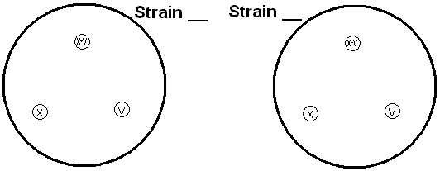

c) The detection of H. influenzae capsule antigens

Describe the result of agglutination of H. influenzae capsule antigens by means of latex agglutination.

d) The detection of P. multocida using typical antibiotic susceptibility pattern

Very typical for P. multocida is its susceptibility to penicilin, very rare among G– rods. On the other hand, it is resistant to much stronger (but for G+ bacteria only) antibiotic – vancomycin. Fill the table

Task 4: Hajna medium
Observe the results of culture of four strains on Hajna medium. Mark strain able to ferment glucose (yellow colour) as „+“, strains unable to ferment it (red colour) as „–“

Task No. 5 Determination of G– glucose non-fermenters and G- cocci

a) Oxidase test
Demonstration of oxidase test for three strains shown to be G– non-fermenters, and for all strains shown to be G– cocci (neisseriae or moraxellae). Write down your results to the table.
For G– non fermenters: Pseudomonas, should be allways positive, Burkholderia is usually positive, too, but not necesarilly; on the other hand, Stenotrophomonas uses to be negative. Oxidase postitive bacteria with typical odour and pigmentation (mostly green, less often blue of maroon) is quite sure Pseudomonas aeruginosa. In this bacterium it is not necessary to perform furhter biochemical testing, described in Task 5a. In other two strains this biochemical testing is necessary.
For G– cocci: Both Neisseria and Moraxella use to be oxidase positive, although in Moraxella it is possible to see slightly delayed reaction.

b) Detailed biochemical testing
Evaluate given results of NEFERMtest 24, beeng incubated two days berfore (difference from other bicochemical tests) at 30 °C (again a dífference, other test require 37 °C). The way of code counting is different, too, as there are three rows in the test. Allways upper row is „1“ when positive, medium row is „2“ and lowest one „4“. First number is for oxidase test: write „1“, when positive, and „0“, when negative. Results of „B“ and „A“ collumns are NOT used for code counting. So, you obtain 7 position code: first number is „0“ or "1“, and six more positions are for results of tests in collumns H to C.
Strain: |  | OX | H | G | F | E | D | C | B | A | Code:
 | 1 |  |  |  |  |  |  |  |  |  | Identification:
 | 2 |  |  |  |  |  |  |  |  |  | % of probability:
 | 4 |  |  |  |  |  |  |  |  |  | Typicity index:
 | Code
Strain: |  | OX | H | G | F | E | D | C | B | A | Code:
 | 1 |  |  |  |  |  |  |  |  |  | Identification:
 | 2 |  |  |  |  |  |  |  |  |  | % of probability:
 | 4 |  |  |  |  |  |  |  |  |  | Typicity index:
 | Code

Evaluate also results of NEISSERIAtest (Lachema). Here it is much simplier, the test has one row only. The test was inoculated one day before. Read it according to the scheme. The first well contains a negative control, so the proper test starts in the SECOND well! Dropping of Lugol solution was allready done, you should not do it yourselves. Remark low biochemical activity of some Neisseria. Compare the result with cultivation conditions (the strain, found to be N. gonorrhoeae, shoud grow on chocolate agar only; the strain, found to be N. meningitidis, on chocolate and modified blood agar only).
Strain: | H | G | F | E | D | C | B | A
 | NEC |  |  |  |  |  |  |  |  | Code: | Identification:
 | × | 1 | 2 | 4 | 1 | 2 | 4 | 1
 | ×
Strain: | H | G | F | E | D | C | B | A
 | NEC |  |  |  |  |  |  |  |  | Code: | Identification:
 | × | 1 | 2 | 4 | 1 | 2 | 4 | 1
 | ×
Strain: | H | G | F | E | D | C | B | A
 | NEC |  |  |  |  |  |  |  |  | Code: | Identification:
 | × | 1 | 2 | 4 | 1 | 2 | 4 | 1
 | ×
Strain: | H | G | F | E | D | C | B | A
 | NEC |  |  |  |  |  |  |  |  | Code: | Identification:
 | × | 1 | 2 | 4 | 1 | 2 | 4 | 1
 | ×

c) Indoxylacetate test
The strain shown to be Moraxella catarrhalis could be identified also by a simplier way. Look at a demostration of indoxylacetate test (positive for M. catarrhalis, negative for Neisseria)

Task No. 6: Susceptibility tests of pathogenic bacteria to antibiotics
For time reasons, read only susceptibility tests of G– non-fermenters, although normally, of course, tests for pathogens from Pasteurellaceae family and G– cocci would be performed, too.

Test for Gram non-fermenters:
Strain →
Antibiotic  (full name) | Zone ∅ (mm) | Interpr. | Zone ∅ (mm) | Interpr. | Zone ∅ (mm) | Interpr.

Task No. 7 Direct detection of antigens of causative agents of meningitis in the cerebrospinal fluid (demonstration of a diagnostic kit and observation of a videoclip)
Meningococcal meningitis is a severe disease. It is not possible to wait for culture, so we need a quick diagnostic method. Besides microscopy, latex agglutination is one very important method for this purpose.

a) Demostration of a latex agglutination kit
Observe the kit and write down the names of bacteria that can be found using this method.

b) Videoclip
Look at the videoclip. In our example, the pathogen was found to be __________________________________

Task No. 8 Diagnostics of Bordetella, Brucella, Legionella and Francisella

a) Culture diagnostics of Bordetella
There is a special medium for Bordetella pertussis, an a special way of inoculation is used here. Unlike many other bacteria, Bordetella is resistant to penicillin; so we start by making a drop of penicillin solution in the middle of the agar plate. The swab is mixed with the drop, and inoculated in a spiral form. Then the loop is used to make radial rays. Write down the name of the medium, and re-draw the way of its inoculation from your slideshow.

Name of the medium: ____________________

b) Demonstration of a culture medium for Legionella
Observe the culture medium for Legionella. Write down some data about it:
Abbreviation | What the individual letters of the abbreviation mean | Colour

c) Antibody detection in tularemia
Indirect diagnostics of Francisella is done using aglutination. The wells wiht positive reaction show presence of aglutinate (larger target of irregullar shape), the wells with a negative reaction show bacterial sedimentation (smaller, intensivelly white round target).
For time reasons, the task is not performed.

d) A Thought for Brucella
Diagnostics of Brucella is difficult and it is not easy in practice, as diseases caused by Brucella are not common in today Central Europe. Nevertheless, brucellosis still exists in many parts of the world. It is necessary to know at least, what is the connection between the species and the host animal.
What to do: Connect a picture of a typical host withe the name of a corresponing species of Brucella.

Brucella mellitensis Brucella abortus Brucella suis

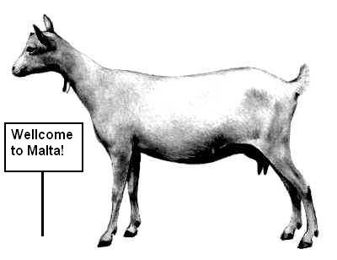
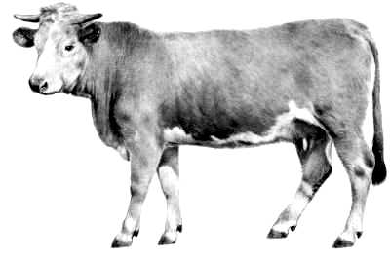
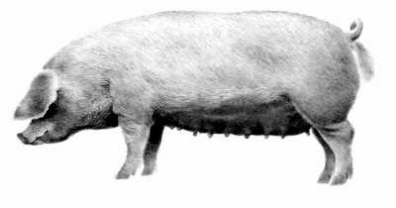

Check-up questions:
1. When are the hemophili able to growth on Blood agar? Why?

2. What is the most typical material for Pasteurella multocida findings?

3. Which hemophilus species is the most pathogenic? Which diseases it causes?

4. Why it is usually not necessary to perform NefermTest in Pseudomonas aeruginosa?

5. What are the most typical infections caused by G– non-fermenters?

6. What are the most recommended specimens for gonorrhoea diagnostics? And how should they be transported to the laboratory?

7. When taking CSF specimen, can you see any differences between healthy person and a person with purulent meningitis? (Just at the pacient, not in the laboratory.)

8. Neisseria and Moraxella are both gram-negative. Does this mean that they grow on Endo agar?

9. What causative agent of meningitis is the most common one in pre-scholar age, what in teens, what in elder people?

10. What is the most typical source of tullaremia infection?

11. There exist also gram-negative cocci and bacilli, that were not studied in practical lessons, but may be important. Find in textbooks or www, what diseases are caused by following microorganisms:

a) Bartonella quintana

b) Bartonella hensellae

c) members od HACEK group (and write also the names of all bacteria belonging to this group).

