Topic P08: Laboratory diagnostics of tuberculosis, actinomycetes and nocardiae
To study: Mycobacterium, Actinomyces, Nocardia (from textbooks, WWW etc.)
From spring term: Microscopy, culture, antibiotic susceptibility, PCR

Task 1: Microscopy of acid-fast and partially acid fast microoorganisms
While entirely acid-fast microorganisms (Mycobacterium) cannot be stained using Gram staining. only partialy acid-fast ones (Actinomyces, Nocardia) can be Gram strained, but they stain inconstantly; they also tend to have branched filamentous forms.

a) Staining of (negative) clinical material using Ziehl-Neelsen staining method
Ziehl-Neelsen staining is used for mycobacteria (M. tuberculosis, M. leprae), but also for some parasites (Cryptosporidium parvum, Cyclospora cayetanensis). The acid-fast organisms are stained only when heated during staining, but then they are not decororized even by acid alcohol (alcohol with a minaeral acid). Decolorized bacground is then counerstained.
________________________________________________________________________________
Stain the negative sputum according to the Ziehl-Neelsen method (methylene blue variant). It is not likely that acid-fast rods would be present. Observe in microscope (immersion). Draw the results; at least, you will see the bacground, e. g. leucocytes, epithelia and other objects. Do not forget do describe your picture (use lines)!
Describe also the staining procedure – fill in the following table with names of used reagents.
1. | During the staining the preparation is until
2. | This reagent is made of | and
3. | Instead of this reagent, it is also possible to use

b) Microscopy of a mycobacterial culture
________________________________________________________________________________
Examine microscopically (immersion oil, immersion 100× objective) the preparation of mycobacterial culture stained by Ziehl-Neelsen staining method.
Evaluate presence of red acid-fast rods.
Draw observed structures.
Do not forget do describe your picture (use lines)!

c) Microscopic examination of actinomycetes and nocardia strains
________________________________________________________________________________
Examine microscopically the slide stained by Gram. Describe and draw observed formations. Observe high polymorphism of the microorganisms (from coccal shape, through rods to fibre/strings, often branched; Gram-positive, but often staining half Gram-negative).
Do not forget do describe your picture (use lines)!

Task 2: Culture of mycobacteria, Actinomyces and Nocardia.
The culture requests of acid fast and partialy bacteria are very different.
- For Mycobacterium tuberculosis we use special media: liquid media (Šula) and solid media (Ogawa, Löwenstein-Jenssen). The solid media are different from majority of other solid media used in medical microbiology; they do not contain agar, they are „solid“ because of coagulated egg proteins. Before culture, the medium should be specially treated.
- For Nocardia a current blood agar is sufficient.
- For Actinomyces we need VL-agar and culture in anaerostat/anaerobic jar (see P07), as this organism is anaerobic.

a) Describe media for mycobacterial cultivation
Medium name | liquid/solid | colour | notes

b) Describe and draw the growth of Mycobacterium, Actinomyces and Nocardia on (in) given media
Bacterium | Medium name | Presence/absence of growth, eventually growth character  (use your own words to characterize the growth)
Mycobacterium
Actinomyces | blood agar
Actinomyces | VL agar
Nocardia | blood agar
Nocardia | VL agar

Task 3: Assessment of antimicrobial drugs susceptibility
For treatment of mycobacterial infections, it is necessary to use special drugs, called antituberculotics. The way of testing is different from other bacteria, too: antituberculotics are added directly to the culture media. On the oter hand, Actinomyces and Nocardia are treated by „normal“ antibiotics and also „normal“ diffusion disc test is used for testing.

a) Assessment of mycobacterial susceptibility to antituberculotics
By comparing with a control test-tube, read the results of antituberculotic susceptibility tests of Mycobacterium
tuberculosis strain.
Antituberculotic |  |  |  | Growth control
Growth Y/N
Interpretation

b) Antibiotic susceptibility of Nocardia and Actinomyces
Perform in vitro susceptibility testing of Nocardia and Actinomyces to suitable antibiotics.
Into the table, write the abbreviation of the antibiotics according to a card and for all tested strains measure the susceptibility zones. On your card, you have limit zones – according to them, interprete the zones as susceptible (S) resistants (R) and dubious (D).
Strain →
Antibiotic  (full name) | Zone ∅ (mm) | Interpretation | Zone ∅ (mm) | Interpretation

Task 4: PCR in diagnostics of TB
As the culture of mycobacteria is complicated, PCR becomes a very important method in its diagnostics.
Read a result of PCR TB diagnostics (from slideshow), write the results and interprete them.
Patient No. | Sample band | Control band | Interpretation
1
2
3
4

Task 5: Diagnostics of leprosy
Leprosy is a disease that still affects millions of people in uderdevelopped states. It diagnostics is very difficult. Fill in the following table.
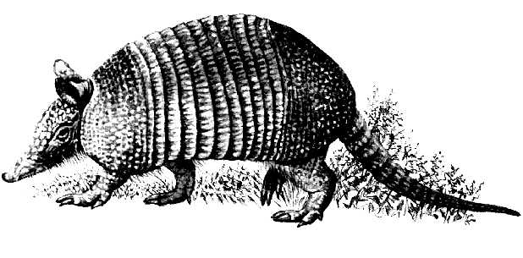 | The name of this animal is
 | It is used to produce
 | and this substance is used for
Picture source: http://www.1-costaricalink.com/costa_rica_fauna/nine_banded_armadillo.htm

Check-up questions:
1. Which samples are taken when there is a suspicion for TB?

2. How long does it take to culture of M. tuberculosis?

3. What is purpose the decontamination of a sample before culturing M. tuberculosis?

4. What is importance of Mantoux reaction and quantiferon (try this term in a www searching machine)?

5. In which conditions and how long do the nocardiae and actinomycetes grow?

6. What is ther reason for implementation of automatic culture in TB diagnostics?

7. In Task 4, how would „inhibition of reaction“ look like and what would be its interpretation?

8. For students with interest in microbiology only: Why it is necessary to check Mantoux reaction and quantiferon in persons treated by biologic treatment (monoclonal antibodies)?

