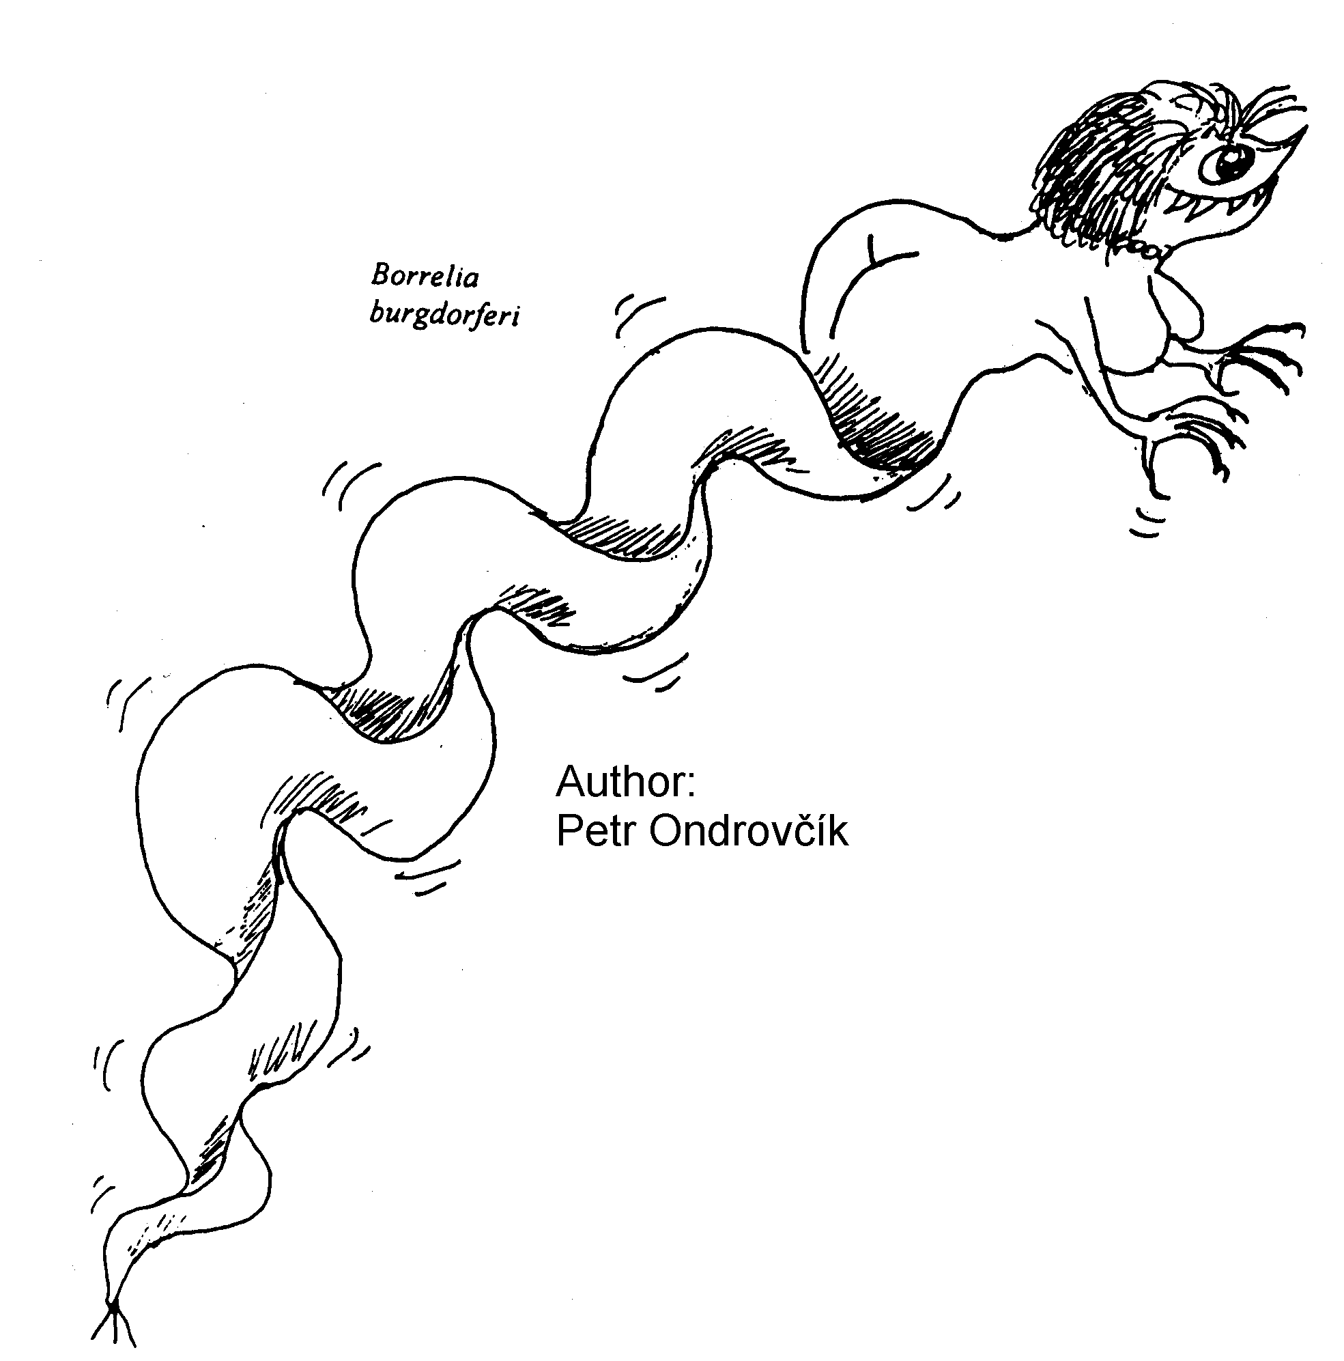
Topic P09: Diagnostics of spirochetal infections
To study: Borrelia, Leptospira,Treponema (from textbooks, WWW etc.)
From spring term: Microscopy, PCR, methods of decection of antibody and antigen

Lyme borreliosis
Common table for Task 1, 2 and 3.
Patient  Letter | Short clinical  description  (1–3 words characterizing the situation | ELISA (Task 1) |  |  |  | W. blotting (T2) |  | PCR  (T3)  (+/–) | Conclusion:  final interpretation, recommendation for event. therapy
Patient  Letter |  | IgM |  | IgG |  | IgM  (+/–) | IgG  (+/–) | PCR  (T3)  (+/–)
Patient  Letter |  | Abs. | (+/–) | Abs. | (+/–)
J
K
L
M
N

Task 1: Proof of antibodies to Borrelia garinii using ELISA
Read the results of patients with suspect Lyme borreliosis. Both IgG and IgM antibodies are assessed. In A1 field (corresponding to A1 well of the microtitration plate) you can see CAL level (borderline level; all absorbance levels above CAL are positive, all absorbance levels beneath CAL are negative). There are controls in B1 and C1. Patients J to N are in fields with coloured squares.
Write CAL level here, check, whether negative control is really negative and positive control really positive. Then read and interprete ELISA results for patients J, K, L, M, N (do not write them here, use main table above).
CAL level  (well A1): |  | K+ absorbance level (well B1): |  | ❒ K+ is OK   K+ is not OK | ←  tick what is correct
IgM |  | K– absorbance level (well C1): |  | ❒ K– is OK   K– is not OK | ←  tick what is correct
CAL level  (well A1): |  | K+ absorbance level (well B1): |  | ❒ K+ is OK   K+ is not OK | ←  tick what is correct
IgG |  | K– absorbance level (well C1): |  | ❒ K– is OK   K– is not OK | ←  tick what is correct

Task 2: Proof of antibodies to Borrelia garinii using Western blotting
In patients diagnosed in the task No.1, the serum samples or CSF were performed by Western blotting. Read results according to instructions. Use the given pattern for evaluation of the rection. A diagnostic scheme is always the same – ELISA is used for screening, whereas Western blotting is performed as a confirmation of ELISA results. Read the Western blot results of patients J to N and write the results to the main table.

Task 3: Diagnostics of Lyme borreliosis using polymerase chain reaction (PCR)
According to the given photos of PCR product on the agarose gel, draw and record which of the tested samples is positive. After that, interprete finally the total of all three examinations and write down a conclusion.

Syphilis
The causative agent of syphilis, Treponema pallidum, is NOT a culturable microoranism. The diagnostics is dependent on a stage of disease.

Task 4: Direct proof of syphilis

Direct proof of syphilis is only possible if suitable samples are sent to the laboratory. In some stages of the disease it is not possible to take anything for this purpose.


a) Rabbit infectivity testing – RIT
Write down the name of the rabbit used for the test.
(It is derived from these islands: →→→→→→→→→.)
Exsudate from a suspect ulcer uses to be evaluated by darkfield microscopy and inoculated to rabbits testes. The tested animal starts to suffer from orchitis after 10 days after inoculation. Rabbit name:

b) Darkfield microscopy
Look at the microphotography of treponemas taken from a darkfield microscope, draw the principle of darkfield microscopy, and also record your observation.

c) Direct immunofluorescence
Look at the microphotography of treponemas taken from a fluorescent microscope and record your observation.
4b) principle | 4b) result | 4c)

Indirect diagnostics of syfilis
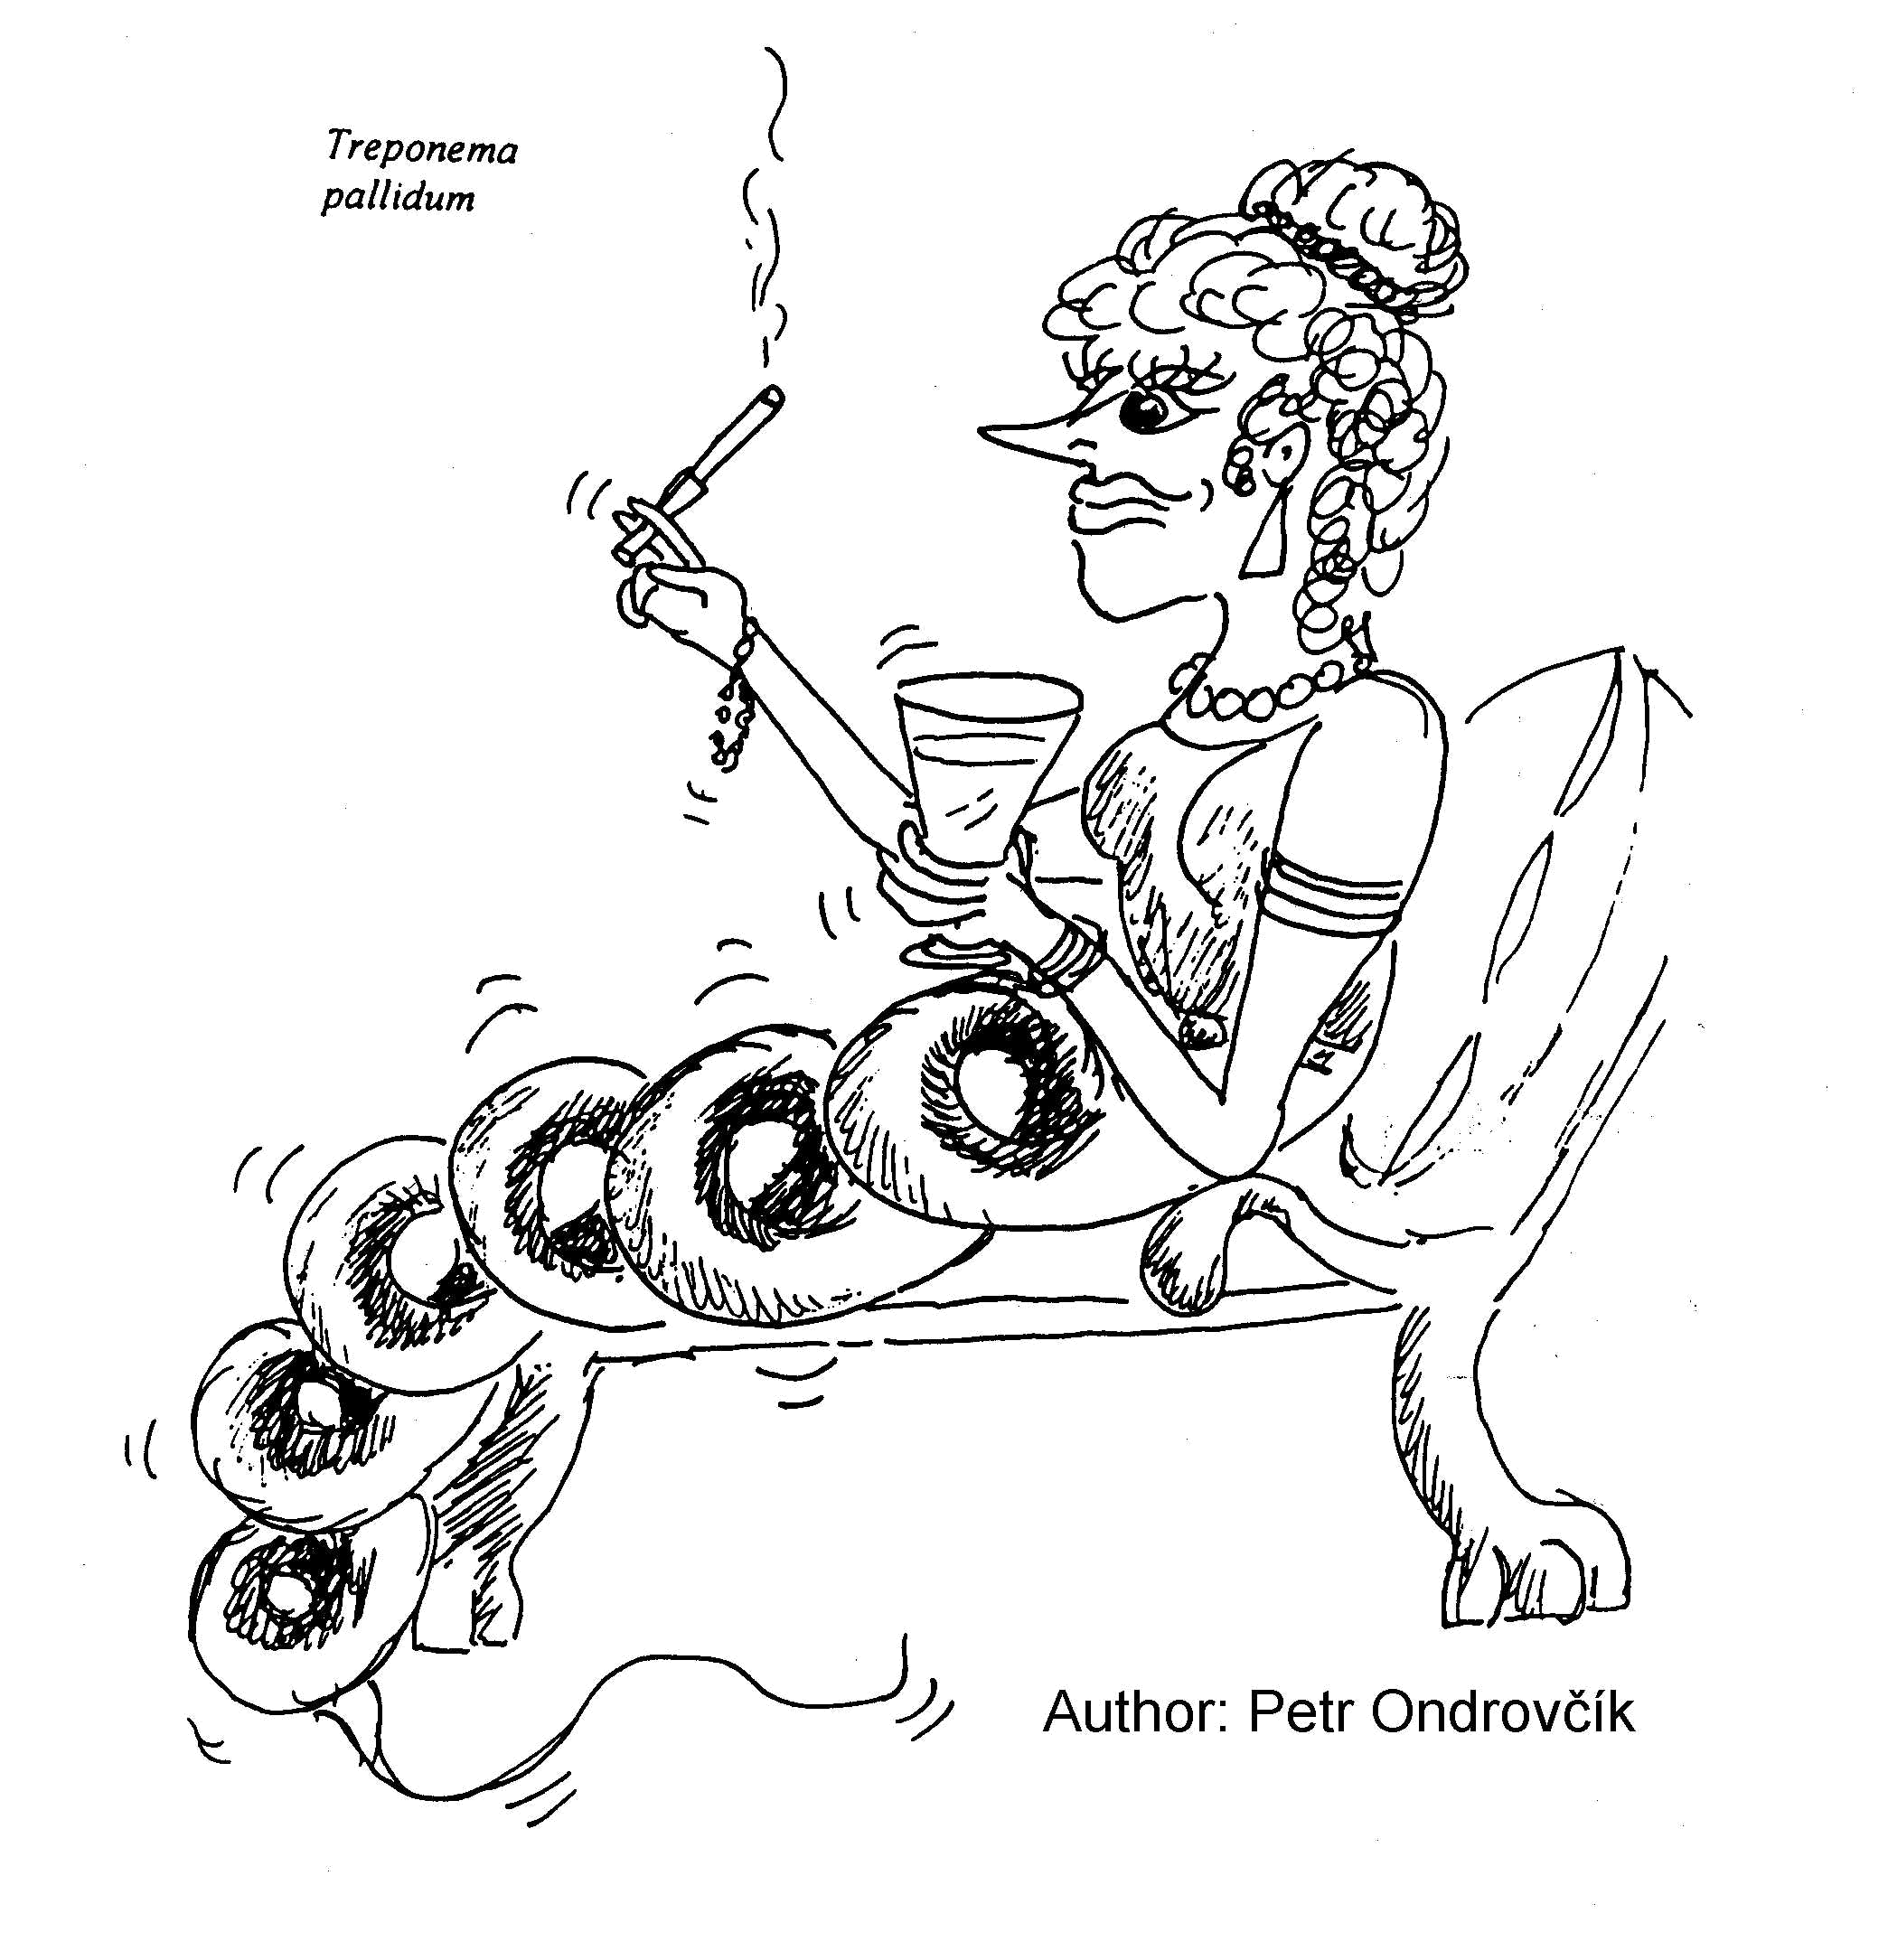
Common table for Task 5 and 6.
Patient  Letter | Short  clinical  characterisation | Task 5  screening |  | Task 6  confirmation |  |  |  |  |  |  | Conclusion:  final interpretation, eventually recommended therapy
Patient  Letter | Short  clinical  characterisation | RRR | MHA-TP | FTA-ABS | ELISA |  |  |  | WB
 |  |  |  |  | IgM |  | IgG |  | IgM (+/–) | IgG (+/–)
 |  |  |  |  | Absor- bance | (+/–) | Absor- bance | (+/–) | IgM (+/–) | IgG (+/–)

A
B
C
D
E

Task 5: Screening of syphilis – RRR and MHA-TP
Pregnant women and blood donors undergo a screening using rapid reagin reaction (RRR) and Treponema pallidum microhemagglutination (MHA-TP). Read results of screening in a given group of persons and assess who of them need to be tested using confirmation tests. Record your results directly into the table.
RRR: floculation in the well is positive; MHA-TP: agglutinate formation positive (see practical J07).

Task 6: Confirmation of syphilis – FTA-ABS, ELISA and Western blotting
Evaluate the results of FTA-ABS, ELISA a western blotting (WB) in patients who are suspect of syphilis (see the previous task). In ELISA reaction, count the cut-off and compare K–, + and patient values with it.
A1 field (A1 well) represents the blank.
Cut off level (C1 + D1) / 2 |  | K– absorbance level (B1 value): |  | ❒ K– is OK   K– is not OK | ←  tick what is correct
IgM |  | K+ absorbance level (E1 value): |  | ❒ K+ is OK   K+ is not OK | ←  tick what is correct
Cut off level (C1 + D1) / 2 |  | K– absorbance level (B1 value): |  | ❒ K– is OK   K– is not OK | ←  tick what is correct
IgG |  | K+ absorbance level (E1 value): |  | ❒ K+ is OK   K+ is not OK | ←  tick what is correct

Leptospirosis
Task 7: Direct proof of Leptospira sp.
According to a given picture, describe and draw morphology of leptospires cultivated in the liquid Korthoff's medium for 2 weeks. Urine of a patient who is suspect of leptospirosis was used for the test.
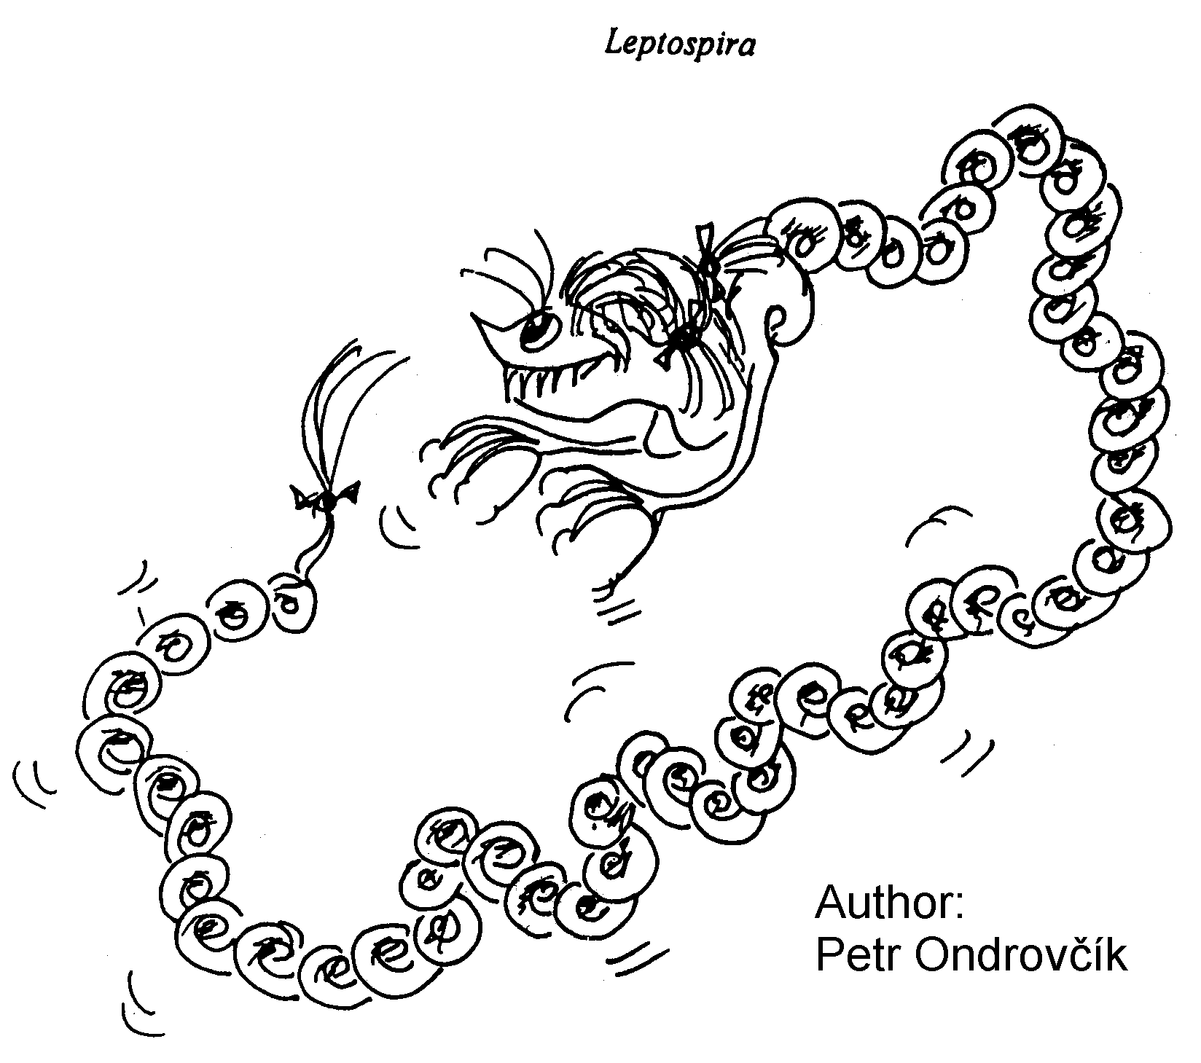

Check-up questions:

1. What is the basic limitation in diagnostics of spirochetal infections in comparison with common bacterial infections?

2. A patient had a tick two days in his fossa poplitea. The tick was extracted and the doctor decided to take blood "for Borrelia". What type of diagnostics was meant by this and what finding can be supposed in this case?

3. Why materials with findings of antiborrelial antibodies are usually re-examined by Western blotting?

4. What are possible specimens for direct diagnostics of syfilis?

5. Does have a sense to use PCR method for testing seronegative patients (not having anti-borrelial antibodies)?

6. Do we perform antibiotic susceptibility testing in agents of spirochetal infections?

7. In a pregrant woman, RRR was found to be positive. What would be the interpretation, eventually what more tests would be required?

8. Should be syfilitics at control testing allways re-tested by all serological tests?

9. What reaction is the best to assess the activity of syphilis?

