Topic P10+P11: Basics of clinical mycology and parazitology
To study: Fungi
From spring term: Microscopy, culture, antibiotic susceptibility, precipitation

Table for major results of Task 1 to Task 3 (to be filled step by step):
Strain |  | K | L | M | N
Gram stain – Task 1

Culture (blood agar) Task 2a | Size
Culture (blood agar) Task 2a | Colour
Culture (blood agar) Task 2a | Shape
Culture (blood agar) Task 2a | Profile
Culture (blood agar) Task 2a | Haemolysis
Culture (blood agar) Task 2a | Surface
Culture (blood agar) Task 2a | Odour
Task 2b: growth on Sabouraud + chloramphenicol (growth +/–)
Task 2c: growth on a chromogenic medium
FINAL CONCLUSION (according to Task 2c/Task 3)

Task 1: Microscopy of strains of bacteria and yeasts
Gram stain given cultures of microorganisms. Use immersion microscopy (immersion objective magnifying 100×). Write down your results to the table. Remark size differences between yeasts and bacteria

Task 2: Culture of bacteria and yeasts

a) Culture on blood agar
Describe colonies of given strains on blood agar and fill in the main table. Do not forget to describe odour. Remark, that colonies of yeasts (according to Task 1) are simillar to colonies of some bacteria (especially to the colonies of G+ cocci, likely to be staphylococci according to the morphology of colonies).

b) Culture on Sabouraud agar with chloramphenicol
Evaluate growth of given strains on selective agar for yeasts and molds (Sabouraud agar with chloraphenicol). Sabouraud agar itself is not selective, but it is made selective with help of a broad-spectre antibiotic (chloramphenicol).

c) Culture on a chromogenic medium
Chromogenic media for yeasts enable differentiation of the most important species of Candida genus. With the help of control strains, try to assess species of Candida using the chromogenic medium. If the colonies are white (no colour substance present), it means, that the strain cannot be differenciated using this chromogenic medium.

Task 3: Auxacolor
Read the results of Auxacolor for the strain that could not be differenciated using chromogenic medium. In this case, we do not count the code, but we compare the results with the table. (You might get more than one taxon. If so, remember, that C. albicans would be green in 2c) and Rhodotorula would be pigmented (red) in 2b.)
C Neg* | Glu** | Mal** | Sac** | Gal** | Lac** | Raf** | Ino**
Cel** | Tre** | Ado** | Mel** | Xyl** | Ara** | Act*** | Pox#
Result of identification:
*normally blue **yellow positive, blue negative
***yellow positive, colourless negative #brown positive, colourless negative

Task 4: Assessment of antimicrobial drugs susceptibility
For treatment of fungal infections, it is not possible to use antibiotics. We have to use special drugs – antimycotics. These, on the other hand, are not effective against bacteria.

a) Assessment of susceptibility to antimycotics
Perform in vitro susceptibility testing of given strains to antimycotics. Into the table, write the full name of the antimycotics according to a card and for all tested strains assess susceptibility or resistance. For Amphotericin B, the reference zone is 10 mm. For other antimycotics, it is 20 mm, but is is not necessary, that the inside of the zone is absolutelly clear.
Strain →
Antimycotic  (full name) | Zone ∅ (mm) | Interpretation | Zone ∅ (mm) | Interpretation

Strains ___ and ____ (i. e. strains of _____________________) are resistant to all given drugs.

b) Assessment of susceptibility to antibiotics
The task is not performed in today practical. Logicaly, bacterial strains would be susceptible to antibiotics, while fungal strains would be resistant.

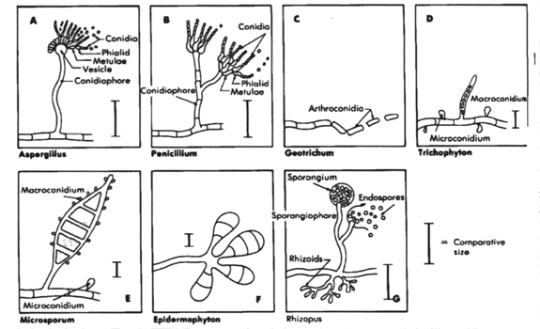
Task 5: Microscopy of molds
Molds are usually microscopied differently than yeasts. Gram staining is used rarelly. Mostly we use wet mount, objectives magnifying 10× to 40×.
In this double practical you would not microscopy fungi and draw their pictures. Only look at these pictures from www (address: http://www.atsu.edu/faculty/chamberlain/Website/Lects/Fungi.htm)

Task 6: Culture of molds
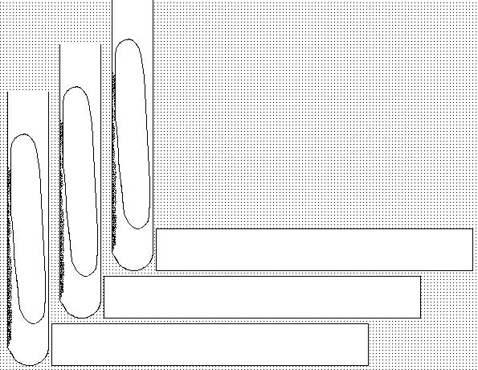
Molds usually require longer time to grow. That is why we mostly do not use Petri dishes for culture, but only test tubes (to avoid drying and contamination. Draw culture resuls of given molds.

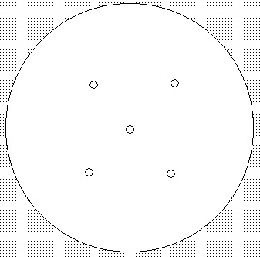
Task 7: Indirect diagnostics of aspergilosis
Evaluate results of precipitation in gel in order to diagnose antibodies in aspergilosis.
Draw the result.

Task 8: Sampling for mycoses
Basic rules for sampling in superficial mycoses are allready filled in in this double practical.
Particles of skin, parts of nails, hairs etc are sent; always the specimen should contain the site where the inflammation is active, and not to catch contamination; even surface disinfection is recommended (to destroy contaminants from skin surface).

Topic P11: Basics of clinical parasitology
To study: Protozoa, Nematoda, Cestoda, Trematoda, Arthropoda
From spring term: Microscopy, CFT, ELISA

Task 1: Sampling in medical parasitology

a) Sampling for intestinal parasites
Observe and draw the container for intestinal parasites. Remember, that it is not possible to use rectal swabs for parasitological examination. | 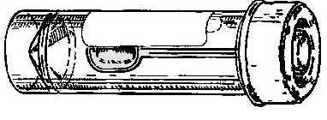 | Stool sample is not very suitable for detection of (name of a worm):
 |  | In this case, it is recommended to use rather (name of a method):

b) Sampling for blood parasites
Look at the videoclips and describe in one or two sentences, how to prepare a thick and a thin blood smear. In thin smear, draw the position of both slides at preparing.
Thick smear:  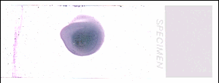 | Thin smear – description  make a drop, using another slide to spread latitudinally and then longitudinally | Thin smear – picture  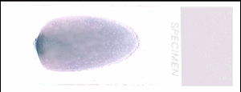

c) Other sampling methods
Connect with lines methods from the left collumn and sampling approaches in the rigth collumn.

diagnostics of toxoplasmosis
diagnostics of trichomonosis
diagnostics of urinary schistosomosis
diagnostics of giardiasis
diagnostics of acanthamoebiasis
sending used compact lenses
sending gastric juice (+ stool)
histological examination of urinary bladder tissue
sending C. A. T. swab + smear
sending blood for serology

Task 2: Microscopy of intestinal parasites

a) Kató preparation (stool of a healthy person)
The preparation was made by Kato method, which is thick smear of faeces covered with a cellophane sheet saturated with glycerine containing malachite green order to improve the visualization of certain structures. Examine the preparation, which was made by this method under the microscope at a magnification of objective 20× (no oil immersion). Note the fat globules and granules that resemble the ova of parasites. Learn these structures and draw your result.

b) Faust concentration method (stool of a healthy person)
Examine the demonstrated materials and draw and describe the principle of the Faust concentration method. Examine the preparation, which was made by this method under the microscope at a magnification of objective 20× (no oil immersion). Draw your result.

c) Graham method (with presence of pinworm eggs)
Presence of the pinworm eggs is examined by Graham‘ s method – tape is impressed on unwashed peri-anal skin and stick on slide. Examine the eggs of pinworm, under the microscope at a magnification of objective 20× (no oil immersion). Draw the result of observation.
Kató preparation | Faust preparation | Faust – principle | Graham method

Task 3: Demonstration of parasites, their ova and life cycles

a) Demonstraion of parasital preparations
Look at preparations of parasites conservated by ethanol and draw and describe two of them.
________________________________________________  ________________ | ________________________________________________  ________________

b) Demonstraion of parasital pictures, pictures of their ova and life cycles
Add missing descriptions to your pictures (in the first part, write allways parasite name + stage of development)
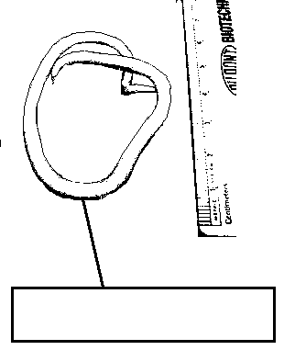
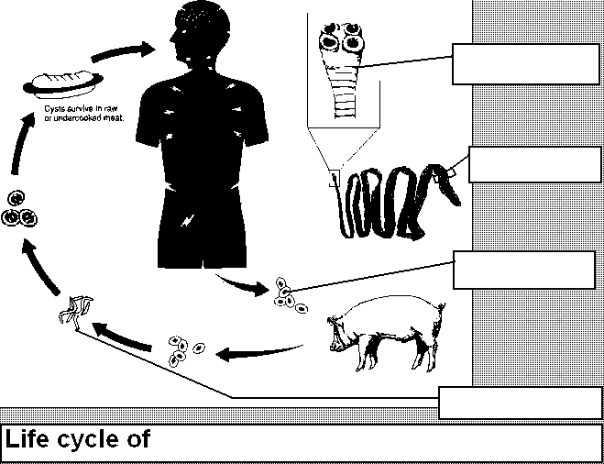
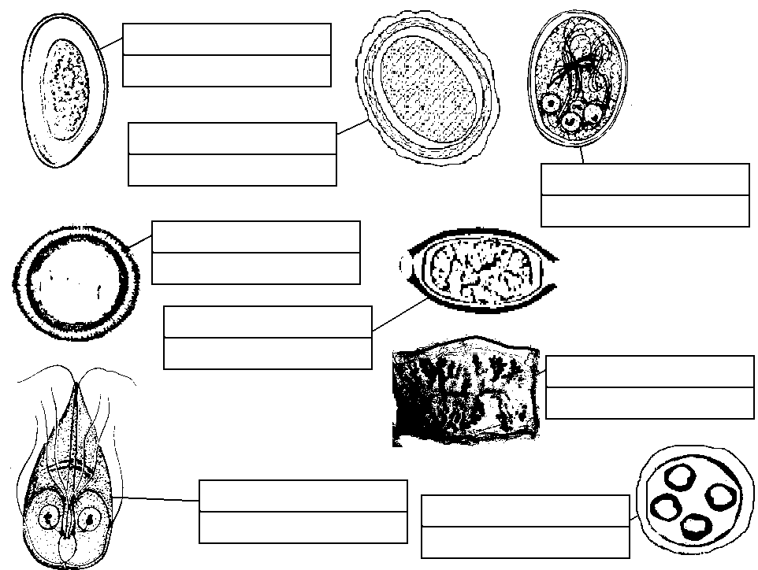

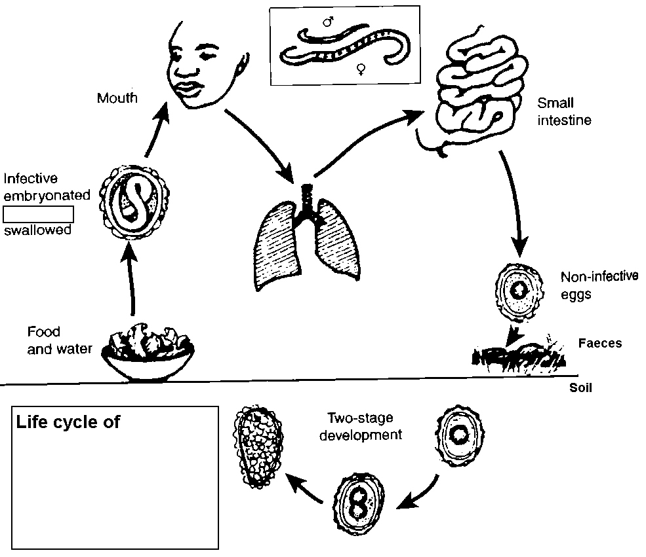
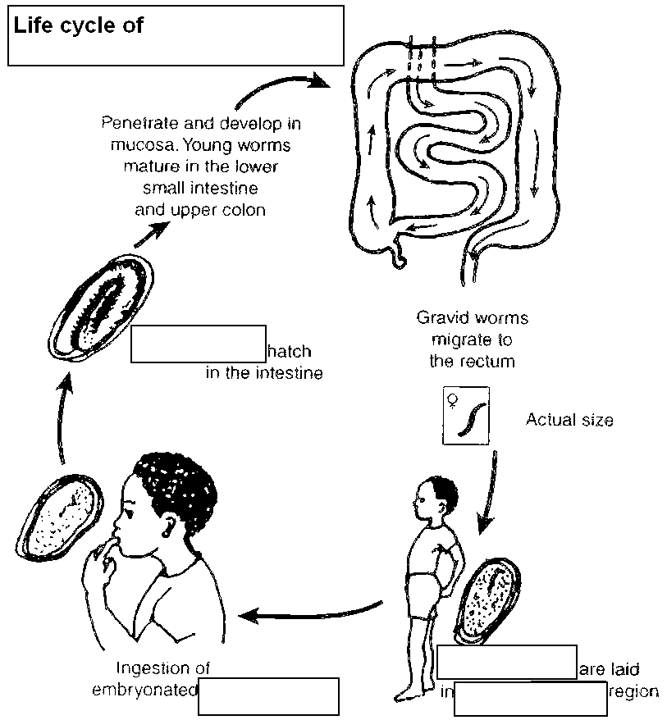

Task 4: Microscopy of Trichomonas vaginalis
T. vaginalis
________________________________________________
________________
Examine a Giemsa stained vaginal smear. Find the protozoon T. vaginalis in the specimen. This protozoon is of ovoid shape, about 10times larger than bacteria, light blue in colour with red elongated and pointed nucleus. It is necessary to differentiate 1) epithelial cells (different in colour); 2) leukocytes (less cytoplasm, usually wrinkled nucleus). Describe also all other obbserved objects (yeasts, bacteria, epitelial cells, white blood cells). In bacteria remark morphology.

Task 5: Diagnostics of malaria

a) Microscopy of a malaric thin smear
This part is cancelled in the double-practical

b) Evaluation of stages of parasite
Fill in the description fields to individual pictures. Use words: schizont, early trophozoite, gametocyte, merozoites, late trophozoite.
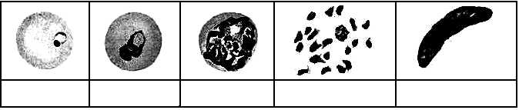

Task 6: Diagnostic of Toxopalsma gondii by serological tests
We work with following sera, coming for serological examination:
P: screening of a 29-years old healthy pregnant woman, no clinical problems, two cats at home
Q: screening of another, 24-years old healthy pregnant woman, no clinical problems, no cats
R: young lady, student, 21-years old, spending her free time by trekking in forests, no cats, two weeks ago started to be tired, enlarged lymphonodes
S: retired man, 65-years old, living in a vilage his hobby is working in garden, cats often walk through his garden; symptomatology of chorioretinitis, other causative agents than Toxoplasma excluded already

a) Complement-fixing test

Read CFT titres in sera of clients P, Q, R, S tested for andibodies against by Toxoplasma gondii. The first dilution is 1:5 an then the dilution continues in geometric series. Carefully evaluate controls of anticomplementarity. Draw a result and write titer.

b) ELISA test for demonstration IgA antibodies
The results of the ELISA for IgA antibodies against T. gondii in patient sera are demonstrated on a serological plate. The measured results of optical density are on enclosed paper. According to learners directions. Well A1 is a blank. Calculate the cut off (average of both c. o. values, i. e. wells C1 and D1) and determine optical density of negative (B1) and positive (E1) controls.
Write down the interpretation for both parts of the task (a + b)
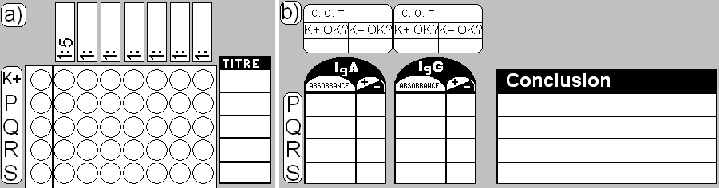

Technical note: If you would have not enough time, finish tasks No. 13, 15 and 17 at home.

Pictures concerning parasites were created by O. Z. with use of pictures from following websites:

http://creatures.ifas.ufl.edu
http://www.apartmenttherapy.com
http://www.bed-bug.org
http://www.dkimages.com
http://www.aaainsectpestcontrol.com
http://encyklopedie.divoch.info
http://www.wikieducator.org
http://pedagogie.ac-montpellier.fr
http://www.humanillnesses.com
http://upload.wikimedia.org
http://www.wadsworth.org
http://teaching.path.cam.ac.uk
http://www.wikieducator.org
http://www.cmpt.ca
http://pathmicro.med.sc.edu
http://www.bushwalking.org.au
http://picasaweb.google.com

Task 7: Diagnostics of ectoparasites

a) Survey of ectoparasites
Connect the pictures with corresponding names of ectoparasites in latin and in English (or encircle them by the same colour, label with the same nubers etc.)
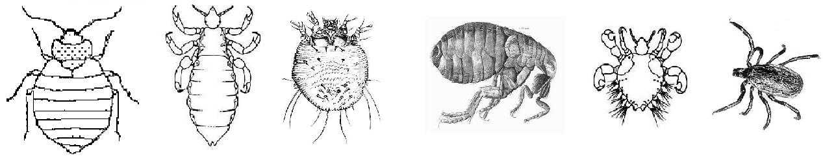

Hard tick Flea Itch mite Head louse Bed bug Crab louse

Phthirus Ixodes Cimex Pediculus Pullex Sarcoptes
pubis ricinus lectularius capitis irritans scabiei

b) A note to myiases
Just read the already written definition of a myiasis.
Myiasis is an animal or human disease caused by parasitic dipterous fly larvae feeding on the host's necrotic or living tissue. Colloquialisms for myiasis include flystrike and fly-blown. In Greek, "myia" means fly.

Check-up questions:
1. Name some antimycotics that could be used for surface mycoses

2. Name some antimycotis suitable for generalized candidoses and other systemic mycoses

3. What are suitable culture media and temperatures for pathogenic fungi?

4. What diseases are caused by protozoa of genus Leishmania?

5. Do you know some more bloodstream parasites besises malaric plasmodia?

6. Find in textbook, www etc. at least two staining methods for intestinal protozoa

7. What is the importance of Cyclospora cayetanensis and Cryptosporidium parvum? What staining method can be used for diagnostics of these organisms?

8. Do you know an example of artificial (iatrogenous) myiase used for treatment?

