Topic P10: Basics of clinical mycology
To study: Fungi
From spring term: Microscopy, culture, antibiotic susceptibility, precipitation

Table for major results of Task 1 to Task 3 (to be filled step by step):
Strain |  | K | L | M | N
Gram stain – Task 1

Culture (blood agar) Task 2a | Size
Culture (blood agar) Task 2a | Colour
Culture (blood agar) Task 2a | Shape
Culture (blood agar) Task 2a | Profile
Culture (blood agar) Task 2a | Haemolysis
Culture (blood agar) Task 2a | Surface
Culture (blood agar) Task 2a | Odour
Task 2b: growth on Sabouraud + chloramphenicol (growth +/–)
Task 2c: growth on a chromogenic medium
FINAL CONCLUSION (according to Task 2c/Task 3)

Task 1: Microscopy of strains of bacteria and yeasts
Gram stain given cultures of microorganisms. Use immersion microscopy (immersion objective magnifying 100×). Write down your results to the table. Remark size differences between yeasts and bacteria

Task 2: Culture of bacteria and yeasts

a) Culture on blood agar
Describe colonies of given strains on blood agar and fill in the main table. Do not forget to describe odour. Remark, that colonies of yeasts (according to Task 1) are simillar to colonies of some bacteria (especially to the colonies of G+ cocci, likely to be staphylococci according to the morphology of colonies).

b) Culture on Sabouraud agar with chloramphenicol
Evaluate growth of given strains on selective agar for yeasts and molds (Sabouraud agar with chloraphenicol). Sabouraud agar itself is not selective, but it is made selective with help of a broad-spectre antibiotic (chloramphenicol).

c) Culture on a chromogenic medium
Chromogenic media for yeasts enable differentiation of the most important species of Candida genus. With the help of control strains, try to assess species of Candida using the chromogenic medium. If the colonies are white (no colour substance present), it means, that the strain cannot be differenciated using this chromogenic medium.

Task 3: Auxacolor
Read the results of Auxacolor for the strain that could not be differenciated using chromogenic medium. In this case, we do not count the code, but we compare the results with the table. (You might get more than one taxon. If so, remember, that C. albicans would be green in 2c) and Rhodotorula would be pigmented (red) in 2b.)
C Neg* | Glu** | Mal** | Sac** | Gal** | Lac** | Raf** | Ino**
Cel** | Tre** | Ado** | Mel** | Xyl** | Ara** | Act*** | Pox#
Result of identification:
*normally blue **yellow positive, blue negative
***yellow positive, colourless negative #brown positive, colourless negative

Task 4: Assessment of antimicrobial drugs susceptibility
For treatment of fungal infections, it is not possible to use antibiotics. We have to use special drugs – antimycotics. These, on the other hand, are not effective against bacteria.

a) Assessment of susceptibility to antimycotics
Perform in vitro susceptibility testing of given strains to antimycotics. Into the table, write the full name of the antimycotics according to a card and for all tested strains assess susceptibility or resistance. For Amphotericin B, the reference zone is 10 mm. For other antimycotics, it is 20 mm, but is is not necessary, that the inside of the zone is absolutelly clear.
Strain →
Antimycotic  (full name) | Zone ∅ (mm) | Interpretation | Zone ∅ (mm) | Interpretation

Strains ___ and ____ (i. e. strains of _____________________) are resistant to all given drugs.

b) Assessment of susceptibility to antibiotics
Perform in vitro susceptibility testing of given strains to antibiotics. Into the table, write the abbreviation of the antibiotics according to a card and for all tested strains measure the susceptibility zones. On your card, you have limit zones – according to them, interprete the zones as susceptible (S) resistants (R) and dubious (D).
Strain →
Antibiotic  (full name) | Zone ∅ (mm) | Interpretation | Zone ∅ (mm) | Interpretation

Strains ___ and ____ (i. e. strains of _____________________) are resistant to all given drugs.

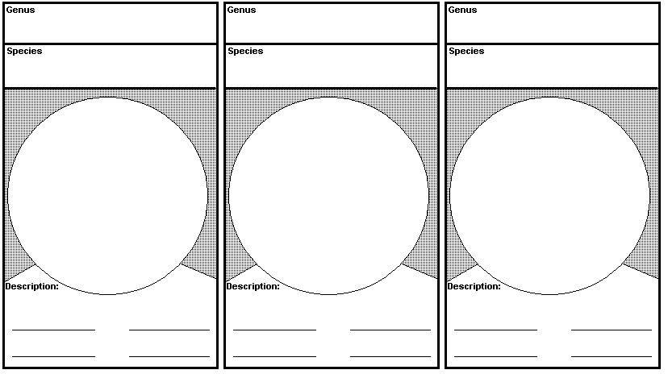
Task 5: Microscopy of molds
Molds are usually microscopied differently than yeasts. Gram staining is used rarelly. Mostly we use wet mount, objectives magnifying 10× to 40×. Draw and describe three given species of molds. Do not forget to describe hyphae, macro- and microconidiae and other observed objects. Use lines or numbers to connect description to the objects.

Task 6: Culture of molds
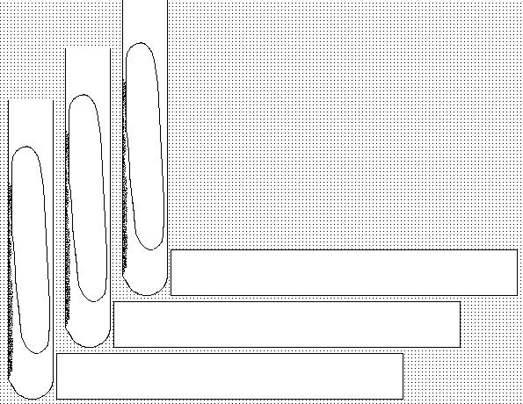
Molds usually require longer time to grow. That is why we mostly do not use Petri dishes for culture, but only test tubes (to avoid drying and contamination. Draw culture resuls of given molds.

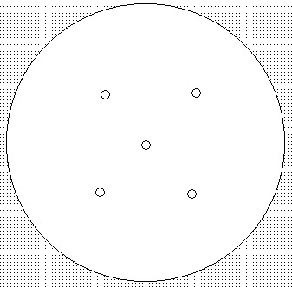
Task 7: Indirect diagnostics of aspergilosis
Evaluate results of precipitation in gel in order to diagnose antibodies in aspergilosis.
Draw the result.

Task 8: Sampling for mycoses
Look at the video „Sampling of cutaneous mycoses. Write down basic rules for sampling in superficial mycoses

Check-up questions:
1. Name some antimycotics that could be used for surface mycoses

2. Name some antimycotis suitable for generalized candidoses and other systemic mycoses

3. What is the growth time (in days, approx.) of

a) yeasts

b) zygomycets

c) aspergilli

d) dermatophytes

4. What are suitable culture media and temperatures for pathogenic fungi?

5. Name at least five factors helping systemic mycoses to get formed:

