Topic P11: Basics of clinical parasitology
To study: Protozoa, Nematoda, Cestoda, Trematoda, Arthropoda
From spring term: Microscopy, CFT, ELISA

Task 1: Sampling in medical parasitology

a) Sampling for intestinal parasites
Observe and draw the container for intestinal parasites. Remember, that it is not possible to use rectal swabs for parasitological examination. |  | Stool sample is not very suitable for detection of (name of a worm):
 |  | In this case, it is recommended to use rather (name of a method):

b) Sampling for blood parasites
Look at the videoclips and describe in one or two sentences, how to prepare a thick and a thin blood smear. In thin smear, draw the position of both slides at preparing.
Thick smear: | Thin smear – description | Thin smear – picture

c) Other sampling methods
Connect with lines methods from the left collumn and sampling approaches in the rigth collumn.

diagnostics of toxoplasmosis
diagnostics of trichomonosis
diagnostics of urinary schistosomosis
diagnostics of giardiasis
diagnostics of acanthamoebiasis
sending used compact lenses
sending gastric juice (+ stool)
histological examination of urinary bladder tissue
sending C. A. T. swab + smear
sending blood for serology

Task 2: Microscopy of intestinal parasites

a) Kató preparation (stool of a healthy person)
The preparation was made by Kato method, which is thick smear of faeces covered with a cellophane sheet saturated with glycerine containing malachite green order to improve the visualization of certain structures. Examine the preparation, which was made by this method under the microscope at a magnification of objective 20× (no oil immersion). Note the fat globules and granules that resemble the ova of parasites. Learn these structures and draw your result.

b) Faust concentration method (stool of a healthy person)
Examine the demonstrated materials and draw and describe the principle of the Faust concentration method. Examine the preparation, which was made by this method under the microscope at a magnification of objective 20× (no oil immersion). Draw your result.

c) Graham method (with presence of pinworm eggs)
Presence of the pinworm eggs is examined by Graham‘ s method – tape is impressed on unwashed peri-anal skin and stick on slide. Examine the eggs of pinworm, under the microscope at a magnification of objective 20× (no oil immersion). Draw the result of observation.
Kató preparation | Faust preparation | Faust – principle | Graham method

Task 3: Demonstration of parasites, their ova and life cycles

a) Demonstraion of parasital preparations
Look at preparations of parasites conservated by ethanol and draw and describe two of them.
________________________________________________  ________________ | ________________________________________________  ________________

b) Demonstraion of parasital pictures, pictures of their ova and life cycles
Add missing descriptions to your pictures (in the first part, write allways parasite name + stage of development)
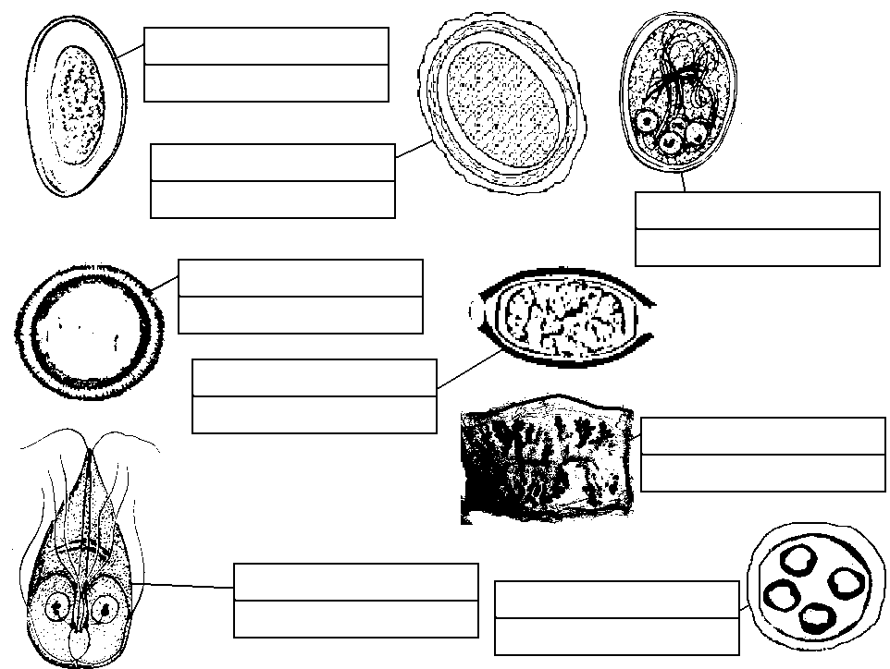

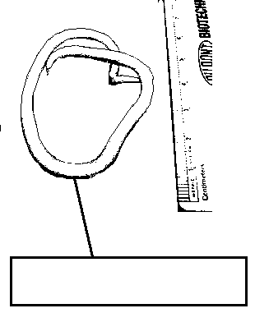
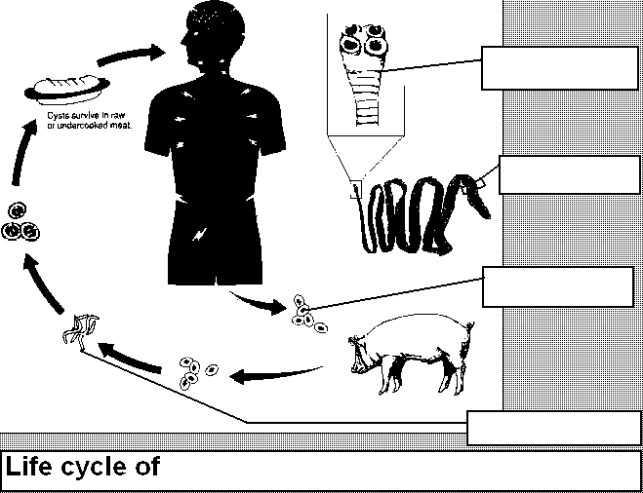

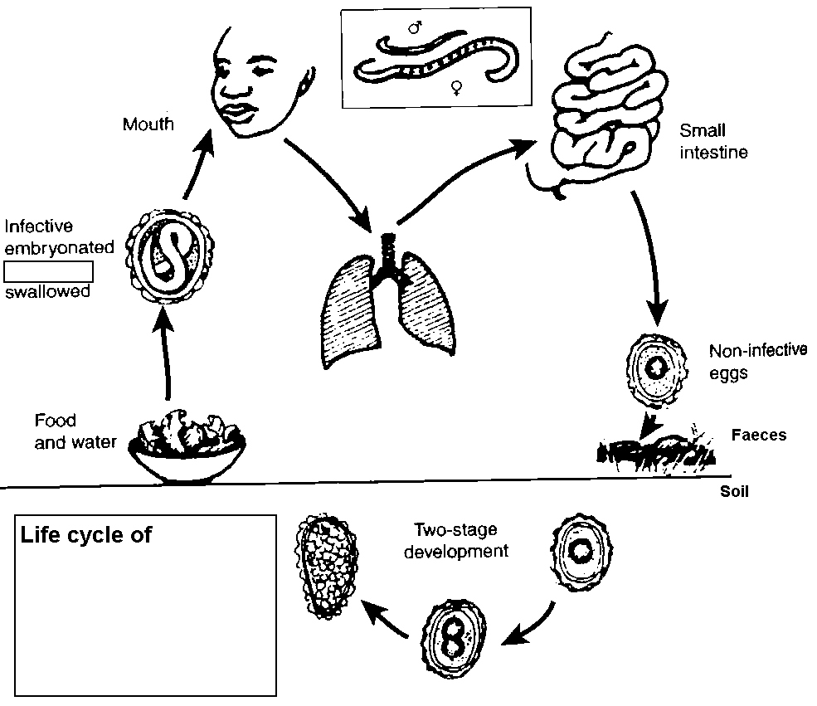
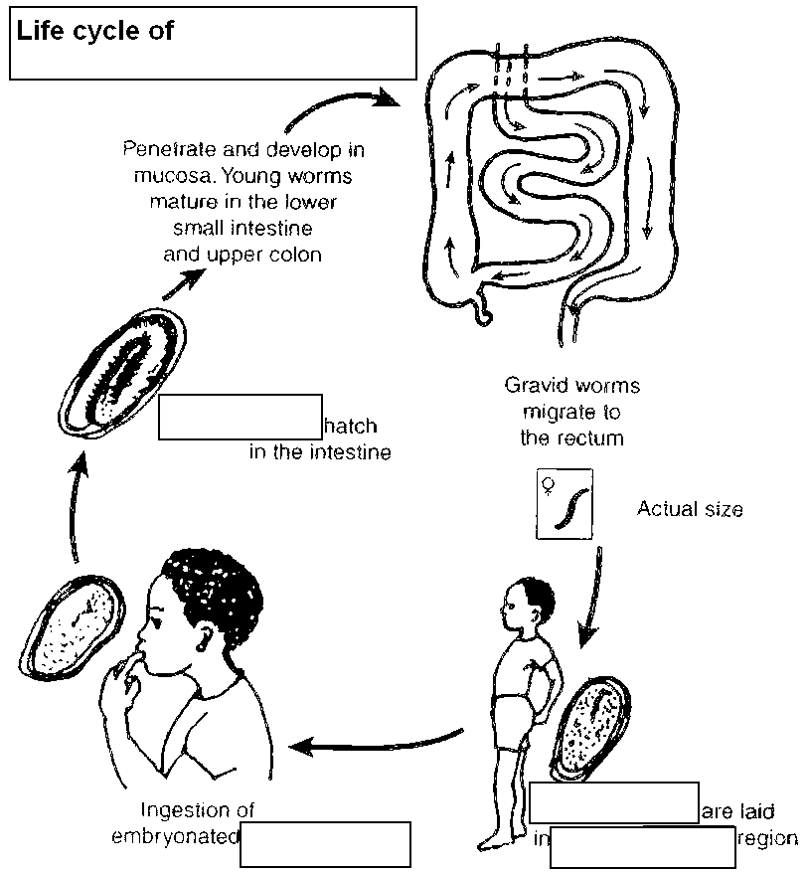

Task 4: Microscopy of Trichomonas vaginalis
Examine a Giemsa stained vaginal smear. Find the protozoon T. vaginalis in the specimen. This protozoon is of ovoid shape, about 10times larger than bacteria, light blue in colour with red elongated and pointed nucleus. It is necessary to differentiate 1) epithelial cells (different in colour); 2) leukocytes (less cytoplasm, usually wrinkled nucleus). Describe also all other obbserved objects (yeasts, bacteria, epitelial cells, white blood cells). In bacteria remark morphology.
T. vaginalis
________________________________________________
________________

Task 5: Diagnostics of malaria

a) Microscopy of a malaric thin smear
red blood cells
malaric plasmodium
________________________________________________
Observe a given preparation. Try to draw observed objects.
Avoid getting confused by artifacts, platelets and other objets appearing similarly like malaric plasmodia.

b) Evaluation of stages of parasite
Fill in the description fields to individual pictures. Use words: schizont, early trophozoite, gametocyte, merozoites, late trophozoite.
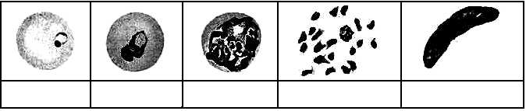

Task 6: Diagnostic of Toxopalsma gondii by serological tests
We work with following sera, coming for serological examination:
P: screening of a 29-years old healthy pregnant woman, no clinical problems, two cats at home
Q: screening of another, 24-years old healthy pregnant woman, no clinical problems, no cats
R: young lady, student, 21-years old, spending her free time by trekking in forests, no cats, two weeks ago started to be tired, enlarged lymphonodes
S: retired man, 65-years old, living in a vilage his hobby is working in garden, cats often walk through his garden; symptomatology of chorioretinitis, other causative agents than Toxoplasma excluded already

a) Complement-fixing test

Read CFT titres in sera of clients P, Q, R, S tested for andibodies against by Toxoplasma gondii. The first dilution is 1:5 an then the dilution continues in geometric series. Carefully evaluate controls of anticomplementarity. Draw a result and write titer.

b) ELISA test for demonstration IgA antibodies
The results of the ELISA for IgA antibodies against T. gondii in patient sera are demonstrated on a serological plate. The measured results of optical density are on enclosed paper. According to learners directions. Well A1 is a blank. Calculate the cut off (average of both c. o. values, i. e. wells C1 and D1) and determine optical density of negative (B1) and positive (E1) controls.
Write down the interpretation for both parts of the task (a + b)
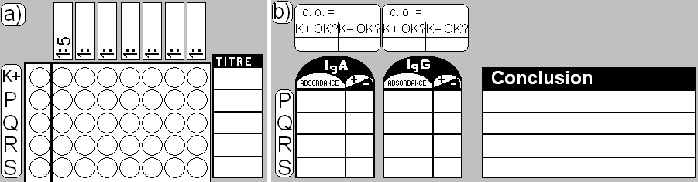

Task 7: Diagnostics of ectoparasites

a) Survey of ectoparasites
Connect the pictures with corresponding names of ectoparasites in latin and in English (or encircle them by the same colour, label with the same nubers etc.)
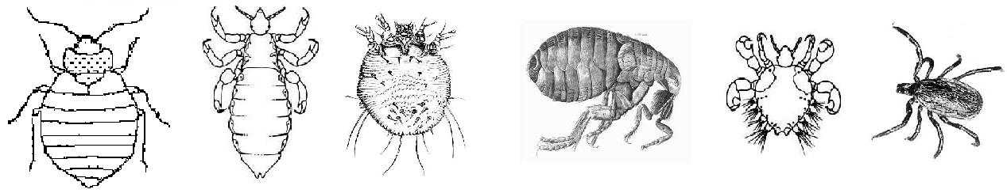

Hard tick Flea Itch mite Head louse Bed bug Crab louse

Phthirus Ixodes Cimex Pediculus Pullex Sarcoptes
pubis ricinus lectularius capitis irritans scabiei

b) A note to myiases
Look at the videoclip showing a case of a myiase. Write down a definition, what a myiase is.

Check-up questions:
1. What diseases are caused by protozoa of genus Leishmania?

2. Do you know some more bloodstream parasites besises malaric plasmodia?

3. Find in textbook, www etc. at least two staining methods for intestinal protozoa

4. What is the importance of Cyclospora cayetanensis and Cryptosporidium parvum? What staining method can be used for diagnostics of these organisms?

5. Write names of at leas three non pathogenic intestinal amoebae (may be confused with E. histolytica)

6. Name at least one disease transmitted by each of following vectors:

a) Glossina fly

b) Anopheles mosquito

c) Aëdes mosquito

d) Ixodes ricinus tick

e) Phlebotomus gnat

7. Do you know an example of artificial (iatrogenous) myiase used for treatment?

Picture concerning biofilm: Veronika Holá
Pictures concerning parasites were created by O. Z. with use of pictures from following websites:

http://creatures.ifas.ufl.edu
http://www.apartmenttherapy.com
http://www.bed-bug.org
http://www.dkimages.com
http://www.aaainsectpestcontrol.com
http://encyklopedie.divoch.info
http://www.wikieducator.org
http://pedagogie.ac-montpellier.fr
http://www.humanillnesses.com
http://upload.wikimedia.org
http://www.wadsworth.org
http://teaching.path.cam.ac.uk
http://www.wikieducator.org
http://www.cmpt.ca
http://pathmicro.med.sc.edu
http://www.bushwalking.org.au
http://picasaweb.google.com

