P 14 Clinical microbiology II
To study: Infections of various organs and organ systems (from textbooks, WWW etc.)
From spring term: Microscopy, culture, biochemical identification

Task 1: Search for respiratory pathogens in practical microbiology
With help of your teacher and the slideshow, describe following picture. Use the knowledge from this picture in following two tasks (Task 2 and Task 3)
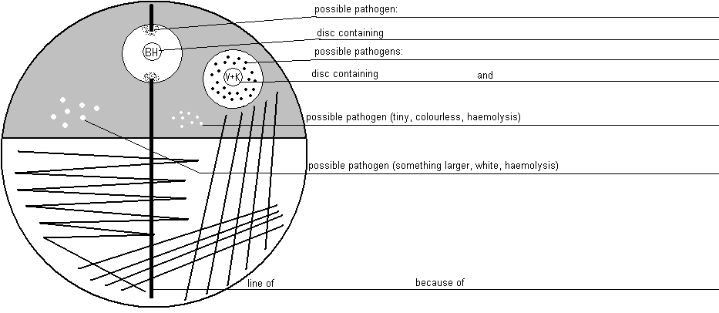
Common pharyngeal flora mostly consists of
a) _____________ appearance: ________________________
b) _____________ appearance: ________________________

Task 2: Case A
For this casuistic, documented by a the order form, try to examine corresponding sample (sputum), to find a pathogen and to make a conclusion and interpretation. Step by step, fill in the individual fields in the „screen of laboratory information system“
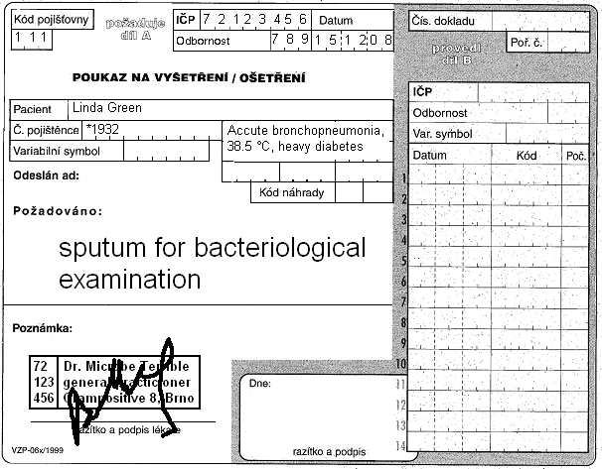

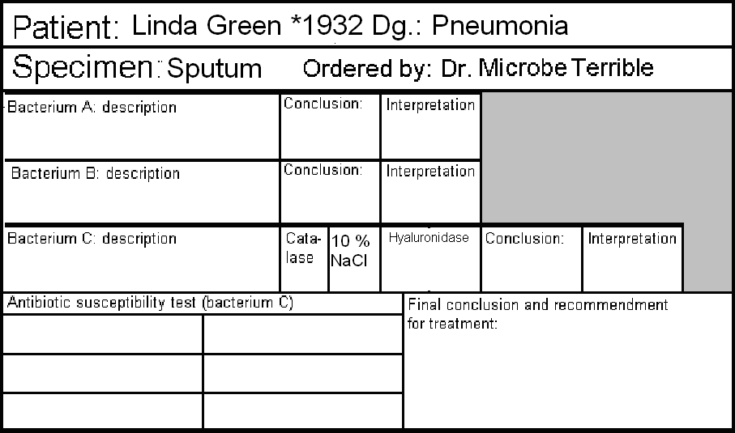
Microscopy result:
Epithelial cells:
WBCs:
Bacteria (describe):

a) Microscopy of sputum
Look at the smear prepared of your specimen. Try to find individual objects (bacteria, host cells). Fill in the field „Microscopy“:
+++ = more than 10 in the observation area
++ = less than 10 in the observation area
+ = only rare (one or less per an observation area)
0 = none

b) Description of bacteria
On blood agar, describe size, colour and haemolytical properties of given bacteria. Do not describe other characteristics. Take into account, that there was no growth visible on Endo agar. Bacteria A and B should be bacteria considered to be parts of normal flora. Bacterium C will be a pathogenic bacterium, that will be more tested in parts c) and d)

c) More tests
Fill in the results of catalase test, hyaluronidase test and growth on blood agar with 10 % NaCl for Bacterium C.

d) Antibiotic susceptibility
Fill in the antibiotic susceptibility test for Bacterium C. Write down allways name of antibiotic and „S“ or „R“ (susceptible or resistant). Reference zones are written on your table.

e) Final conclusion
Try to formulate several words for general practicioner. Especially try to find out (with help of your teacher) what antibiotics among susceptible ones would be the best antibiotic of choice.

Task 3: Case B
Also for this casuistic, documented by a the order form, try to examine corresponding sample (throat swab), to find a pathogen and to make a conclusion and interpretation. Step by step, fill in the individual fields in the „screen of laboratory information system“. The way of doing it is like in previous task.
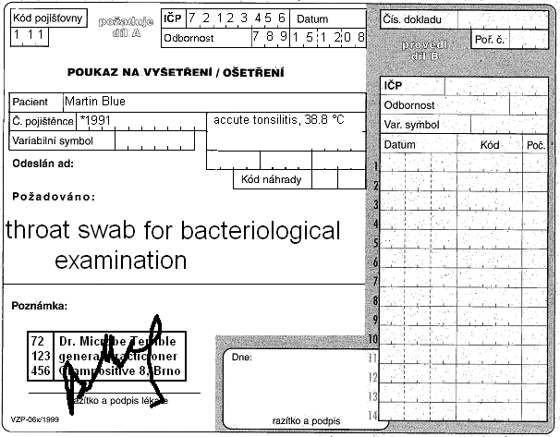

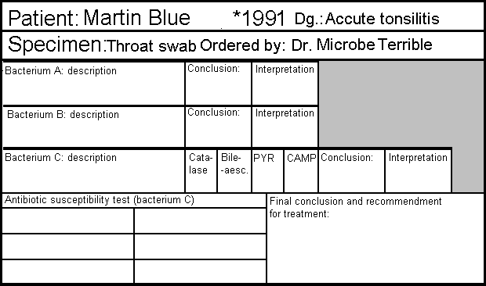

Task 4: Case C
In case of a wound swab, there is no „common flora“. That is the main difference between this task and previous task: it is not nesessary to search for a patogen among normal flora.
On the other hand, we use mostly more culture media to detect all possible pathogens, even if they would be mixed. Usually, we use blood agar with 10 % NaCl, but also blood agar with amikacin in order to search for streptococci and enterococci (but none of these media is used in our task).
Fill in the formular again.
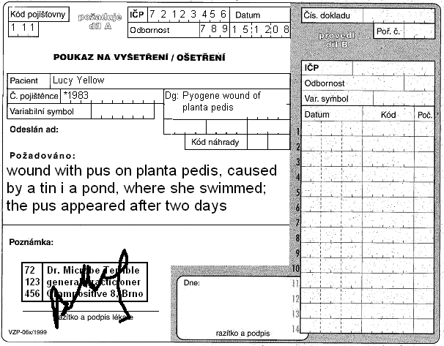
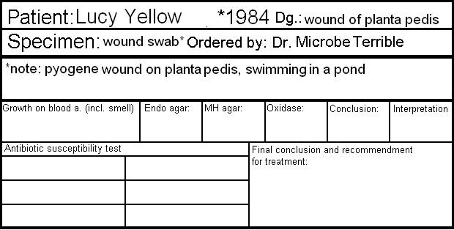

Task 5: Case D
In case of cystitis, there is one difference: the urine is examined (semi)quantitativelly.
Before solving the problem, try to fill in the following table (for finding of one only species).
Number of colonies on agar | Number of bacteria in one microliter (µl) | Number of bacteria in one mililiter (ml) | Interpretation
<10
10–100
>100
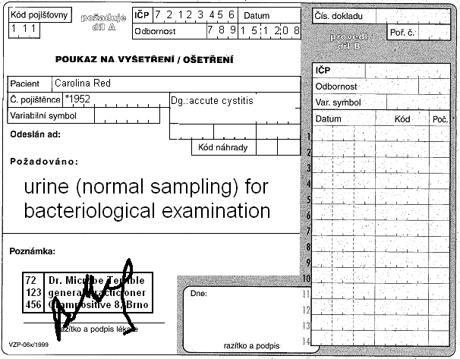
Form for results of Enterotest 16:
ONPG | 1H | 1G | 1F | 1E | 1D | 1C | 1B | 1A | 2H | 2G | 2F | 2E | 2D | 2C | 2B | 2A
+ | black | blue | red | blue | red | green | black | blue | blue | yellow | yellow | yellow | yellow | yellow | yellow | yellow
– | colourless | green | yellow | green | yellow | yellow | colourless | yellow | yellow | green | green | green | green | green | green | green
?
1 | 2 | 4 | 1 | 2 | 4 | 1 | 2 | 4 | 1 | 2 | 4 | 1 | 2 | 4 | 1 | 2
Code: |  |  |  |  |  | Identification |  |  |  |  |  | % prob. |  |  | T index

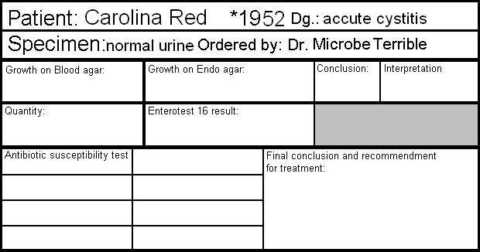

Check-up questions:
1. Why some samples (like sputum) are microscopied and some are not?

2. Why for each type of specimen another set of media is used?

3. Pathogens are usually susceptible to more than one antibiotic. Try to explain at least some factors for decision, what antibiotic should be used.

4. How would be the semiquantitative examination of urine be biased if the urine would not be properly taken and transported?

