Complications of Diabetes in the United States

Diabetes is associated with an increased risk for a number of serious, sometimes life-threatening complications and certain populations experience an even greater threat. Good diabetes control can help reduce your risk, however many people are not even aware that they have diabetes until they develop one of its complications.

Heart disease and stroke
- Heart disease and stroke account for about 65% of deaths in people with diabetes.
- Adults with diabetes have heart disease death rates about 2 to 4 times higher than adults without diabetes.
- The risk for stroke is 2 to 4 times higher and the risk of death from stroke is 2.8 times higher among people with diabetes.
Deaths from heart disease have decreased significantly among men with diabetes in recent years, but that trend has not been true in women. From 1971 to 2000, the rate of death from heart disease among men with diabetes decreased from 16.8 deaths per 1000 men to 8.1 deaths per 1000. Among women with diabetes, however, deaths from heart disease did not decline from 1971 to 2000, and the difference in death rate from all causes between diabetic and nondiabetic women more than doubled, from a difference of 8.3 to 18.2 annual deaths per 1000 women.

High blood pressure
- About 73% of adults with diabetes have blood pressure greater than or equal to 130/80 millimeters of mercury (mm Hg) or use prescription medications for hypertension.

Blindness
- Diabetic retinopathy causes 12,000 to 24,000 new cases of blindness each year making diabetes the leading cause of new cases of blindness in adults 20-74 years of age.
- In people with type 1 diabetes, therapy that keeps blood sugar levels as close to normal as possible reduces damage to the eyes by 76%. Experts believe that these results can also be applied to those with type 2 diabetes.

Kidney Disease
- Diabetes is the leading cause of kidney failure, accounting for 44% of new cases in 2005.
- In 2005, 46,739 people with diabetes began treatment for end-stage renal disease (ESRD).
- In 2002, a total of 178,689 people with ESRD due to diabetes were living on chronic dialysis or with a kidney transplant.

Nervous system disease
- About 60% to 70% of people with diabetes have mild to severe forms of nervous system damage. The results of such damage include impaired sensation or pain in the feet or hands, slowed digestion of food in the stomach, carpal tunnel syndrome, and other nerve problems.
- Almost 30% of people with diabetes aged 40 years or older have impaired sensation in the feet (i.e., at least one area that lacks feeling).

Amputations
- More than 60% of nontraumatic lower-limb amputations occur in people with diabetes.
- In 2004, about 71,000 nontraumatic lower-limb amputations were performed in people with diabetes.
- The rate of amputation for people with diabetes is 10 times higher than for people without diabetes.

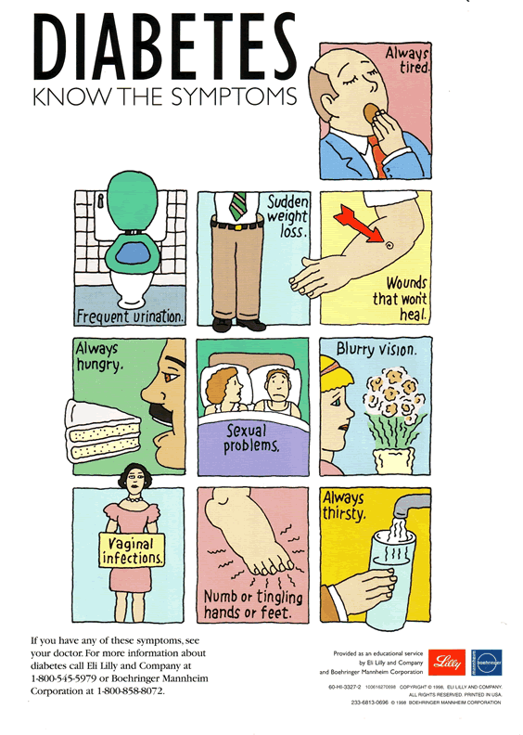
Article taken from http://www.diabetes.org/diabetes-statistics/complications.jsp
Picture taken from http://www.diabetesandrelatedhealthissues.com/

