DIABETES
Warm-up: What do you know about diabetes? Consider the types of diabetes, its causes and complications, and the treatment (the picture below will help you).
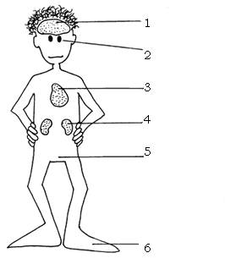
Do you know anybody who suffers from this disease? (Provide details: How long have they had it? What type of diabetes do they suffer from? How is their lifestyle different from that of a healthy person? )
Activity 1: Read the article “Complications of Diabetes in the United States” quickly. What do the following figures refer to?
Example: 65% - This is the percentage of deaths caused by heart disease and stroke in people with diabetes.
65% from 1971 to 2000 44%
46, 739 40 2004 10

Activity 2: Choose 5 figures from the text. Prepare questions so that your partner answers with the figure.
Example:
How many amputations were performed in people with diabetes in 2004? Around 71,000.

Activity 3: Read the article again. Find words which can complete the following definitions.
- A serious illness when a blood vessel in the brain bursts or is blocked. It can cause death or the loss of the ability to move or to speak clearly.
- High blood pressure.
- The state of not working correctly or as expected.
- To be the explanation or cause of something.
- A process for separating substances from a liquid, especially for taking waste substances out of the blood of people with damaged kidneys.
- Damaged or made worse.
- A measurement of the number of times something happens or exists during a particular period.

Follow-up:
Watch the following video “Delicious Diabetic Diets”. Make notes about new information/knowledge that you have learned from the video.
http://link.brightcove.com/services/player/bcpid1078549946?bclid=909933387&bctid=1126051447

Homework:
Watch more videos on diabetes from the follow-up activity or listen to a BBC health program about diabetes on this webpage:
http://www.bbc.co.uk/radio4/science/checkup_20060406.shtml
Prepare a short (two-minute) presentation about what new or important information you have learned from watching the videos or listening to the health program.

