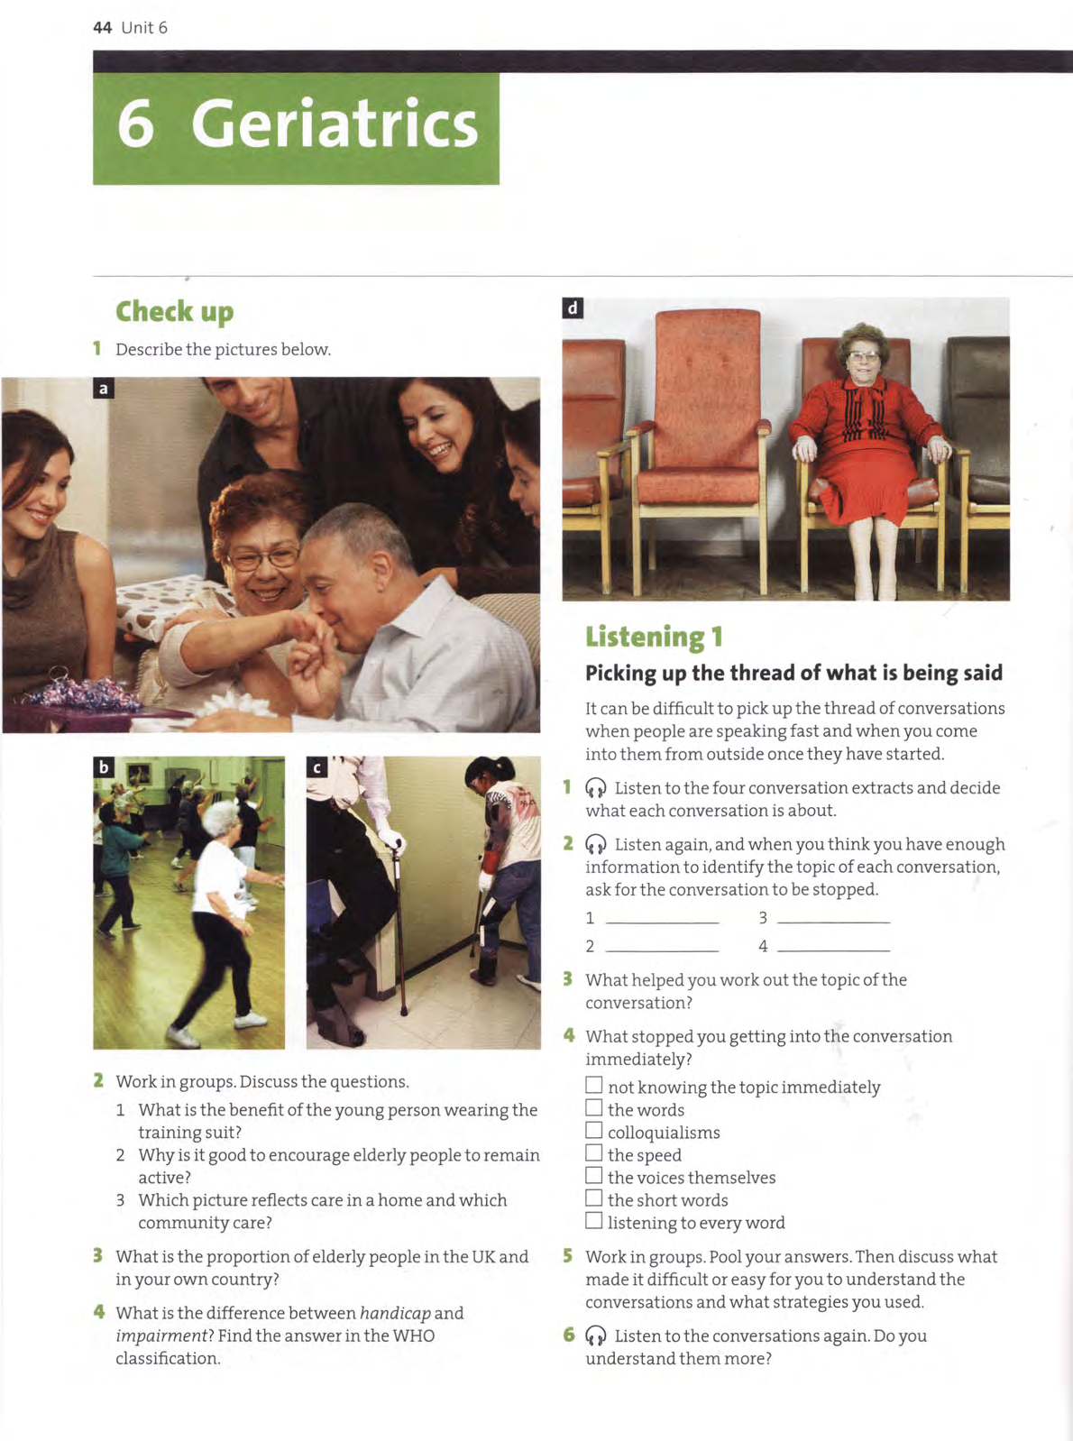

Taken from:
McCarter, Sam (2010) Oxford English for Careers – Medicine 2. Oxford: OUP.

