
BACK
Exercise 1 - warm-up: Describe the pictures. (As for the vertebrae – write their names and numbers)
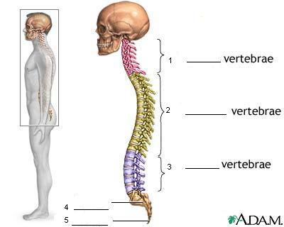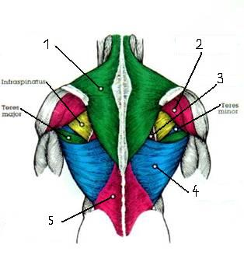

Exercise 2: Answer the following questions.
What are some of the causes of back pain?
What can people do to avoid back pain?

How your back works
Exercise 3: Use the words in the picture to complete the sentences on the right.
Your back is a complex system of interlocking components:
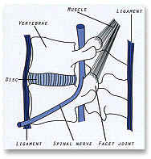 | __________¹ are the bones that make up the spinal column.  __________² separate the vertebrae and act as shock absorbers.  __________³ between the vertebrae guide spinal movement.  __________⁴ hold the vertebrae together.  __________⁵ are attached to the bones. They control and produce movement.

What Causes Back Pain?
Exercise 4: Complete the text with the words from the box.

swelling buttocks growth wear severe rupture
inflammation tear relieve tire arise cause

Postural Stress
Poor posture stresses your spine. Ligaments are overstretched, muscles __________¹ and joints and nerves are put under pressure.
Muscle Strains
Minor back muscle strains quickly improve on their own, but more __________² strains will need physiotherapy treatment to __________³ pain and promote healing.

Ligament Sprains
Stretching ligaments too far or too quickly makes them __________⁴ and bleed into surrounding tissues, causing __________⁵ and pain. Motor vehicle and sporting accidents are common causes.
Disc Problems
Discs are anchored to the vertebrae, above and below, so they cannot 'slip' out of place. They can __________⁶ down with age, but most disc problems __________⁷ from injury. Discs can bulge (prolapse), herniate or even __________⁸.
Sciatica
The sciatic nerves run from the lower back, through the __________⁹ and down the back of your legs. Irritation anywhere along this pathway will __________¹⁰ pain in the back and legs.
Arthritis
Vertebral and facet joints can be affected by arthritis, causing degeneration and __________¹¹ within the joint and the __________¹² of bony spurs on the edges of the vertebrae.
Other conditions causing back pain

Exercise 5: Match.

1. Spinal stenosis | a. It is a degenerative joint condition that causes slow deterioration of the disks between the bones that make up the backbone. It is known as “wear-and-tear” arthritis.
2. Spondylosis | b. This condition occurs when a fever and a tender, warm area accompany back pain.
3. Cancer in the spine | c. Damage to the bones, ligaments, or muscles of the back can cause severe pain.
4. Infection of the spine | d. This condition occurs when the space around the spinal cord and nerve roots narrows due to arthritis and bone overgrowth. This can press or pinch a nerve.
5. Injury | e. A tumor on the spine can press on a nerve causing back pain.
6. Osteoarthritis | f. It is a type of arthritis affecting the spine. It is due to the degenerative changes in the spine that often come with aging.

Exercise 6: Correct the following nonsense words – the letters are in the wrong order.

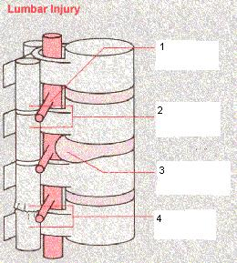 | 1. VERNE TROO  2. CTEAF JINOT  3. THREEDIAN SDIC  4. GREENLAD CTEAF JINOT

Preventing Back Pain

Exercise 7: Read the paragraphs. Complete their headings – names of various activities.

Here is some useful advice to help you prevent back pain:
1. __________
With your feet shoulder-width apart, bend at the hips and knees. Grip the load firmly and hold it close to your body, tighten your stomach muscles and use the strong muscles of your legs to lift. Keep your back as straight as possible. Avoid twisting - turn by using your feet, not your back.
2. __________
Think tall: chest lifted, shoulders relaxed, chin tucked in and head level. It should be stable, balanced and relaxed when sitting, walking or standing.
3. __________
Don't stay seated for too long - stand up, stretch and walk around. The right back support will also help.
4. __________
Stay in shape - healthy body-weight is less strain on your back. Your physiotherapist can show you how to keep your back flexible and strong with correct back and abdominal ones.
5. __________
Good support from your car seat will prevent back pain. If you need more lower back support, use a lumbar roll or a rolled-up towel.
6. __________
Your mattress should be firm enough to support your natural shape.
Treatments for Bad Backs
Exercise 8: Complete the following headings into the article.
TRACTION, SURGERY, EPIDURAL INJECTION, MANIPULATION, PAIN MEDICATION, BED REST

1. _______________ .For 48 hours or until the acute period passes. Stay in there - even for meals, if possible. If yours sags in the middle, add a board under your mattress.

2. _______________ . It is prescribed by your physician and it will help get you through the period of most severe pain, but it won't help you get better.

3. _______________ . Recent studies indicate that this done in hospital may be effective only because it confines the patient to bed rest. Most experts agree that short applications of this in the lumbar region in a clinical, outpatient setting can be an effective treatment.

4. _______________ . Manual mobilization of the lumbar region may assist recovery; restoring range of motion, reducing spasm and stimulating circulation.

5. _______________ . They contain anti-inflammatory or pain medication. It has been shown to be an effective treatment for many patients with low-back symptoms.

6. _______________ . This should be considered only with the failure of conservative treatment to control severe, chronic pain or neurological symptoms. An example is laminectomy - a procedure that allows removal of disc material.

Exercise 9: Read the two paragraphs. Answer the comprehension questions.
1. Why is it important to maintain healthy back muscles?
2. What type of conditioning is best for a healthy back?
3. What is the first step people should do in returning to a healthy back after injury?
4. What is the purpose of evaluation in physical therapy?
5. What type of therapy is carried out to help people recover from back pain?

Conditioning Your Back
The muscles of your back provide structure as well as mobility - they help hold your spinal column together. That's why maintaining healthy back muscles is so important in avoiding or recovering from injury.
But recent studies indicate that the most important factor in avoiding back injury may be your general conditioning, not the power of your back muscles. This suggests that regular aerobic exercise, such as walking or swimming, may provide all the conditioning a healthy back needs.
After injury, the first step in getting your back healthy is gentle exercise to improve flexibility. When you've recovered and are free from pain, your physical therapist may recommend mobilization and strengthening exercises.

How Physical Therapy Can Help Your Back
Evaluation. Physical therapy places greatest emphasis on this process. Your therapist will take the time to talk with you and perform a thorough physical evaluation to identify the dysfunction that causes your pain.
Therapy. Your physical therapist will plan a treatment regimen suited to your individual problem, and begin working to restore flexibility and ease discomfort. Treatment may include heat, cold, massage, traction, manipulation and exercises for relaxation, conditioning, and restoring range of motion.

Exercise 10: Look at the pictures. Give instructions.

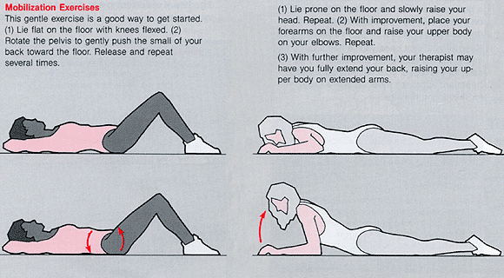

What other exercises do you know for maintaining a healthy back? Describe them.

Key:
Exercise 1 - warm-up: Describe the pictures.
Skeleton: 1.) 7 Cervical vertebrae, 2.) 12 Thoracic vertebrae, 3.) 5 Lumbar vertebrae,
4.) Sacrum, 5.) Coccyx
Muscles: 1. UPPER BACK (Trapezius), 2. REAR SHOULDER (Posterior deltoid),
3. Rhomboids, 4. MIDDLE BACK (Latissimus dorsi), 5. LOWER BACK (Erector spinae)
Exercise 2: Answer the following questions.
What are some of the causes of back pain?
The causes are: postural stress, muscle strains, ligament sprains, muscle spasms, disc problems, osteoarthritis, osteoporosis, sciatica, spinal stenosis, spondylosis, cancer in the spine, infection of the spine, injury
What can people do to avoid back pain?
To keep your back healthy and strong:
Exercise. Regular low-impact aerobic activities — those that don't strain or jolt your back — can increase strength and endurance in your back and allow your muscles to function better. Walking and swimming are good choices. Talk with your doctor about which activities are best for you.
Build muscle strength and flexibility. Abdominal and back muscle exercises (core-strengthening exercises) help condition these muscles so that they work together like a natural corset for your back. Flexibility in your hips and upper legs aligns your pelvic bones to improve how your back feels.
Quit smoking. Smokers have diminished oxygen levels in their spinal tissues, which can hinder the healing process.
Maintain a healthy weight. Being overweight puts strain on your back muscles. If you're overweight, trimming down can prevent back pain.
Use proper body mechanics:
Stand smart. Maintain a neutral pelvic position. If you must stand for long periods of time, alternate placing your feet on a low footstool to take some of the load off your lower back.
Sit smart. Choose a seat with good lower back support, arm rests and a swivel base. Consider placing a pillow or rolled towel in the small of your back to maintain its normal curve. Keep your knees and hips level.
Lift smart. Let your legs do the work. Move straight up and down. Keep your back straight and bend only at the knees. Hold the load close to your body. Avoid lifting and twisting simultaneously. Find a lifting partner if the object is heavy or awkward.
Sleep smart. People with back pain have commonly been told to use a firm mattress, but recent studies indicate that a medium-firm mattress might be better. Use pillows for support, but don't use a pillow that forces your neck up at a severe angle.

Exercise 3: Use the words in the picture to complete the sentences on the right.
1. Vertebrae, 2. Discs, 3. Facet joints, 4. Ligaments, 5. Muscles

Exercise 4: Complete the text with the words from the box.
¹ tire, ² severe, ³ relieve, ⁴ tear, ⁵ swelling, ⁶ wear, ⁷ arise, ⁸ rupture, ⁹ buttocks, ¹⁰ cause,
¹¹ inflammations, ¹² growth
Exercise 5: Match.
1. d 2. f 3. e 4. b 5. c 6. a

Exercise 6: Correct the following nonsense words – the letters are in the wrong order.
1. NERVE ROOT, 2. FACET JOINT, 3. HERNIATED DISC, 4. ENLARGED FACET JOINT

Exercise 7: Read the paragraphs. Complete their headings – names of various activities.
1. Lifting, 2. Posture, 3. Sitting, 4. Exercise, 5. Driving, 6. Sleeping
Exercise 8: Complete the following headings into the article.
1. Bed Rest, 2. Pain Medication, 3. Traction, 4. Manipulation, 5. Epidural Injections, 6. Surgery

Exercise 9: Read the two paragraphs. Answer the comprehension questions.
1. Why is it important to maintain healthy back muscles?
Because the muscles of the back provide structure as well as mobility - they help hold the spinal column together. It is important in avoiding or recovering from injury.
2. What type of conditioning is best for a healthy back?
It is general conditioning, not the power of the back muscles. This suggests that regular aerobic exercise, such as walking or swimming, may provide all the conditioning a healthy back needs.
3. What is the first step people should do in returning to a healthy back after injury?
After injury, the first step in getting your back healthy is gentle exercise to improve flexibility. When you've recovered and are free from pain, your physical therapist may recommend mobilization and strengthening exercises
4. What is the purpose of evaluation in physical therapy?
The purpose of evaluation is to identify the dysfunction that causes your pain.
5. What type of therapy is carried out to help people recover from back pain?
Treatment may include heat, cold, massage, traction, manipulation and exercises for relaxation, conditioning, and restoring range of motion.

Exercise 10: Look at the pictures. Give instructions.

Adapted from:
http://www.nlm.nih.gov/medlineplus/backpain.html

