
Head & Neck
Warm up: What are the names of the bones and the muscles in the two pictures?

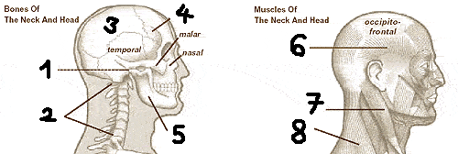

What are some of the head and neck injuries?
What are the causes of neck pain and headaches?
Have you ever suffered from neck pain? Do you ever suffer from headaches? What did/do you do to ease the pain?

Exercise 1: Read the two paragraphs below. Complete the gaps with the words from the box.
discs misalignment traceable avoid spinal cord
posture wear and tear ligaments whiplash
vulnerable recover spread down

What You Need To Know About Neck Pain
Your head and neck region is __________¹ to many different stresses. Bad __________² can cause __________³ of your neck, head, and spine. Car accidents can cause __________⁴. Age and __________ ⁵ can cause arthritis. Even activities such as gum chewing and reading in bed can cause pain. How do we __________⁶ these potential problems? And if we can't avoid them, how can we __________⁷ as quickly as possible?

Anatomy of the Neck Region
One of the most flexible regions of the spine is the neck (cervical) region, which consists of vertebrae, seven shock-absorbing __________⁸, muscles, and vertebral __________⁹ to hold them in place. The uppermost cervical disc connects the top of the spinal column to the base of the skull. The __________ ¹⁰, which sends nerve impulses to every part of the body, runs through a canal in the cervical vertebrae and continues all the way down the spine. The cervical nerves __________ ¹¹ into the arms; because of this, arm pain is sometimes __________¹² to a problem in the neck.

Exercise 2: Read the text below. Complete these prepositions (AS, FOR, IN, INTO, OF, TO, WITHOUT) and conjunctions (IF, THAN).

Possible Causes of Neck Pain and Headaches
One ______¹ the most common causes of neck pain, and sometimes headaches, is poor posture. It's easy to get ______² bad posture habits ______³ even realizing it - even an activity as "innocent" ______⁴ reading in bed can ultimately lead ______⁵ pain, headaches, and more serious problems.
The basic rule is simple: keep your neck ______⁶ a "neutral" position whenever possible. In other words, don't bend or hunch your neck forward ______⁷ long periods. Also, try not to sit in one position for a long time. If you must sit ______⁸ an extended period, make sure your posture is good. Keep your head in a neutral position, make sure your back is supported, keep your knees slightly lower ______⁹ your hips, and rest your arms ______¹⁰ possible.

Exercise 3: Describe the pictures. What advice about avoiding head and neck pain is given in them? Use these words to describe the pictures: pillow, support, neutral position, spine, straight, adjust, eye-level, armrest, footstool, legs and hips.

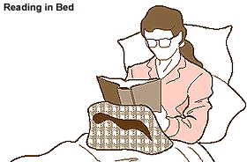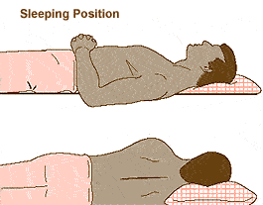

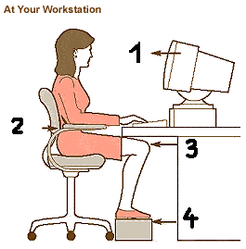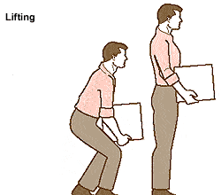

Exercise 4: Read the text. Find the English equivalents to the Czech words below each paragraph.
Other bad habits
- “Shopper's tilt”- carrying items on one shoulder for a long period.
- Carrying items that are too heavy.
"Shopper's tilt" can be avoided by using a back pack-style bag to more evenly distribute the weight you're carrying. (Be sure to wear the back pack correctly, with both arms through the shoulder loops, or the benefit will be lost.) A variation on "shopper's tilt" - "traveler's droop" - is a familiar experience to anyone who has ever tried to lug a heavy suitcase across an airline terminal. Again, a back pack can be helpful, or consider purchasing a compact "rolling suitcase" with wheels and a retractable handle.
Believe it or not, simply talking on the phone can create neck problems. Some people are in the habit of cradling the telephone receiver between the shoulder and the neck. Not only does this put stress on the neck, but over a long period it can cause the cervical discs to place pressure on the nerves. If you spend a great deal of time on the phone, you might try one of the products designed to make it a more comfortable experience – e.g. a "hands-free" headset.

batoh, ruksak |  |  | způsobit problémy
rozložit váhu |  |  | telefonní sluchátko
tahat se s kufrem |  |  | zatěžovat
zvažte koupi |  |  | meziobratlové ploténky krční oblasti

TMJ Disorders
The TMJ - temporomandibular joint - is the joint at which the jaw is hinged to the skull. Painful TMJ problems occur in people who overuse or abuse this joint through teeth grinding, constant clenching and unclenching of the jaw, or excessive gum chewing. Sometimes people are born with a misalignment of the jaw that can bring on similar symptoms.

čelist |  |  | špatně zacházet
kloubně zavěsit |  |  | skřípot zubů
lebka |  |  | zatínání (zubů)
příliš používat |  |  | vychýlení

Migraine Headaches
True migraine headaches are most likely the result of problems affecting the blood vessels in the head, or of an allergic reaction. However, many other types of headaches can mimic migraines and are often misdiagnosed. Some of these originate in the neck or jaw, such as the TMJ disorders mentioned above.

s největší pravděpodobností |  |  | krevní cévy
postihující |  |  | chybně diagnostikovaný

Other Kinds of Headaches
Most people know from experience that emotional stress can cause headaches. These "simple" headaches can be treated in a variety of ways, from taking nonprescription pain relievers to practicing meditation. Most simple headaches will go away by themselves; however, if the headache is persistent or recurring, make sure that neck strain, poor posture, or eyestrain isn't the culprit. Sometimes muscles in the back of the neck can irritate nerves in the head, causing a headache.

zapříčinit |  |  | léky proti bolesti
být léčen |  |  | samy odezní
různými způsoby |  |  | vracející se
bez předpisu |  |  | příčina, viník

Whiplash
Whiplash - a violent back-and-forth motion of the neck - is probably the most common traumatic injury to the neck region. It is frequently associated with automobile accidents, although it occasionally occurs in other situations (such as skiing accidents or amusement park rides). In acute cases, a device known as a cervical collar may be appropriate in order to "rest" the neck and calm the inflammation. Once the tissue has been rested, a physical therapy program designed to regain strength, function, and range of motion can begin.

hyperextenze krku |  |  | přístroj, zařízení
nejběžnější |  |  | krční límec
často spojovaný |  |  | vhodný
ačkoliv |  |  | zklidnit zánět

"Pain In The Neck"
Pain in the cervical region can cause arm pain as well as the "pain in the neck." Why? In the case of the arms, it's because the nerves that branch out from the neck go all the way down into the arms and into the hands. Sometimes it's difficult to tell whether the pain is actually originating in the neck, or the arms, or both. Symptoms in the arms include numbness, tingling, cold, aching, and "pins and needles." These symptoms can be confused with carpal tunnel syndrome (CTS), a condition found in people who work at computer keyboards or perform other repetitive motion tasks for extended periods.

bolest v pažích |  |  | pocit necitlivosti
bolest krční páteře |  |  | brnění
rozvětvovat se |  |  | mravenčení
vznikající |  |  | opakovaný pohyb

How Physical Therapy Can Help With Neck Pain and Headaches
Physical therapy always begins with a detailed history and evaluation of the problem. Your physical therapist will take many things into account, including your age, general health, occupation, and lifestyle. If major trauma or disease is involved, your physical therapist will work with you in consultation with a physician.
After a diagnosis has been made, your physical therapist may choose from a range of treatment options, including exercises for flexibility, strength, stability, and restoration of range of motion. Other options include ice, heat, electrical stimulation, traction or mobilization, and massage. Your physical therapist may also analyze your home and work environment in order to ensure that you're not re-injuring yourself.
Much evidence suggests that low-impact aerobic exercise such as swimming, walking, low-impact aerobics, and stationary bicycling may also be helpful in decreasing neck pain. A physical therapist can design a pain-free exercise program just for you.

detailní anamnéza |  |  | pracovní prostředí
vzít v úvahu |  |  | beznárazový
všeobecný lékař |  |  | šlapání na rotopedu
možnosti léčby |  |  | snížení, pokles

Exercise 5: Reread the text. Answer the comprehension questions.

1. What is “shopper’s tilt” and “traveler’s droop”? How can they be avoided?
2. In what way can telephoning create neck pain? How can the neck pain be avoided?
3. What does the abbreviation TMJ stand for? What are the main causes of TMJ disorders?
4. What problems are thought to cause true migraines?
5. How can simple headaches be treated?
6. What is whiplash? What is it caused by?
7. Why can pain in the cervical region cause arm pain as well as the "pain in the neck"?
8. What does the abbreviation CTS mean? What is this condition the result of?
9. How can physiotherapy help with neck pain and headaches? What treatment options are there?
10. What type of exercises is useful in reducing neck pain? Give examples.

Exercise 6: Give instructions about how to do the following exercises.

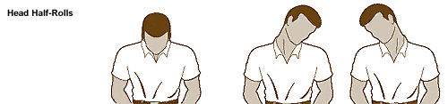
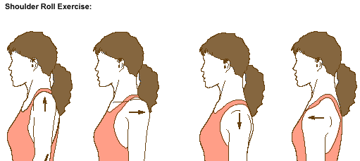
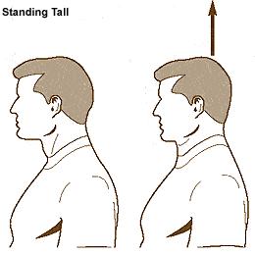
Discussion: Summarize all the information fro this unit. What is the best way of protecting the cervical spine? What exercises/treatments do you find most useful?

Key:
Warm up: What are the names of the bones and the muscles in the two pictures?
1 TMJ – temporomandibular joint
2 cervix/cervical spine/neck
3 parietal bone
4 frontal bone
5 mandible/lower jaw
6 temporal
7 sternomastoid
8 trapezius

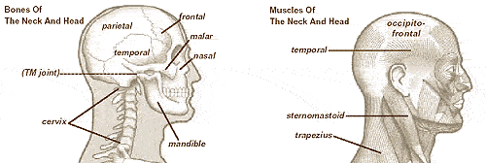

What are some of the head and neck injuries?
Whiplash (an injury to the vertebral column from sudden hyperextension or hyperflexion forces), Wry Neck (a synonymous term with Torticollis, it is a positional irregularity of the head and neck where the head is bent to the side of the irregularity and the chin points towards the opposite shoulder), motor vehicle accidents, sports injuries, falls, occupational accidents, fights, diving accidents…

What are the causes of neck pain and headaches?
Neck pain can be the result of various things: overuse, poor posture, trauma, degeneration.

Have you ever suffered from neck pain? Do you ever suffer from headaches? What did/do you do to ease the pain?
Painkillers, anti-inflammatories such as NSAIDS (non-steroidal anti-inflammatory drugs) or aspirin…

Exercise 1: Read the two paragraphs below. Complete the gaps with the words from the box.
1. vulnerable, 2. posture 3. misalignment 4. whiplash 5. wear and tear 6. avoid 7. recover 8. discs 9. ligaments 10. spinal cord 11. spread down 12. traceable

Exercise 2: Read the text below. Complete these prepositions (AS, FOR, IN, INTO, OF, TO, WITHOUT) and conjunctions (IF, THAN).
¹ of ² into ³ without ⁴ as ⁵ to ⁶ in ⁷ for ⁸ for ⁹ than ¹⁰ if

Exercise 3: Describe the pictures. What advice about avoiding head and neck pain is given in them? Use these words to describe the pictures: pillow, support, neutral position, spine, straight, adjust, eye-level, armrest, footstool, legs and hips.
Reading in Bed
A wedge-shape pillow or a portable “mini-desk” can help reduce neck strain by supporting your arms and helping you keep your neck in a neutral position.
Sleeping Position
The correct pillow should keep your spine straight and your neck in a “neutral” position.
At Your Workstation
1 Adjust your desk, chair, and monitor so that the monitor is at eye-level.
2 Use an armrest.
3 Knees should be slightly lower than hips.
4 Use a footstool if necessary.
Lifting
Keep the object close to your “center of gravity” and use your legs and hips to lift – not your back and neck.

Exercise 4: Read the text. Find the English equivalents to the Czech words below each paragraph.
Other bad habits
batoh, ruksak | back pack |  | způsobit problémy | create problems
rozložit váhu | distribute the weight |  | telefonní sluchátko | telephone receiver
tahat se s kufrem | lug a suitcase |  | zatěžovat | put stress on
zvažte koupi | consider purchasing |  | meziobratlové ploténky krční oblasti | cervical discs
TMJ Disorders
čelist | jaw |  | špatně zacházet | abuse
kloubně zavěsit | hinge |  | skřípot zubů | teeth grinding
lebka | skull |  | zatínání (zubů) | clenching
příliš používat | overuse |  | vychýlení | misalignment
Migraine Headaches
s největší pravděpodobností | most likely |  | krevní cévy | blood vessels
postihující | affecting |  | chybně diagnostikované | misdiagnosed
Other Kinds of Headaches
zapříčinit | cause |  | léky proti bolesti | pain relievers
být léčen | be treated |  | samy odezní | go away by themselves
různými způsoby | in a variety of ways |  | vracející se | recurring
bez předpisu | nonprescription |  | příčina, viník | culprit
Whiplash
hyperextenze krku | whiplash |  | přístroj, zařízení | device
nejběžnější | most common |  | krční límec | cervical collar
často spojovaný | frequently associated |  | vhodný | appropriate
ačkoliv | although |  | zklidnit zánět | calm the inflammation
"Pain In The Neck"
bolest v pažích | arm pain |  | pocit necitlivosti | numbness
bolest krční páteře | pain in the neck |  | brnění | tingling
rozvětvovat se | branch out |  | mravenčení | pins and needles
vznikající | originating |  | opakovaný pohyb | repetitive motion
How Physical Therapy Can Help With Neck Pain and Headaches
detailní anamnéza | detailed history |  | pracovní prostředí | work environment
vzít v úvahu | take into account |  | beznárazový | low-impact
všeobecný lékař | physician |  | šlapání na rotopedu | stationary bicycling
možnosti léčby | treatment options |  | snížení, pokles | decreasing

Exercise 5: Read the following paragraphs. Answer the comprehension questions.
1. “Shopper’s tilt” - carrying items on one shoulder for a long period. “Traveler’s droop” - trying to lug a heavy suitcase. They can be avoided: by using a back pack-style bag to more evenly distribute the weight you're carrying or by purchasing a compact "rolling suitcase" with wheels and a retractable handle.
2. Telephoning can create neck pain by cradling the telephone receiver between the shoulder and the neck - this puts stress on the neck, but over a long period it can cause the cervical discs to place pressure on the nerves. The neck pain can be avoided by getting one of the products designed to make telephoning a more comfortable experience – e.g. a "hands-free" headset.
3. The abbreviation TMJ stands for temporomandibular joint. The main causes of TMJ disorders are when people overuse or abuse this joint through teeth grinding, constant clenching and unclenching of the jaw, or excessive gum chewing.
4. True migraines are caused by problems affecting the blood vessels in the head, or by an allergic reaction.
5. Simple headaches can be treated by taking nonprescription pain relievers or practicing meditation.
6. Whiplash is a violent back-and-forth motion of the neck. It is caused by automobile accidents, although it occasionally occurs in other situations (such as skiing accidents or amusement park rides).
7. Pain in the cervical region can cause arm pain as well as the "pain in the neck" because the nerves that branch out from the neck go all the way down into the arms and into the hands.
8. The abbreviation CTS means carpal tunnel syndrome. The condition is the result of
people working at computer keyboards or performing other repetitive motion tasks for extended periods
9. The physical therapist may choose from a range of treatment options, including exercises for flexibility, strength, stability, and restoration of range of motion. Other options include ice, heat, electrical stimulation, traction or mobilization, and massage.
10. Low-impact aerobic exercise is useful in reducing neck pain such as swimming, walking, low-impact aerobics, and stationary bicycling.

Exercise 6: Give instructions about how to do the following exercises.
HEAD HALF-ROLLS
Relax your arms at your sides and gently roll your head from left to right several times. Feel the stretch in your neck muscles. Relax and repeat 5-10 times.
SHOULDER ROLL EXERCISE
Relax your arms and gently roll shoulders in a circular motion. Feel the stretch as you move. Repeat 5-10 times.
STANDING TALL
Stand in normal, relaxed posture, then pretend that a string is pulling you straight up from the top of your head. Feel the stretch in your neck and spine. Relax and repeat 5-10 times.

HW - Exercise: Reading – were you right about the pictures?
READING IN BED
Reading in bed can cause neck strain - especially if you're propped up on several pillows, bending your neck forward, and trying to hold your arms out in order to support the book. If you do read in bed, make it easy on your neck. Consider purchasing one of the products specifically designed for this purpose, such as a wedge pillow to prop up the book or a portable "mini desk." Finally, remember not to stay in any single position too long- our bodies are designed to move.

SLEEPING POSITION
Your sleeping position is another possible source of neck problems. Does your pillow cause you to sleep with your neck at an angle, either too high or too low? If so, you may want to invest in a new pillow. Feather pillows are generally preferable to foam; they conform easily to the shape of the neck. Also, remember that pillows don't last forever. After a year or so feather pillows tend to "collapse" and may need to be replaced. In addition, a bed that doesn't offer enough back support can also be a source of neck discomfort.
Here are some other tips to help you avoid neck strain and pain:
- Try doing stretching exercises before bed and first thing in the morning.
- Don't sleep on your stomach - this position puts great pressure on the neck.
- Don't "over-pillow" your neck; keep your neck and spine in a neutral position.

AT YOUR WORKSTATION
The neutral position rule also holds true for people who spend time working at computer terminals. Again, don't bend your neck forward. Adjust your desk, monitor, and chair to a comfortable height, so that the monitor is at eye level and your knees are slightly lower than your hips. Some people find that a footstool helps in attaining this correct position. Sit close enough to the monitor so that you don't have to bend forward in order to see well. Use the chair's armrests - your arms need support. Wear your eyeglasses if necessary. Consult your physical therapist to find the set-up that is right for you.
You should also follow the neutral position rule when driving a car. Adjust the seat to bring you close enough to the pedals so that you don't have to extend your neck forward.

Proper Lifting Technique
Another cause of neck pain is poor lifting technique. People often think of the lower back as the area at risk, but the cervical region is nearly as vulnerable. Here is the correct way to lift:
- Stand up straight, close to the object.
- Bend at your hips and knees, keeping your back in the neutral position and your head and shoulders up.
- Firmly grasp the object and rise up with your hip and leg muscles.
- Keep the object close to your body. Your hips and legs absorb most of the weight, and you will put less strain on your back and neck.
- The feet should be positioned shoulder-width apart, with one foot slightly ahead of the other.
In addition, you may find that placing one foot forward and one foot back may be easier than trying to lift an object from the "squatting" position.

Adapted from:
http://en.wikipedia.org/wiki/Head_injury
http://backandneck.about.com/od/conditions/tp/commoneckinjury.htm

