P 12 Clinical microbiology I
To study: Sampling, material transportation (from textbooks, WWW etc.)
From spring term: Microscopy

Task 1: Indications of microbiological examination
For following casuistics, fill in the table.
❶ Allways fill in the case description (left collumn)
❷ Then try to find out your solution. Try to structure your answer followingly:
Microbiological examination: yes/no
- if yes, what type of a specimen(s)
- if no, what more steps, e. g. direct treatment – what antibiotic, etc.)
❸ After the two minute limit, write down correction made according to teachers explanation.
 | Description of a case | Your solution ( 2 minutes) | Correction according to teacher explanation
a
b
c
d

Task 2: Swabs and vessels
Observe the swabs on your table and fill in their „identity cards“.
Name: Plain swab
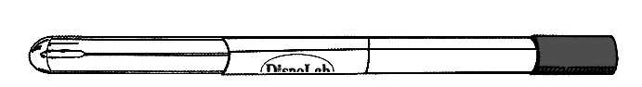 | Stick may be made of | plastic, wood or aluminium
 | Swab is  made of | syntetic cotton
Practical use:

Name: Amies swab
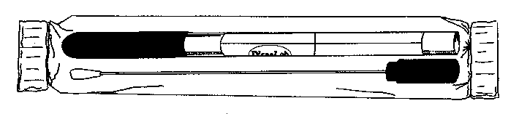 | Stick is made of |  | plastic or aluminium
 | Swab is made of |  | syntetic cotton
 | Medium |  | Amies (Stuart, Cary Blair)
Note: The medium may contain charcoal (then it is black); without charcoal, it would be colourless.
Practical use:

variant with aluminium stick is used for

Name: Fungi-Quick swab
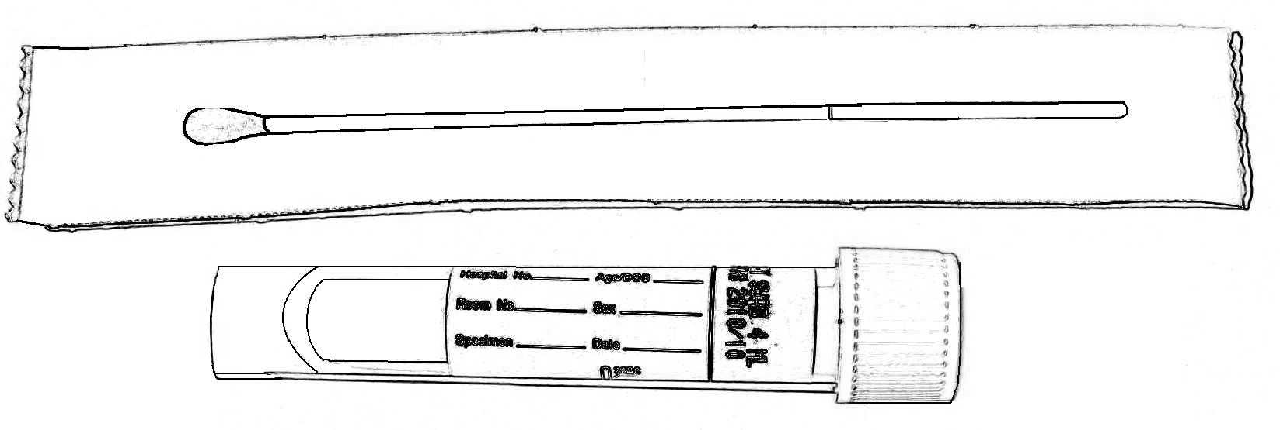 | Stick is made of |  |  | plastic
 | Transport medium colour |  | colourless
 | Cap colour
Practical use:

Name: C. A. T. swab
 | Stick is made of |  |  | plastic
 | Transport medium colour |  | colourless
 | Cap colour
Practical use:

Name: Common test tube for microbiology
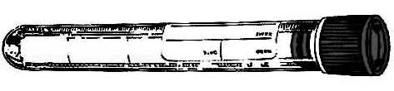 | Sterile? (yes or no)
 | Description | made of polystyrene, 16 × 100 mm, 10 ml
Practical use:

Name: Sputum test tube
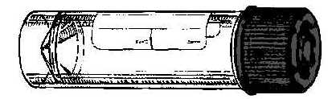 | Sterile? (yes or no)
 | Description | made of polystyrene or polypropylene,  26 × 92 mm, 30 ml
Practical use:

Name: Faeces container
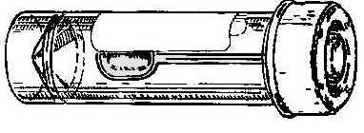 | Sterile? (yes or no)
 | Description | made of polypropylene,  26 × 82 mm, 30 ml
Practical use:

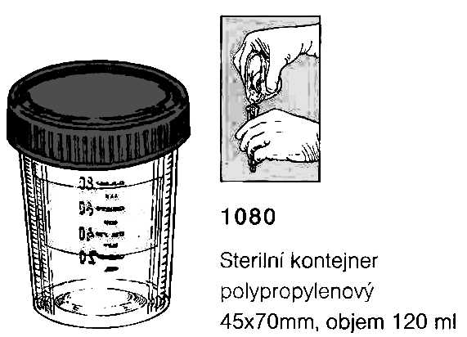
Name: Sampling vessel for urine
 | Sterile? (yes or no)
 | Description | made of polypropylene,  45 × 70 mm, 120 ml
Practical use:

Task 3: Other sampling methods than swabs and vessels

a) Moulage method
Perform the moulage method in pairs. Place a sterile filtration paper to your mate‘s forearm. Using forceps, transport it carefully to a Petri dish with agar. After 10 seconds, remove it and throw it away.

b) Smears
In some cases it is recommended to send directly microscopical smear to the laboratory (actinomycosis, gonorrhoea, but also other genital infections). In gynecologic problems, often two specimens of a vaginal smear is sent to the laboratory. After coming to the laboratory, one is stained using Giemsa staining and the other is stained using Gram staining.
Gram–Giemsa stain
________________________________
________________________________

Observe a result of a vaginal smear, and draw your result to the laboratory report. Write down, whether your slide was Gram or Giemsa stained.

Task 4: Sampling in specific types of samples

a) Blood cultures
Describe use of three types of vessels for blood culture.
blue

green

red

Fill in, what data should not be missing on a order form in case of blood culture sending (only „material type/examination type“ field)
Explain:
Why absolute sterility is necessary in blood culture samples more than in any other blood specimens (e. g. those sent for biochemical examination)?

How many blood cultures should be taken and why?

Fill in the missing fields in description of process of blood culture examination according to videoclip and teacher explanation.
A blood culture vessel comes to the laboratory. Here it is put into a ___________________________________. The positivity is demonstrated by _____________________ and ______________________________. When the cultivation is positive, a smear is prepared and the sample is ____________________ to blood and Endo agar. Also a preliminary _____________________________ test is performed directly from the specimen; as the inoculum is not standardized here, its results are only _________________________.

b) Urine
According to teacher explanation, tick, what sentences concenrning urine sampling and transportation are true/false.
Urine examination is recommended in non-complicated and necessary in complicated cystitis  true  false
Microbiologists recommend use of cathetrized urine as a routine way of sampling urine for bacteriology  true  false
It is not important, whether prepucium (in men) or labia minora (in women) is in the way of urine stream when sampling urine for bacteriology  true  false
External orifice of urethra should be carefully washed and eventually also disinfected before taking sampling urine for bacteriology  true  false
The vessel, that the patient urinates in, should be sterile  true  false
The test tube used for urine transporation to the laboratory should have yellow cap  true  false
The order form should contain information whether urine is „routinelly taken“, cathetrized, punctated, or whether it is a specimen taken from a permanent catheter  true  false
Urine from permanent catether has the same value for bacteriological diagnostics as cathetrized urine (just for examination)  true  false
Urine specimen should be delivered to the laboratory in 2 hours after sampling, in impossible, it should be kept in refrigeratior  true  false
Urine sample is better than urethral swab in gonorrhoea diagnostics  true  false

c) Faeces samples for different types of pathogens and toxins
For some purposes, it is possible to send rectal swabs. For some other purposes, it is necessary to send a specimen of stool. Sometimes also at refrigerator temperature.
Fill in the next table.
Stool sent for | Type of specimen | Stool sent for | Type of specimen
bacteriology |  | virology – virus isolation
mycology |  | parasitology
virology – antigen detection |  | detection of toxin of Clostridium difficile

Task 5: The order form

a) Order form filling in
Fill in the following order form with a patient name and data and requested examination related with the disease that is written on a card that was given to you by a teacher. Do not rewrite the story from your card; try to write the request in a form that would be probably used by a real doctor.
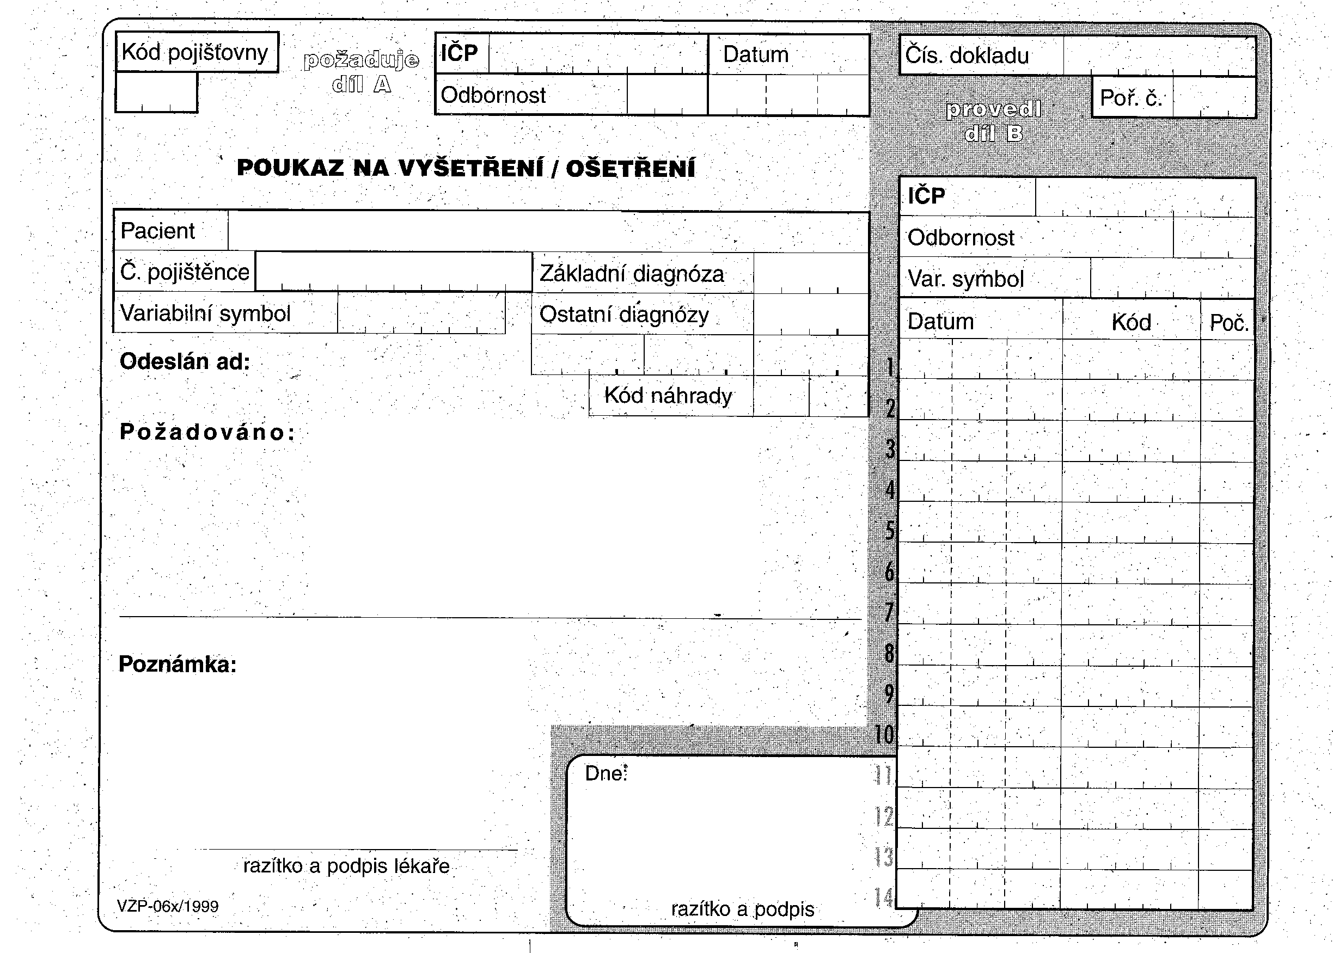

b) Order form common mistakes
To each of following ofder form, write down what is wrong. Some mistakes are mistakes of the order form, but you can also remark inproperly requested examinations.
