Topic P08+09: Laboratory diagnostics of tuberculosis, actinomycetes, nocardiae and spiral bacteria
To study: Mycobacterium, Actinomyces, Nocardia, Borrelia, Treponema, Leptospira (textbooks, WWW etc.)
From spring term: Microscopy, culture, antibiotic susceptibility, PCR, antibody detection methods

Task 08/1: Microscopy of acid-fast and partially acid fast microoorganisms
While entirely acid-fast microorganisms (Mycobacterium) cannot be stained using Gram staining. only partialy acid-fast ones (Actinomyces, Nocardia) can be Gram strained, but they stain inconstantly; they also tend to have branched filamentous forms.

a) Staining of (negative) clinical material using Ziehl-Neelsen staining method
Ziehl-Neelsen staining is used for mycobacteria (M. tuberculosis, M. leprae), but also for some parasites (Cryptosporidium parvum, Cyclospora cayetanensis). The acid-fast organisms are stained only when heated during staining*, but then they are not decororized even by so clled „acid alcohol“ (solution of alcohol with HCl or H₂SO₄). Decolorized bacground is then counerstained.
________________________________________________________________________________
Stain the negative sputum according to the Ziehl-Neelsen method (methylene blue variant). It is not likely that acid-fast rods would be present. Observe in microscope (immersion). Draw the results; at least, you will see the bacground, e. g. leucocytes, epithelia and other objects. Do not forget do describe your picture (use lines)!
Describe also the staining procedure – fill in the following table with names of used reagents.
1. | During the staining the preparation is until
2. | This reagent is made of | and
3. | Instead of this reagent, it is also possible to use

b) Microscopy of a mycobacterial culture
________________________________________________________________________________
Examine microscopically (immersion oil, immersion 100× objective) the preparation of mycobacterial culture stained by Ziehl-Neelsen staining method.
Evaluate presence of red acid-fast rods.
Draw observed structures.
Do not forget do describe your picture (use lines)!

c) Microscopic examination of actinomycetes and nocardia strains
________________________________________________________________________________
Examine microscopically the slide stained by Gram. Describe and draw observed formations. Observe high polymorphism of the microorganisms (from coccal shape, through rods to fibre/strings, often branched; Gram-positive, but often staining half Gram-negative).
Do not forget do describe your picture (use lines)!

Task 08/2: Culture of mycobacteria, Actinomyces and Nocardia.
The culture requests of acid fast and partialy bacteria are very different.
- For Mycobacterium tuberculosis we use special media: liquid media (Šula, Banič) and solid media (Ogawa, Löwenstein-Jenssen). The solid media are different from majority of other solid media used in medical microbiology; they do not contain agar, they are „solid“ because of coagulated egg proteins. Before culture, the medium should be specially treated.
- For Nocardia a current blood agar is sufficient.
- For Actinomyces we need VL-agar and culture in anaerobic box/anaerobic jar (see P07), as this organism is anaerobic.
*Heating may be eventually substituted by use of highly concentrated carbolfuchsin and higly concentrated phenol; this modification of Ziehl Neelsen staining (Kinyoun modification) does not require heating.

a) Describe media for mycobacterial cultivation
Medium name | liquid/solid | colour | notes

b) Describe and draw the growth of Mycobacterium, Actinomyces and Nocardia on (in) given media
Bacterium | Medium name | Presence/absence of growth, eventually growth character  (use your own words to characterize the growth)
Mycobacterium
Actinomyces | blood agar
Actinomyces | VL agar
Nocardia | blood agar
Nocardia | VL agar

Task 08/3: Assessment of antimicrobial drugs susceptibility
For treatment of mycobacterial infections, it is necessary to use special drugs, called antituberculotics. The way of testing is different from other bacteria, too: antituberculotics are added directly to the culture media. On the oter hand, Actinomyces and Nocardia are treated by „normal“ antibiotics and also „normal“ diffusion disc test is used for testing.

a) Assessment of mycobacterial susceptibility to antituberculotics
By comparing with a control test-tube, read the results of antituberculotic susceptibility tests of Mycobacterium
tuberculosis strain.
Antituberculotic |  |  |  | Growth control
Growth Y/N
Interpretation

b) Antibiotic susceptibility of Nocardia and Actinomyces
Perform in vitro susceptibility testing of Nocardia and Actinomyces to suitable antibiotics.
Into the table, write the abbreviation of the antibiotics according to a card and for all tested strains measure the susceptibility zones. On your card, you have limit zones – according to them, interprete the zones as susceptible (S) resistants (R) and dubious (D).
Strain →
Antibiotic  (full name) | Zone ∅ (mm) | Interpretation | Zone ∅ (mm) | Interpretation

Task 08/4: PCR in diagnostics of TB
As the culture of mycobacteria is complicated, PCR becomes a very important method in its diagnostics.
Read a result of PCR TB diagnostics (from slideshow), write the results and interprete them.
Patient No. | Sample band | Control band | Interpretation
1
2
3
4

Task 08/5: Diagnostics of leprosy
Leprosy is a disease that still affects millions of people in uderdevelopped states. It diagnostics is very difficult. Fill in the following table.
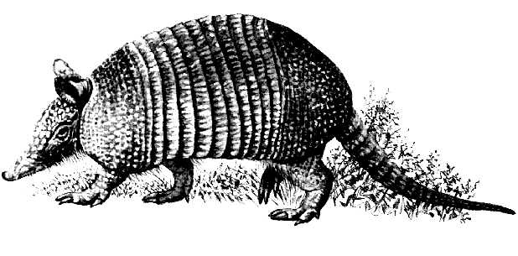 | The name of this animal is
 | It is used to produce
 | and this substance is used for
Picture source: http://www.1-costaricalink.com/costa_rica_fauna/nine_banded_armadillo.htm

Lyme borreliosis
Common table for Task 09/1, 2 and 3.
Patient  Letter | Short clinical  description  (1–3 words characterizing the situation | ELISA (Task 09/1) |  |  |  | W. blotting (T09/2) |  | PCR  (T09/3)  (+/–) | Conclusion:  final interpretation, recommendation for event. therapy
Patient  Letter |  | IgM |  | IgG |  | IgM  (+/–) | IgG  (+/–) | PCR  (T09/3)  (+/–)
Patient  Letter |  | Abs. | (+/–) | Abs. | (+/–)
J
K
L
M
N

Task 09/1: Proof of antibodies to Borrelia garinii using ELISA
Read the results of patients with suspect Lyme borreliosis. Both IgG and IgM antibodies are assessed. In A1 field (corresponding to A1 well of the microtitration plate) you can see CAL level (borderline level; all absorbance levels above CAL are positive, all absorbance levels beneath CAL are negative). There are controls in B1 and C1. Patients J to N are in fields with coloured squares.
Write CAL level here, check, whether negative control is really negative and positive control really positive. Then read and interprete ELISA results for patients J, K, L, M, N (do not write them here, use main table above).
CAL level  (well A1): |  | K+ absorbance level (well B1): |  | ❒ K+ is OK   K+ is not OK | ←  tick what is correct
IgM |  | K– absorbance level (well C1): |  | ❒ K– is OK   K– is not OK | ←  tick what is correct
CAL level  (well A1): |  | K+ absorbance level (well B1): |  | ❒ K+ is OK   K+ is not OK | ←  tick what is correct
IgG |  | K– absorbance level (well C1): |  | ❒ K– is OK   K– is not OK | ←  tick what is correct

Task 09/2: Proof of antibodies to Borrelia garinii using Western blotting
In patients diagnosed in the task No.1, the serum samples or CSF were performed by Western blotting. Read results according to instructions. Use the given pattern for evaluation of the rection. A diagnostic scheme is always the same – ELISA is used for screening, whereas Western blotting is performed as a confirmation of ELISA results. Read the Western blot results of patients J to N and write the results to the main table.

Task 09/3: Diagnostics of Lyme borreliosis using polymerase chain reaction (PCR)
According to the given photos of PCR product on the agarose gel, draw and record which of the tested samples is positive. Remark, that with regard to anamnesis, PCR reaction was performed only in two of our five patients. After that, interprete finally the total of all three examinations and write down a conclusion.

Syphilis

Task 09/4: Direct proof of syphilis
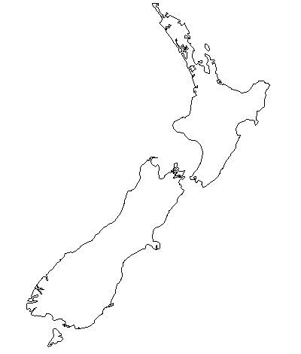
Direct proof of syphilis is only possible if suitable samples are sent to the laboratory. In some stages of the disease it is not possible to take anything for this purpose.

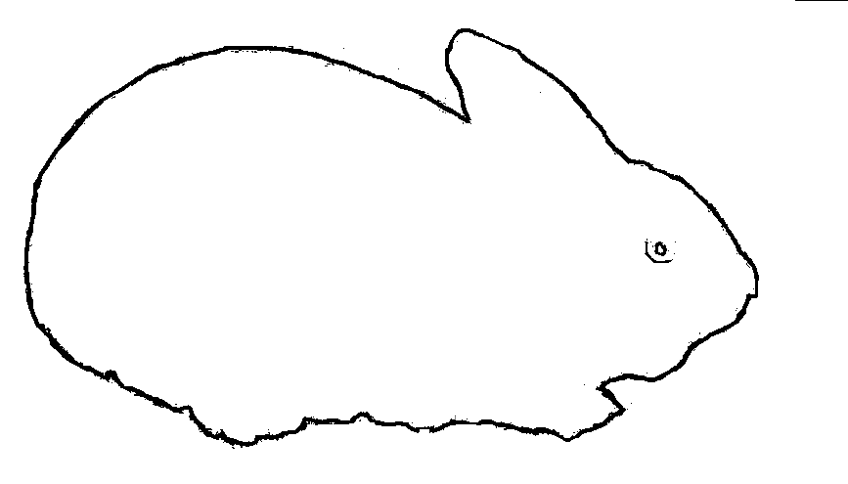
a) Rabbit infectivity testing – RIT
Write down the name of the rabbit used for the test.
(It is derived from these islands: →→→→→→→→→.)
Exsudate from a suspect ulcer uses to be evaluated by darkfield microscopy and inoculated to rabbits testes. The tested animal starts to suffer from orchitis after 10 days after inoculation. Rabbit name:

b) Darkfield microscopy
Look at a photograph of darkfield microscopy. For simplification you have it already filled.

c) Direct immunofluorescence
For simplification you have it already filled.
09/4b) principle  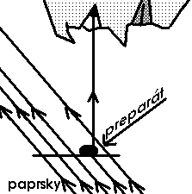 | 09/4b) result (www.medmicro.info)  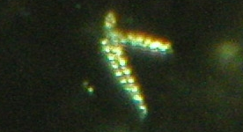 | 09/4c) (www.medmicro.info)  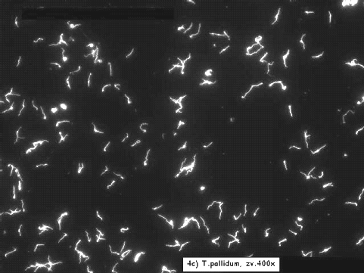
The causative agent of syphilis, Treponema pallidum, is NOT a culturable microoranism. The diagnostics is dependent on a stage of disease.

Indirect diagnostics of syfilis
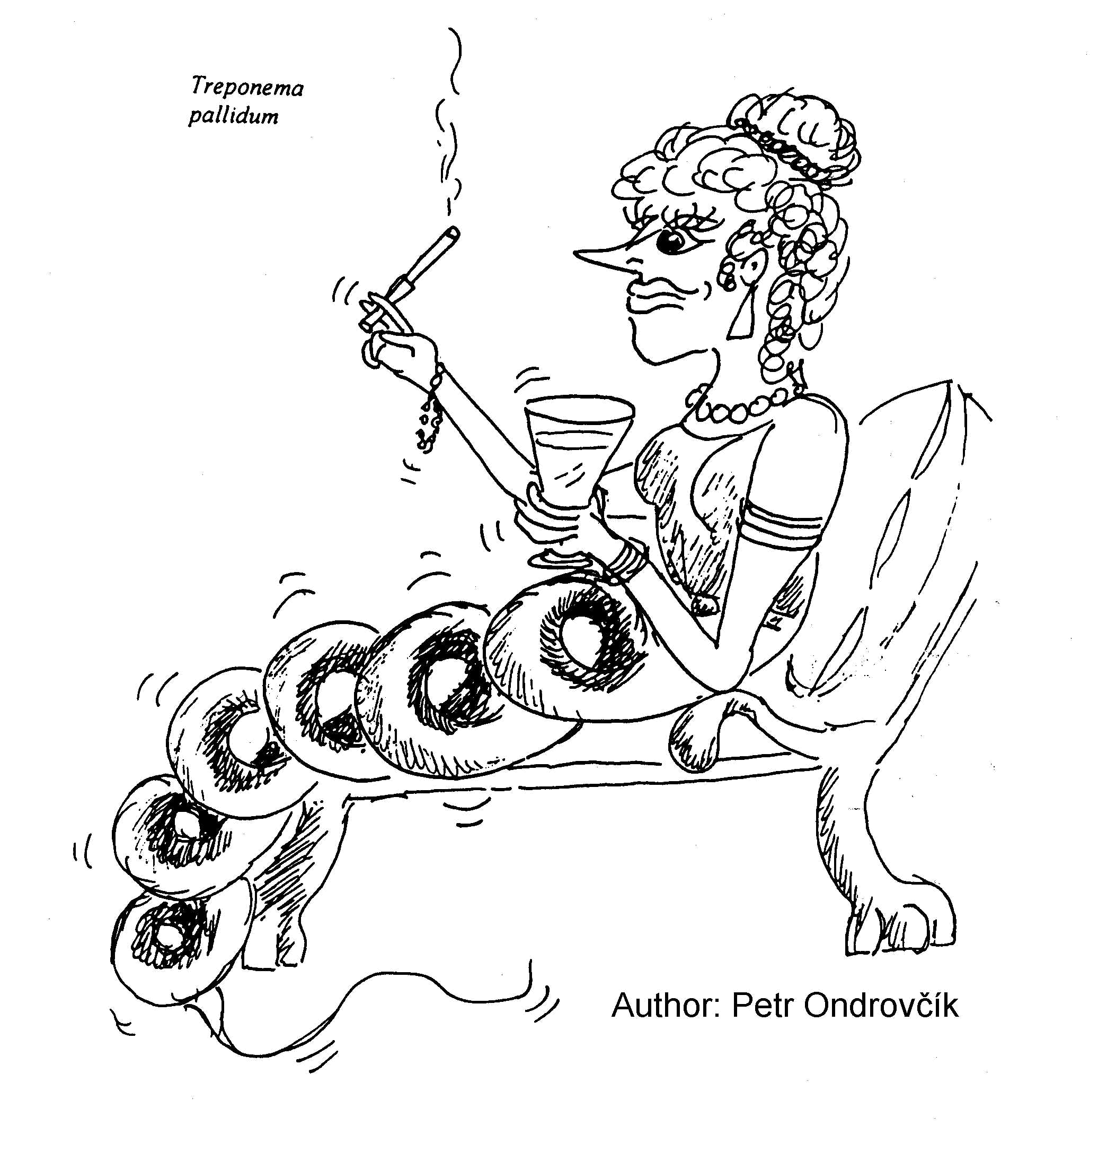
Common table for Task 09/5 and 09/6.
Patient  Letter | Short  clinical  characterisation | Task 09/5  screening |  | Task 09/6  confirmation |  |  |  |  |  |  | Conclusion:  final interpretation, eventually recommended therapy
Patient  Letter | Short  clinical  characterisation | RRR | MHA-TP | FTA-ABS | ELISA |  |  |  | WB
 |  |  |  |  | IgM |  | IgG |  | IgM (+/–) | IgG (+/–)
 |  |  |  |  | Absor- bance | (+/–) | Absor- bance | (+/–) | IgM (+/–) | IgG (+/–)
A
B
C
D
E

Task 09/5: Screening of syphilis – RRR and MHA-TP
Pregnant women and blood donors undergo a screening using rapid reagin reaction (RRR) and Treponema pallidum microhemagglutination (MHA-TP). Read results of screening in a given group of persons and assess who of them need to be tested using confirmation tests. Record your results directly into the table.
RRR: floculation in the well is positive; MHA-TP: agglutinate formation positive (see practical J07).

Task 09/6: Confirmation of syphilis – FTA-ABS, ELISA and Western blotting
Evaluate the results of FTA-ABS, ELISA a western blotting (WB) in patients who are suspect of syphilis (see the previous task). In ELISA reaction, count the cut-off and compare K–, + and patient values with it.
A1 field (A1 well) represents the blank.
Cut off level (C1 + D1) / 2 |  | K– absorbance level (B1 value): |  | ❒ K– is OK   K– is not OK | ←  tick what is correct
IgM |  | K+ absorbance level (E1 value): |  | ❒ K+ is OK   K+ is not OK | ←  tick what is correct
Cut off level (C1 + D1) / 2 |  | K– absorbance level (B1 value): |  | ❒ K– is OK   K– is not OK | ←  tick what is correct
IgG |  | K+ absorbance level (E1 value): |  | ❒ K+ is OK   K+ is not OK | ←  tick what is correct

Leptospirosis
Task 09/7: Direct proof of Leptospira sp.
According to a given picture, describe and draw morphology of leptospires cultivated in the liquid Korthoff's medium for 2 weeks. Urine of a patient who is suspect of leptospirosis was used for the test.
For simplification, you have it filled already.
