P13 Clinical microbiology II

Task 1: Search for respiratory pathogens in practical microbiology
With help of your teacher and the slideshow, describe following picture. Use the knowledge from this picture in following two tasks (Task 2 and Task 3)
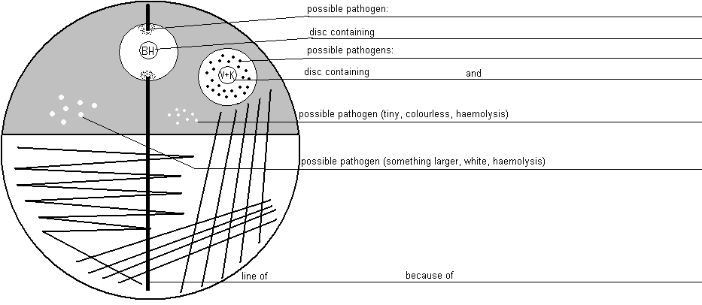
Common pharyngeal flora mostly consists of
a) _____________ appearance: ________________________
b) _____________ appearance: ________________________

Task 2: Case A
For this casuistic, documented by a the order form, try to examine corresponding sample (sputum), to find a pathogen and to make a conclusion and interpretation. Step by step, fill in the individual fields in the „screen of laboratory information system“
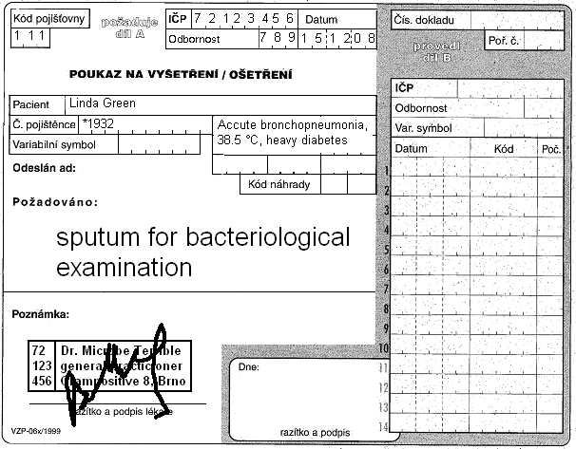

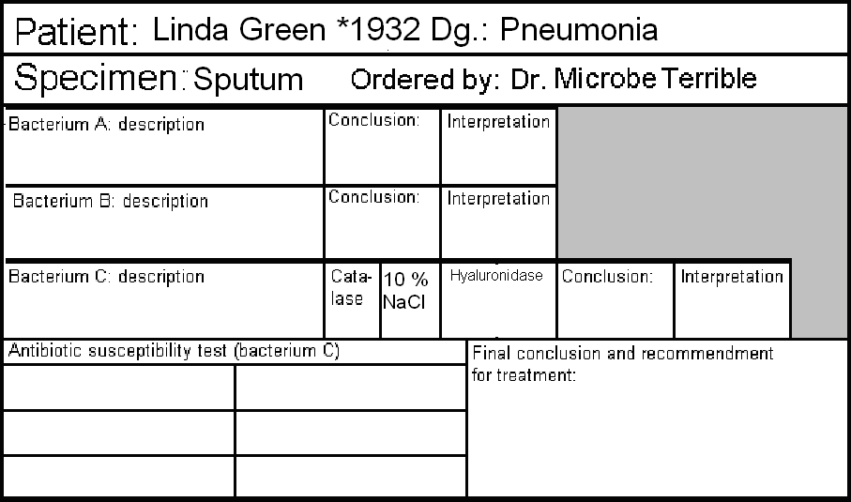
Microscopy result:
Epithelial cells:
WBCs:
Bacteria (describe):

a) Microscopy of sputum
Look at the smear prepared of your specimen. Try to find individual objects (bacteria, host cells). Fill in the field „Microscopy“:
+++ = more than 10 in the observation area
++ = less than 10 in the observation area
+ = only rare (one or less per an observation area)
0 = none

b) Description of bacteria
On blood agar, describe size, colour and haemolytical properties of given bacteria. Do not describe other characteristics. Take into account, that there was no growth visible on Endo agar. Bacteria A and B should be bacteria considered to be parts of normal flora. Bacterium C will be a pathogenic bacterium, that will be more tested in parts c) and d)

c) More tests
Fill in the results of catalase test, hyaluronidase test and growth on blood agar with 10 % NaCl for Bacterium C.

d) Antibiotic susceptibility
Fill in the antibiotic susceptibility test for Bacterium C. Write down allways name of antibiotic and „S“ or „R“ (susceptible or resistant). Reference zones are written on your table.

e) Final conclusion
Try to formulate several words for general practicioner. Especially try to find out (with help of your teacher) what antibiotics among susceptible ones would be the best antibiotic of choice.

Task 3: Case B
Also for this casuistic, documented by a the order form, try to examine corresponding sample (throat swab), to find a pathogen and to make a conclusion and interpretation. Step by step, fill in the individual fields in the „screen of laboratory information system“. The way of doing it is like in previous task.
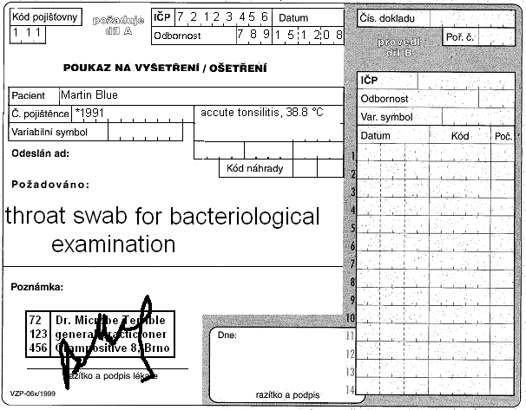

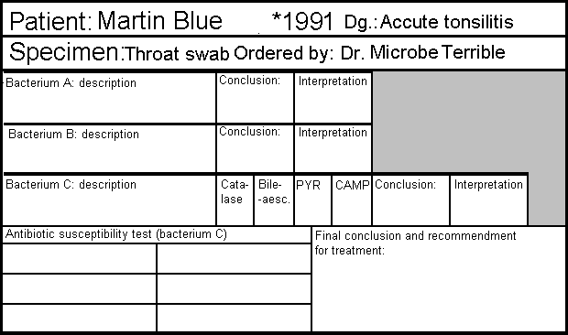

Task 4: Case C
Only for General Medicine students

Task 5: Case D
In case of cystitis, there is one difference: the urine is examined (semi)quantitativelly.
Before solving the problem, try to fill in the following table (for finding of one only species).
Number of colonies on agar | Number of bacteria in one microliter (µl) | Number of bacteria in one mililiter (ml) | Interpretation
<10
10–100
>100
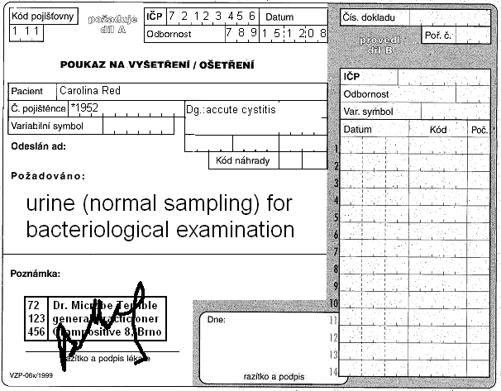
Results of Enterotest 16: E. coli, PP 99,9 %

