Topic P07: Diagnostics of anaerobic bacteria
To study: Clostridium; spore non-forming anaerobes (from textbooks, www etc.)
From spring term: Microscopy, culture, biochemical identification, animal experiment, neutralization

Table for major results of Task 1 to Task 4 (to be filled step by step):
Strain |  | K | L | M | N
Gram stain of a strain – Task 1b
(including information concerning possible spore formation)
Culture – task 3 2 | Blood agar (“KA”) growth Y/N
Culture – task 3 2 | VL agar (“VLA”) growth Y/N
Culture – task 3 2 | VL broth growth Y/N
Culture – task 3 2 | Description of colonies on BA/VLA*
FINAL CONCLUSION (result of Task 4 – ANAEROtest, or result of previous tasks for non-anaerobes)
*Use VLA (VL agar) for bacteria not growing on BA (blood agar)

Task 1: Microscopy of the clinical specimen and microscopy of the strain

a) Observation of a clinical specimen
Observe a Gram-stained smear.
________________________________________________________________________________
You will probably find a mix of various bacteria, as it is typical for anaerobic infections, in which usually not one particular microbe, but a combination of them is responsible for an infection. Besides bacteria, you might see leucocytes (mostly polymorphonuclears), possibly epithelial cells or tissue detritus and so on.
Do not forget to describe your picture (use the arrows)!

b) Microscopy of suspicious strains
Anaerobic bacteria can be cocci, bacilli or spirals, Gram-positive or Gram-negative, so in their shape, they are not different from other bacteria. On the other hand, anaerobes tend to be much more pleomorphic. In the Clostridium genus, the shape, dimension and localization of endospores are used as an important diagnostic sign. Try to find endospores in one of your strains (robust G+ rods).

Task 2: Anaerobic jar and anaerobic box
Anaerobiosis can be obtained using three ways in the laboratory:
a) For liquid media, paraffin oil is used as a barrier between the medium and the atmosphere.
b) Solid media are placed into an anaerobic jar, where oxygen is chemically replaced by a mixture of other gases.
c) Solid media may also be placed into an anaerobic box; the mixture of other gases comes from a cylinder.

Add your description to the pictures of an anaerobic jar and an anaerobic box (you will see a real anaerobic jar and pictures of both an anaerobic jar and an anaerobic box in the slideshow).
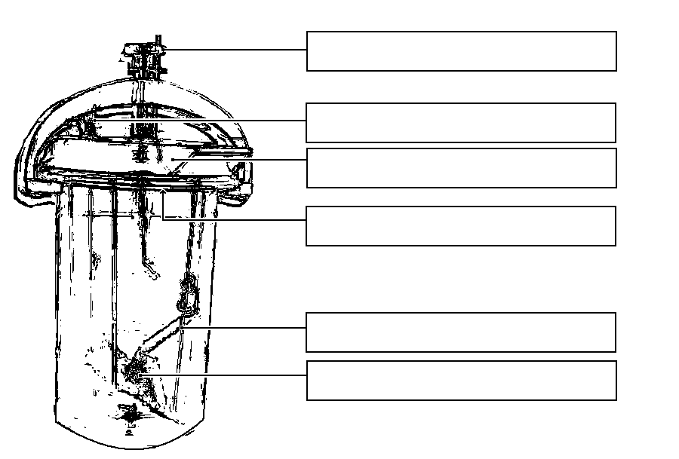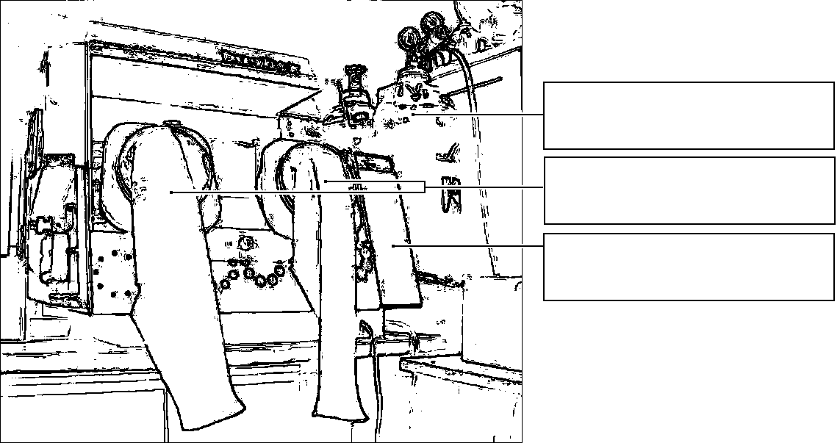

Task 3: Cultivation on agar media
Describe cultivation results of the presented strains on both aerobic and anaerobic media.

a) Aerobic culture on blood agar (BA)
Write down whether the bacteria grow on it or do not grow, and possibly describe the colonies.

b) Anaerobic culture on VL agar (VL blood agar)
VL (blood) agar is similar to blood agar, but it has a decreased redox potential and it is cultured either in the anaerobic jar or anaerobic box. Write down which strains are able to grow on it and describe those not growing on BA

c) Multiplication of anaerobic bacteria in VL broth
VL broth is used especially for the multiplication of rare anaerobic bacteria. Check the presence of turbidity (i.e. the growth) in VL broth, write it in the table and compare with the results of Part b)

Task 4: Species diagnostics of anaerobic bacteria using biochemical tests
In the strains found to be anaerobes read the biochemical microtest (ANAEROtest 23 Erba-Lachema) inoculated two days prior. Read it according to the scheme. Attention! The codebook has four parts, so you have to find a proper part according to the microscopy. Results of “B” and “A” columns are NOT used for code compiling. Therefore, you obtain a 6-position code only from the results of the tests in columns H to C.
Strain: |  | H | G | F | E | D | C | B | A | Code:
 | 1 |  |  |  |  |  |  |  |  | Identification:
 | 2 |  |  |  |  |  |  |  |  | Probability %:
 | 4 |  |  |  |  |  |  |  |  | Typicality index:
 | Code
Strain: |  | H | G | F | E | D | C | B | A | Code:
 | 1 |  |  |  |  |  |  |  |  | Identification:
 | 2 |  |  |  |  |  |  |  |  | Probability %:
 | 4 |  |  |  |  |  |  |  |  | Typicality index:
 | Code
Notes:

Task 5: Susceptibility tests of anaerobic bacteria to antibiotics
Perform in vitro susceptibility testing of Gram-negative cocci to suitable antibiotics.
Evaluate the diffusion disc susceptibility tests to antibiotics in strains found to be Gram-negative cocci and which are pathogenic. Write the abbreviation of the antibiotics according to a card in the table and for all the tested strains, measure the susceptibility zones. On your card, you have limit zones – according to these, interpret the zones as susceptible (S), resistant (R) and dubious (D).
Strain →
Antibiotics  (full name) | Zone ∅ (mm) | Interpretation | Zone ∅ (mm) | Interpretation

Task 6: Detection of clostridial toxins
In clostridia, for toxin detection we use various tests.

a) Demonstration of the Clostridium perfringens toxin (lecithinase)
C. perfringens lecithinase is a toxin that can be neutralized by a specific antibody. One half of your yolk agar plate has been treated with the antiserum (anti-lecithinase), the other has not. The toxic effect of the lecithinase can be seen as a precipitation area around the examined strain; the particular toxin is neutralized by the antitoxin, other lecithinases are not. Draw the effect into the picture and add description.

b) Demonstration of the Clostridium tetani toxin
Draw a picture of a mouse suffering from tetanus (from your slideshow). Remark the position of the extremities and of the tail.
b)

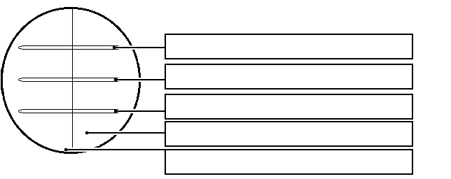
a)

c) Detection of the Clostridium difficile A and B toxins
Pseudomembraneous colitis due to Clostridium difficile toxins is very serious, especially in hospitalized patients. The testing is performed by means of an immunochromatographic test which was already performed in the J09 practical. It is essential in practice to send a genuine piece of stool (NOT rectal swab) to the laboratory. Observe the result of the Clostridium difficile A + B toxins detection in stool specimens X and Y and write down the results:

Specimen X is positive – negative Specimen Y is positive – negative

Task 7: Detection of anaerobic bacteria among facultative anaerobic flora

In practice (especially as it concerns vaginal swabs) it is often necessary to search for anaerobes among other bacteria. For this purpose, we often use plates with discs. Amikacin is effective against G– bacteria, vancomycin against G+ bacteria, but anaerobes are often resistant to both. Draw and mark in which place the anaerobes can mostly be observed, if possible mark also other findings.
Note, that on such a plate, lactobacilli can be seen quite often as tiny, grey α-haemolytic colonies. They are microaerophilic organisms, but our not entirely perfect anaerobiosis is definitely more suitable for their growth than aerobic conditions.

