Topic P10: Fundamentals of clinical mycology
To study: Fungi
From spring term: Microscopy, culture, antibiotic susceptibility, precipitation

Table for major results of Task 1 to Task 3 (to be filled step by step):
Strain |  | K | L | M | N
Gram stain – Task 1

Culture (blood agar) Task 2a | Size
Culture (blood agar) Task 2a | Colour
Culture (blood agar) Task 2a | Shape
Culture (blood agar) Task 2a | Profile
Culture (blood agar) Task 2a | Haemolysis
Culture (blood agar) Task 2a | Surface
Culture (blood agar) Task 2a | Odour
Task 2b: Growth on Sabouraud + chloramphenicol (growth +/–)
Task 2c: Growth on a chromogenic medium
FINAL CONCLUSION (according to Task 2c/Task 3)

Task 1: Microscopy of bacteria and yeasts
Stain the presented cultures of microorganisms by Gram. Use immersion microscopy (immersion objective magnifying 100×). Write your results in the table. Note the size difference between yeasts and bacteria.

Task 2: Culture of bacteria and yeasts

a) Culture on blood agar
Describe colonies of the presented strains on blood agar and fill in the main table. Do not forget to describe the odour. Note that the colonies of yeasts (according to Task 1) are similar to colonies of some bacteria (especially to the colonies of G+ cocci, according to the morphology of colonies most probably staphylococci).

b) Culture on Sabouraud agar with chloramphenicol
Evaluate growth of the presented strains on selective agar for yeasts and moulds (Sabouraud agar with chloraphenicol). Sabouraud agar itself is not selective but it is made selective for yeasts and moulds using broad-spectre antibiotics (chloramphenicol).

c) Culture on a chromogenic medium
Chromogenic media for yeasts enable differentiation of the most important species of the Candida genus. With the help of control strains, try to determine the Candida species using the chromogenic medium. If the colonies are white (no colour substance present) the strain cannot be identified using this chromogenic medium.

Task 3: Biochemical identification of yeasts using Auxacolor set
Read the results of Auxacolor for the strain that could not be identified using the chromogenic medium. In this case, we do not calculate the code but we compare the results with the table. (You might obtain more than one taxon. If so, remember that C. albicans would be green in 2c) and Rhodotorula would be pigmented red in 2b.)
C Neg* | Glu** | Mal** | Sac** | Gal** | Lac** | Raf** | Ino**
Cel** | Tre** | Ado** | Mel** | Xyl** | Ara** | Act*** | Pox#
Result of identification:
*normal blue **yellow positive, blue negative
***yellow positive, colourless negative #brown positive, colourless negative

Task 4: Assessment of antimicrobial drugs susceptibility
For the treatment of fungal infections, it is not possible to use common antibiotics. We have to use special drugs – antimycotics. These, on the other hand, are not effective against bacteria.

a) Assessment of susceptibility to antimycotics
Perform in vitro susceptibility testing of the presented strains to antimycotics. Use the table only for two strains that are susceptible to at least something, the other two strains should be written beneath the table. Complete the table with the full name of the antimycotics according to the card and for all the tested strains assess the susceptibility or resistance. For Amphotericin B, the reference zone is 10 mm. For other antimycotics, it is 20 mm, but the inside of the zone does not have to be perfectly clear.
Strain →
Antimycotics  (full name) | Zone ∅ (mm) | Interpretation | Zone ∅ (mm) | Interpretation

Strains ___ and ____ (i. e. strains of bacteria–fungi*) are resistant to all the tested drugs. *delete as appropriate

b) Assessment of susceptibility to antibiotics
Perform in vitro susceptibility testing of the presented strains to antibiotics. Use the table only for two strains that are susceptible to at least something, the other two strains should be written beneath the table. Complete the table with the abbreviations of the antibiotics according to the card and for all the tested strains, measure the susceptibility zones. On your card there are limit zones – according to these, interpret the zones as susceptible, (S) resistant (R) and dubious (D).
Strain →
Antibiotic  (full name) | Zone ∅ (mm) | Interpretation | Zone ∅ (mm) | Interpretation

Strains ___ and ____ (i.e. strains of bacteria–fungi*) are resistant to all the tested drugs. *delete as appropriate

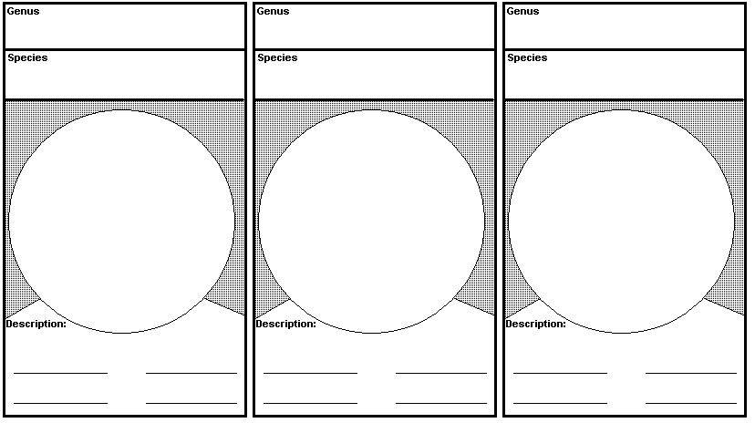
Task 5: Microscopy of moulds
Moulds are usually microscoped differently than yeasts. Gram staining is used rarely. Mostly we use wet mount, objectives magnifying 10× to 40× (→ NO IMMERSION OIL!). Draw and describe the three presented species of moulds (if they are more, choose three of them). Do not forget to describe hyphae, macro- and microconidiae and other observed objects. Use lines or numbers to connect the description with the objects.

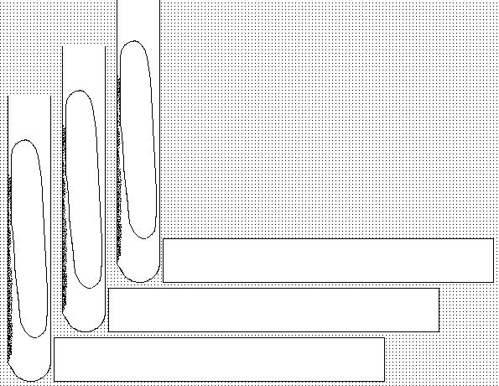
Task 6: Culture of moulds
Moulds usually require longer time to grow (weeks). That is why we usually do not use Petri dishes for culture but only test tubes (to avoid drying and contamination). Draw culture results of the presented moulds. (If they are more than 3, choose 3 of them).
drawing

description

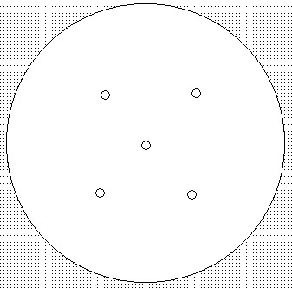
Task 7: Indirect diagnostics of aspergillosis
Evaluate the results of precipitation in gel in order to diagnose antibodies in aspergillosis.
Draw the result and mark the positive and negative cases.

Task 8: Sampling for mycoses
Watch the video “Sampling of cutaneous mycoses”. Write down basic rules for sampling in superficial mycoses.

Attention! For the next practical, one volunteer for each group is needed. The volunteer should not clean his/her teeth in the morning. It will be possible to clean the teeth immediately after the practical, and there will be no permanent effects on your teeth.

