P 12 Clinical microbiology I
To study: Sampling, specimen transport (from textbooks, www etc.)
From spring term: Microscopy

Task 1: Indications for microbiological examination
For following casuistries, fill in the table.
❶ Fill in always the case description (left column).
❷ Try to find out your solution. Try to structure your answer as follows:
Microbiological examination: yes/no
- yes → select a specimen
- no → select other steps, e. g. direct treatment – what antibiotics etc.)
❸ After the three minute limit, write down a correction according to the teacher’s explanation.
 | Description of a case | Your solution ( 3 minutes) | Correction according to the teacher’s explanation
a
b
c
d

Task 2: Swabs and vessels
Observe the swabs in your table and fill in their “identity cards”.
Name: Plain swab
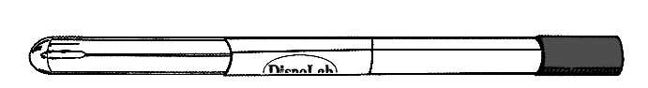 | Stick material | plastic, wood, aluminium
 | Swab material | synthetic cotton
Practical use:

Name: Swab with Amies transport medium
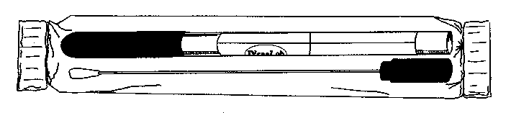 | Stick material |  | plastic or aluminium
 | Swab material |  | synthetic cotton
 | Medium |  | Amies (Stuart, Cary Blair)
Note: The medium may contain charcoal (then it is black); without charcoal, it would be colourless.
Practical use:

Variant with aluminium stick is used for

Name: Fungi-Quick swab
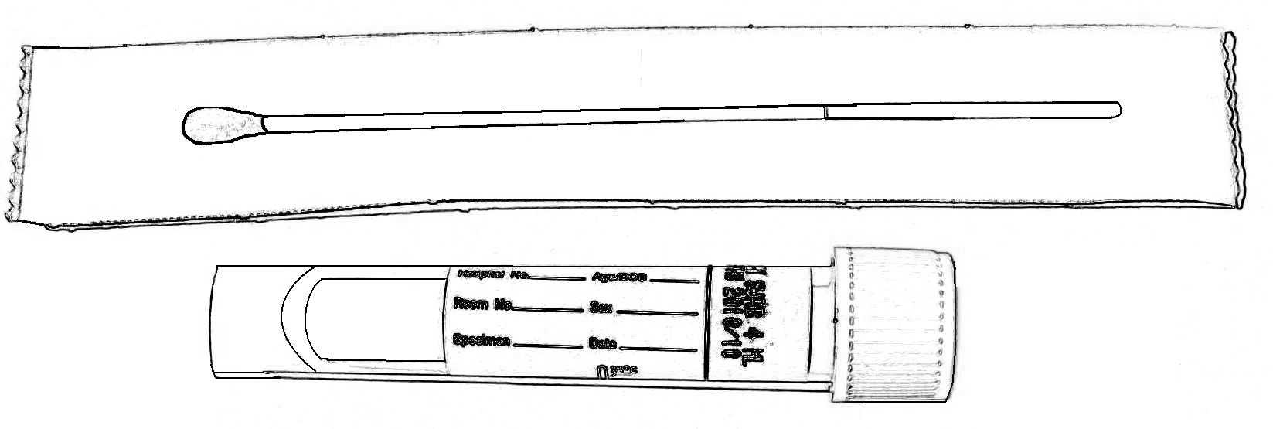 | Stick material |  |  | plastic
 | Transport medium colour |  | colourless
 | Cap colour
Practical use:

Name: C. A. T. swab
 | Stick material |  |  | plastic
 | Transport medium colour |  | colourless
 | Cap colour
Practical use:

Name: Common test tube for microbiology
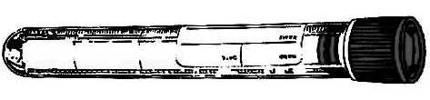 | Sterile? (yes or no)
 | Description | made of polystyrene, 16 × 100 mm, 10 ml
Practical use:

Name: Sputum test tube
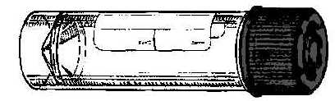 | Sterile? (yes or no)
 | Description | made of polystyrene or polypropylene,  26 × 92 mm, 30 ml
Practical use:

Name: Stool container
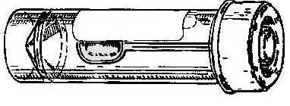 | Sterile? (yes or no)
 | Description | made of polypropylene,  26 × 82 mm, 30 ml
Practical use:

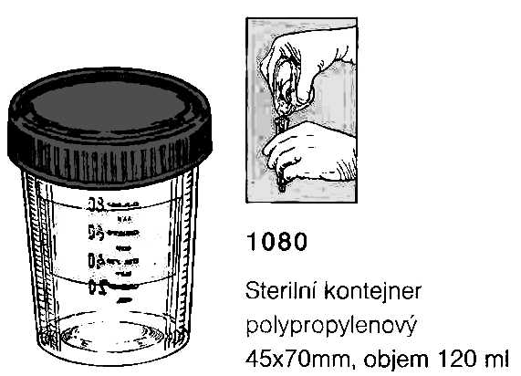
Name: Sampling vessel for urine
 | Sterile? (yes or no)
 | Description | made of polypropylene,  45 × 70 mm, 120 ml
Practical use:

Task 3: Other sampling methods than swabs and vessels

a) Imprint method
Perform the imprint method in pairs. Place a sterile filtration paper on your mate‘s forearm. Using tweezers, transport it carefully to a Petri dish with nutrient agar. After 10 seconds, remove it and throw it away.

b) Smears
In some cases it is recommended to send directly microscopic smear to the laboratory (actinomycosis, gonorrhoea, but also other genital infections). In gynecologic problems, often two specimens of a vaginal smear are sent to the laboratory. There, one is stained by Giemsa and the other by Gram.
Gram/Giemsa staining
____________________________________
____________________________________

Observe a result of a vaginal smear and draw your result in the laboratory report. Write down whether your slide was Gram or Giemsa stained.

Task 4: Sampling in specific types of specimens

a) Blood cultures
Describe the use of three types of blood culture vessels.
blue

green

red

Fill in which data should not be missing on the order form in the case of blood culture (only “material type/examination type” field)
Explain:
Why is absolute sterility in blood culture samples more necessary than in any other blood specimens (e. g. those sent for biochemical examination)?

How many blood cultures should be taken and why?

Fill in the missing fields in the description of blood culture processing and examination according to the video clip and the teacher’s explanation.
A blood culture vessel arrives in the laboratory. Here it is put into a ___________________________________. The positive result is demonstrated by _____________________ and ______________________________. When the cultivation is positive, a smear is prepared and the content of the vessel is ____________________ onto the blood and Endo agar. Also, a preliminary _____________________________ test is performed directly from the specimen; as the inoculum is not standardized here, its results are only _________________________.

b) Urine
According to the teacher’s explanation, tick which sentences concerning urine sampling and transportation are true/false.
Urine examination is recommended in non-complicated and necessary in complicated cystitis.  true  false
Microbiologists recommend the use of catheterized urine as a routine way of sampling the urine for bacteriology.  true  false
It is not important whether praeputium (in men) or labia minora (in women) are in the way of urine stream during sampling the urine for bacteriology.  true  false
External orifice of urethra should be carefully washed and eventually also disinfected before sampling the urine for bacteriology.  true  false
The vessel into which the patient urinates should be sterile.  true  false
The test tube used for urine transportation to the laboratory should have a yellow cap.  true  false
The order form should contain information whether the urine has been “routinely taken”, catheterized, punctured, or whether it is a specimen taken from a permanent catheter.  true  false
Urine from a permanent catheter is equally important for bacteriological diagnostics as the catheterized urine (just for examination).  true  false
Urine specimen should be delivered to the laboratory within 2 hours after sampling; if this is impossible, it should be kept in a refrigerator.  true  false
Urine sample is better than urethral swab in gonorrhoea diagnostics.  true  false

c) Stool samples for different types of pathogens and toxins
For some purposes, it is possible to send rectal swabs, while for others, it is necessary to send a piece of stool, sometimes even refrigerated.
Fill in the next table.
Stool sent for | Type of specimen | Stool sent for | Type of specimen
bacteriology |  | virology – virus isolation
mycology |  | parasitology
virology – antigen detection |  | detection of the Clostridium difficile toxin

Task 5: The order form

a) Filling in the order form
Fill in the following order form with a patient name and data and the requested examination related to the disease, according to a card that has been given to you by the teacher.
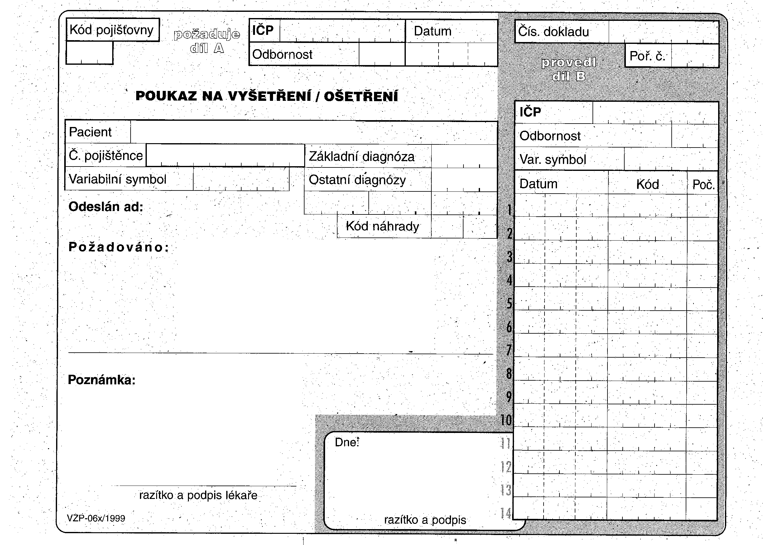

b) Order form common mistakes
To each of the following order forms write down what is wrong. There are some mistakes at filling in the order form, but you should also identify improperly requested examinations.
