P13 Clinical microbiology II
To study: Infections of various organs and organ systems (from textbooks, www etc.)
From the spring term: Microscopy, culture, biochemical identification

Task 1: Search for respiratory pathogens in clinical microbiology
With the help of your teacher and the slideshow, describe the following picture. Use the knowledge from this picture in the Task 2 and Task 3.
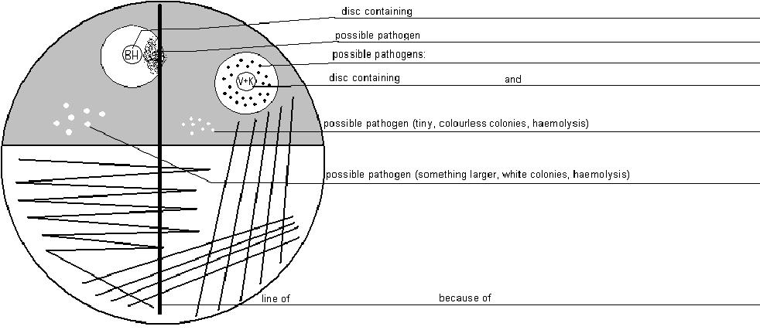
Common pharyngeal flora consists mostly of
a) _____________ appearance: ________________________
b) _____________ appearance: ________________________

Task 2: Case A
For this casuistic, documented by the order form, try to examine the corresponding specimen (sputum), to find a possible pathogen, make a conclusion and interpret the result. Step by step, fill in the individual fields in “the screen of laboratory information system”.
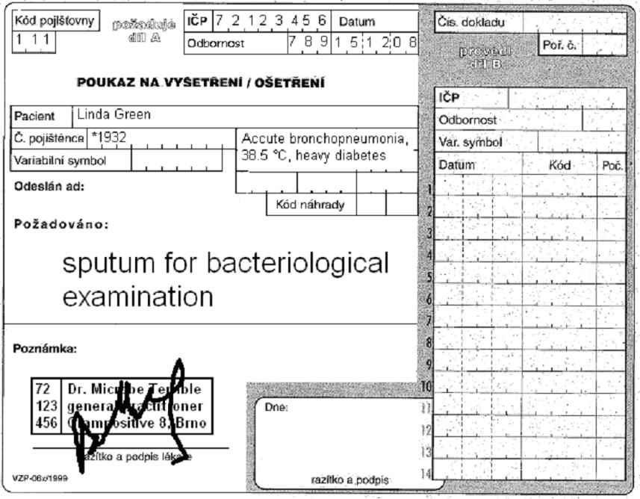

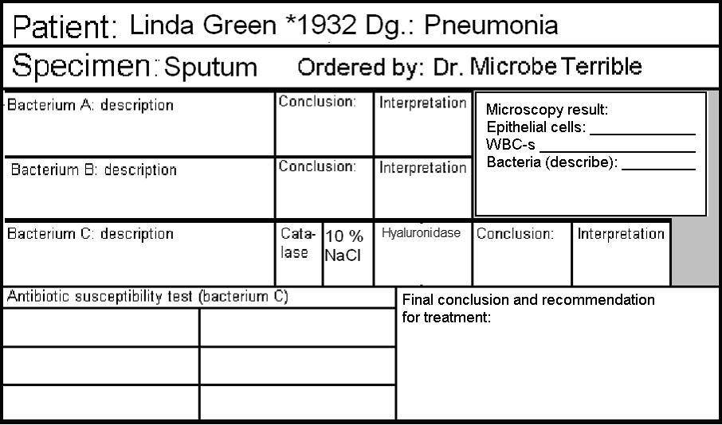

a) Microscopy of sputum
Look at the smear prepared from your specimen. Try to find the individual objects (bacteria, host cells). Fill in the field “Microscopy result”:
+++ = more than 10 objects in the observation area
++ = less than 10 objects in the observation area
+ = only rare objects (one or less per an observation area)
0 = none

b) Description of bacteria
On the blood agar, describe the size, colour and haemolytic properties of the grown bacteria. Do not describe other characteristics. Take into account that there was no growth visible on Endo agar. Bacteria A and B should be bacteria considered to be parts of normal flora. Bacterium C will be a pathogenic bacterium that will be tested in detail in parts c) and d)

c) Further tests
Fill in the results of the catalase test, hyaluronidase test and of the growth on blood agar with 10 % NaCl for Bacterium C.

d) Antibiotic susceptibility
Fill in the antibiotic susceptibility test for Bacterium C. Always write down the name of the antibiotics and “S” or “R” (susceptible or resistant). Reference zones are written on your table.

e) Final conclusion
Try to formulate several words for the general practitioner. Especially try to find out (with the help of your teacher) which antibiotics would be the best choice.

Task 3: Case B
Similarly as in the previous case, there is an order form. Try to examine the corresponding specimen (throat swab) to find a possible pathogen, make a conclusion and interpret the resulst. Step by step, fill in the individual fields in “the screen of laboratory information system”. The way of doing it is the same as in the previous task.
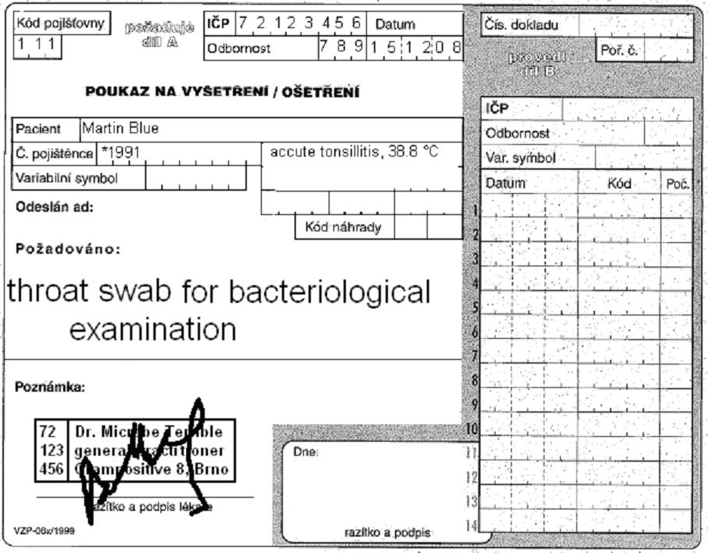

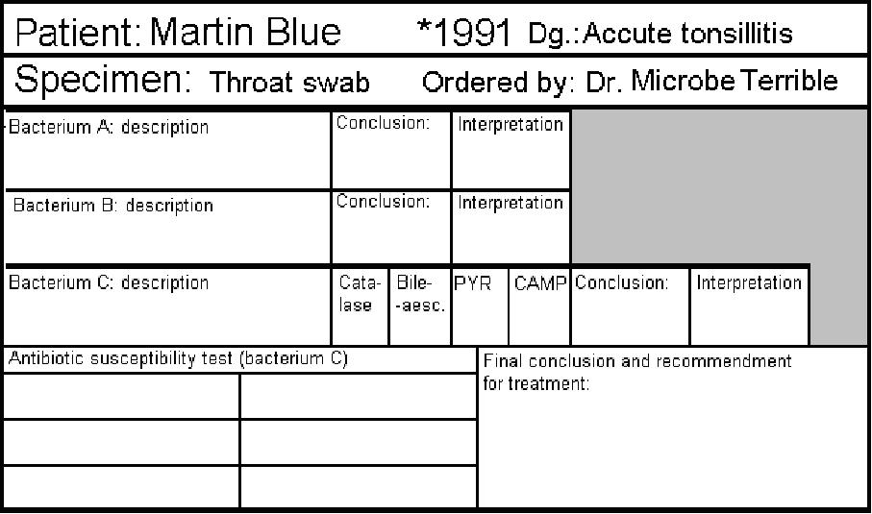

Task 4: Case C
In the case of a wound swab, there is no “common flora”. That is the main difference between this task and the previous ones: it is not necessary to search for a pathogen among the normal flora.
On the other hand, we mostly use more culture media to detect all possible pathogens, even if they would be in a mix. Besides blood agar and Endo agar we usually use also blood agar with 10 % NaCl and blood agar with amikacin in order to search for streptococci and enterococci (but none of these media is used in our task).
Fill in the form again.
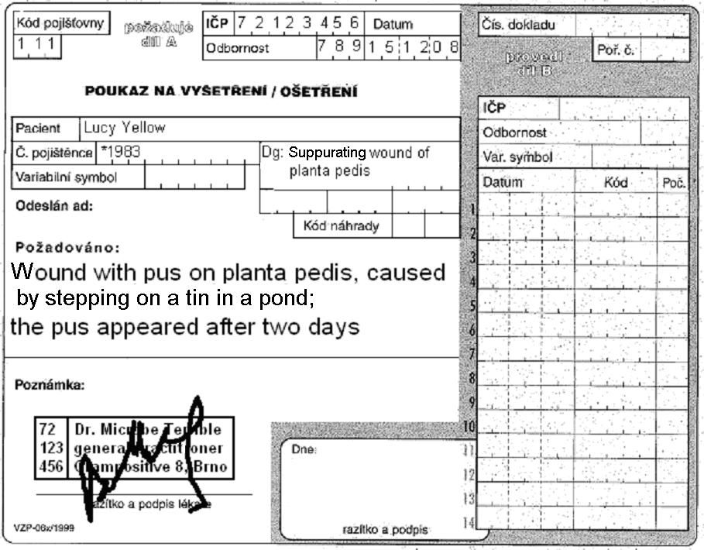
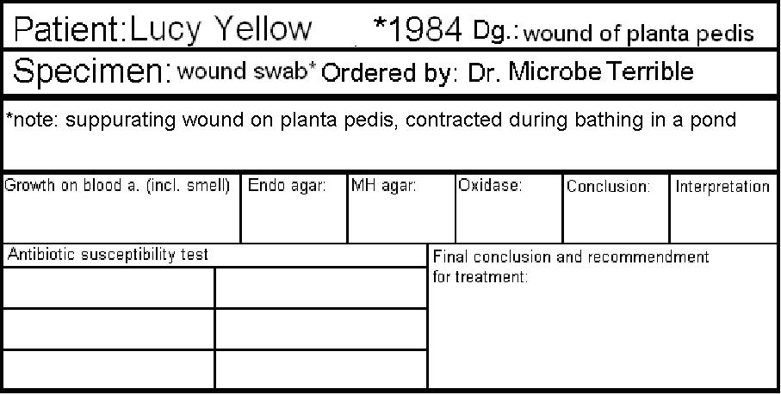

Task 5: Case D
In the case of cystitis, there is one difference: the urine is examined (semi)quantitativelly.
Before solving the problem, try to fill in the following table (for finding only one species).
Number of colonies on agar | Number of bacteria in one microliter (µl) | Number of bacteria in one mililiter (ml) | Interpretation
<10
10–100
>100
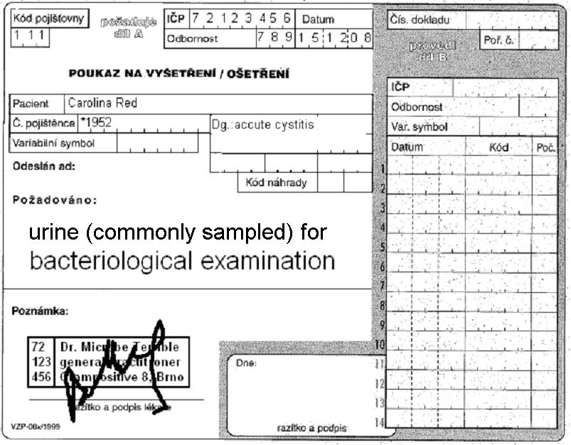
Form for results of Enterotest 16:
ONPG | 1H | 1G | 1F | 1E | 1D | 1C | 1B | 1A | 2H | 2G | 2F | 2E | 2D | 2C | 2B | 2A
+ | black | blue | red | blue | red | green | black | blue | blue | yellow | yellow | yellow | yellow | yellow | yellow | yellow
– | colourless | green | yellow | green | yellow | yellow | colourless | yellow | yellow | green | green | green | green | green | green | green
?
1 | 2 | 4 | 1 | 2 | 4 | 1 | 2 | 4 | 1 | 2 | 4 | 1 | 2 | 4 | 1 | 2
Code: |  |  |  |  |  | Identification |  |  |  |  |  | Probability % |  |  | T index

