Famous Artists B Sheet
Use this dialogue to talk about famous works of art:
Who painted/sculpted _____? | It was painted/sculpted by _____.
When was it painted/sculpted? | It was painted/sculpted in ______.
What was it painted with/sculpted from? | It was painted with/sculpted from ________.
Let me get this straight: It was painted/sculpted by ____ in ______  with/from _________. | That’s right/correct.

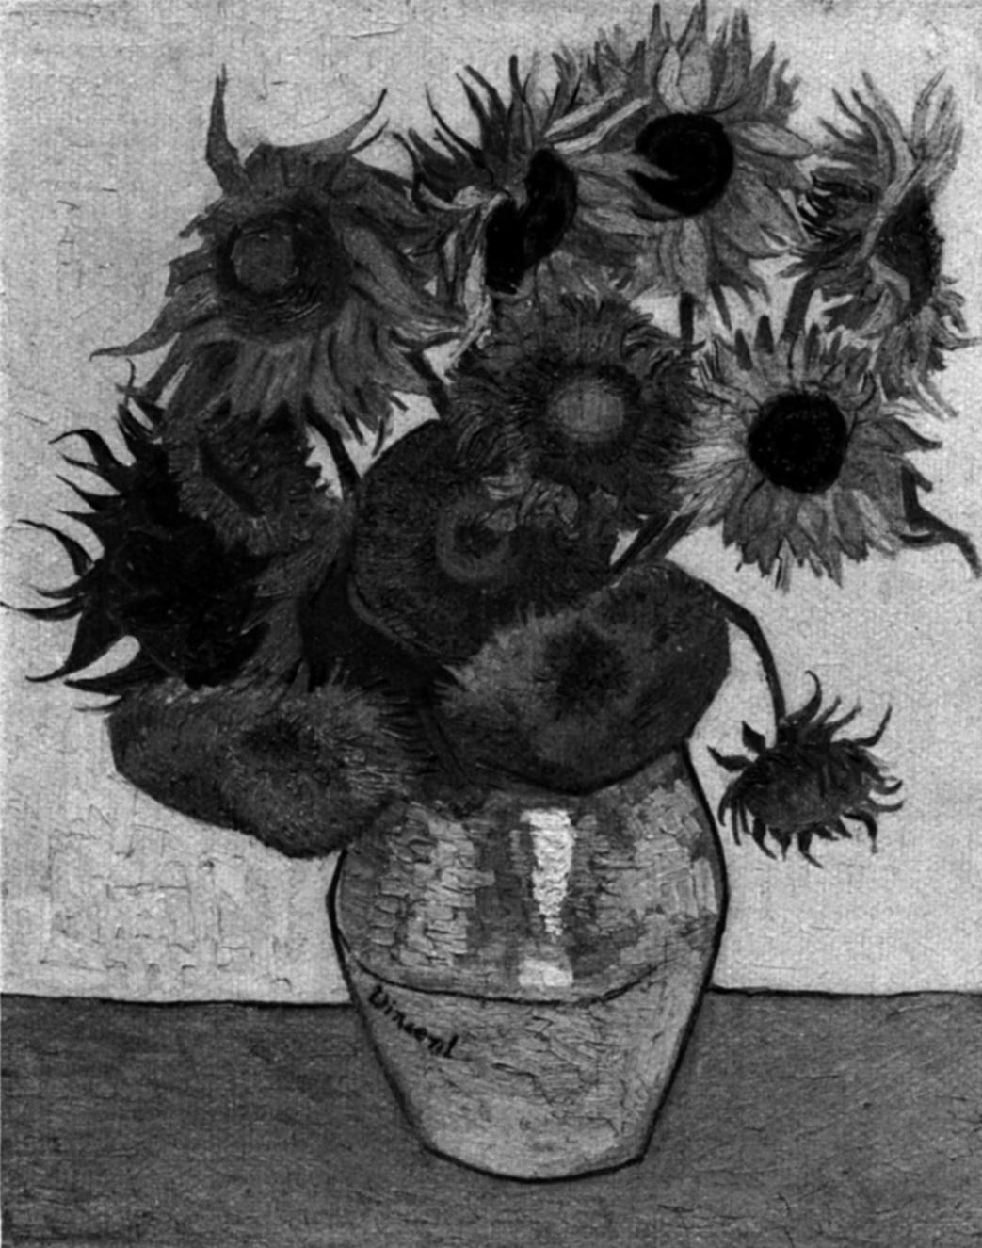 | 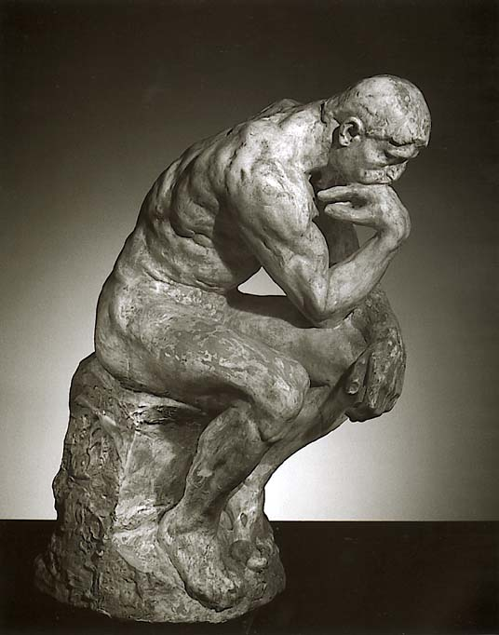 |  | 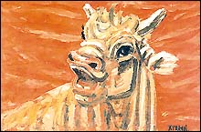
Name: Sunflowers  Artist:  Date:  Materials: | Name: The Thinker  Artist: Rodin  Date: 1882  Materials: Bronze |  | Name: The Ox  Artist:  Date:  Materials:
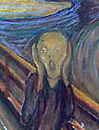 | 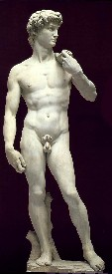 |  | 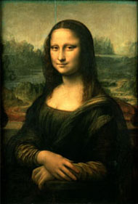
Name: The Scream  Artist: Munch  Date: 1893  Materials: Oil Paints | Name: David  Artist:  Date:  Materials: |  | Name: Mona Lisa  Artist: Da Vinci  Date: 1503-1506  Materials: Oil
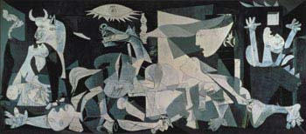 |  | 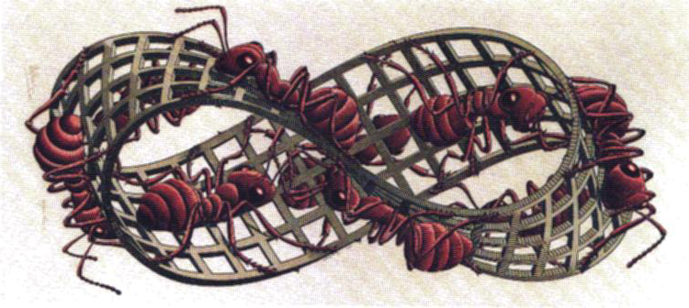
Name: Guernica  Artist:  Date:  Materials: |  | Name: Mobius Strip  Artist: Escher  Date: 1963  Materials: Woodcut
Famous Artists A Sheet
Use this dialogue to talk about famous works of art:
Who painted/sculpted _____? | It was painted/sculpted by _____.
When was it painted/sculpted? | It was painted/sculpted in ______.
What was it painted with/sculpted from? | It was painted with/sculpted from ________.
Let me get this straight: It was painted by ________ in _________  with/from _________. | That’s right/correct.

Name: Sunflowers  Artist: Van Gogh  Date: 1889  Materials: Oil Paints | Name: The Thinker  Artist:  Date:  Materials: |  | Name: The Ox  Artist: Joong-sup Lee  Date: In the 1950s  Materials: Oil paints
Name: The Scream  Artist:  Date:  Materials: | Name: David  Artist: Michelangelo  Date: 1501-1504  Materials: Marble |  | Name: Mona Lisa  Artist:  Date:  Materials:
Name: Guernica  Artist: Picasso  Date: 1937  Materials: Oil Paints |  | Name: Mobius Strip  Artist:  Date:  Materials:
© 2005 www.bogglesworldesl.com

