About mouth anatomy
The mouth is the entrance to the digestive tract. It is lined with mucous membranes. At the top part of the mouth is the palate. The palate is divided into the bony hard palate at the front and the fleshy soft palate at the rear of the mouth. The uvula is the piece of dangling soft tissue in the middle of the throat and it is flanked on both sides by the tonsils at the opening to the throat (pharynx).
At the floor of the mouth is a bundle of muscles that forms the tongue. Tiny bumps called papillae cover the top of the tongue, and each contains tiny pores known as taste buds. Individual taste buds located all over the tongue are designed to sense sweet, salty, sour, bitter or umami (“savory”) tastes. Three pairs of salivary glands in the mouth secrete saliva, a substance containing a digestive enzyme (amylase) that begins to break down carbohydrates before food enters the stomach. Saliva also helps to cleanse the mouth, teeth and gums, acting as an important barrier to tooth decay.

The lips are covered with skin on the outside and mucous membranes on the inside. The inside portion of the lips is connected to the gums. The orbicularis oris is the major lip muscle that controls the movement of the lips. Underlying blood vessels cause the lips to appear darker then other facial skin.
During their lifetime, humans have two sets of teeth that form in the mouth. The first set of 20 primary teeth usually begins to erupt between 6 months and 1 year old. Most children have all their primary teeth by age 3. By the time a child is around 6, a second set of 32 permanent teeth begin to erupt. With proper care, these teeth will last for the rest of the person’s lifetime.
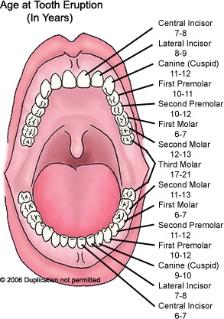
There are several types of permanent teeth. The square teeth called incisors are located in the front of the mouth, with four on the bottom and four on top. Sharp teeth called canines (also called eye teeth) are located on either side of the incisors. The incisors and the canines are used to bite into and tear food.
Behind the canines are the premolars (also known as bicuspids). Four premolars (made up of two sets) are located in each jaw. Behind the premolars are the molars which have the largest chewing surfaces. There are 12 molars total, with six in each jaw. Molars are the last three teeth on each side in both the upper and lower jaws. They are known as the first, second and third molars. The molars have grooves (fissures) and points (cusps) which are designed to grind food.
The third molars are also known as the wisdom teeth. They are the last teeth to come in, and often cause complications that require them to be removed.
All of the permanent teeth erupt in phases that roughly correspond to the following ages:
- 6 to 7 years: first molars
- 6 to 9 years: incisors
- 9 to 12 years: canines
- 10 to 12 years: premolars
- 11 to 13 years: second molars
- 17 to 21 years: third molars (wisdom teeth)
The mouth and teeth work together to begin the process of digesting food. Once food enters the mouth, the teeth begin to break it down. Incisors cut the foods and canines tear it. The premolars grind and mash food. Molars are responsible for the most vigorous chewing of food. As food is being chewed the tongue pushes the food up against the teeth.
Salivary glands in the mouth also contribute to digestion by secreting saliva that moistens the food and causes it to break down further. Once food is properly softened and moistened, it is pushed into the throat and swallowed. The soft palate closes off the nasal passage to prevent swallowed foods from entering the nose.

About tooth anatomy
The crown is the part of the tooth that is visible above the gumline. It is covered by a hard shell of enamel known as the anatomical crown. The enamel is hard enough to endure the strain of a lifetime of biting, chewing and grinding. It also protects the tooth from bacteria and changes in temperature when eating hot or cold foods. Nonetheless, it is brittle and may crack or chip. The enamel is translucent, and most of the color of the tooth actually is produced by the dentin below the enamel.

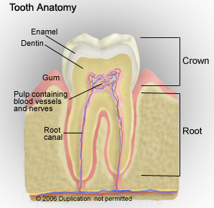
As people age, their gums often start to recede, which makes the crown appear larger as more of the root becomes exposed. Conversely, the crown may appear smaller as the enamel gradually wears away over time. The area of the tooth where the crown meets the root is called the neck (cemento-enamel junction).
The root is the part of the tooth that pushes into the upper (maxilla) or lower (mandible) jawbone, and the structure of the root differs from tooth to tooth. For example, canines and incisors have a single root, while molars may have up to four roots depending on the location in the mouth. Each root has a tiny opening at the bottom called the apical foramen. Blood vessels and nerves enter the root through this space.
A substance called cementum covers the tooth root and attaches to fibers that fasten the root to the jawbone. Similar to enamel, it is a hard protective layer of the tooth.
Just beneath the enamel (covering the crown) and the cementum (covering the root) is the dentin. This substance resembles bone and makes up most of a tooth’s structure and is responsible for the tooth’s color. It typically has a whitish to yellowish hue. As people grow older, the dentin usually darkens or discolors. Exposure to too much fluoride or to certain antibiotics (e.g., tetracycline) during pregnancy also can cause discoloration of teeth in children.
The pulp is located beneath the dentin at the core of the tooth. It is composed of blood vessels, nerves and connective tissue. The blood supply of the pulp provides the nutrients that keep the tooth alive. The pulp is made up of two parts. The pulp chamber is found in the crown of the tooth. The root canal is the part of the pulp located in the root of the tooth. This is where blood vessels and nerves enter the tooth and become part of the pulp chamber. The part of the root that points upward into the teeth is called the pulp horns.

Anatomy of the gums
Gums are the soft tissue below the anatomical crowns of teeth that combine with other features of the mouth to surround and hold teeth in place. Altogether, these features are known as the periodontium. The soft tissue commonly known as the gums is actually called the gingiva. It covers the jaws and encloses the tooth at the neck.
Bundles of connective tissue fibers make up the periodontal ligament. These fibers anchor the teeth to the jaws, with one end of each fiber connected to the cementum and the other embedded in the alveolar socket.
Each alveolar socket is a small hole in the jaw where the tooth is embedded. The walls of these holes are known as the alveolar process, and they help keep the teeth anchored in the jaw.

