Recommended list of diagrams for the Anatomy final examination

Skeleton, joints, muscles
- Pterygopalatine fossa – shape, walls
- Course of facial canal in the pyramid – superior aspect
- Floor of the internal acoustic meatus
- Simple diagram of the ethmoidal bone
- Osseous nasal septum (vomer, lamina perpendicularis ossis ethmoidalis)
- Fasciae of the neck (horizontal section)
- Sheath of rectus abdominis – transverse section above and below the umbilicus
- Difference between the discus and meniscus – transverse section
- Difference between the arthrodia and enarthrosis
- Ligaments of the atlanto-axial joint – superior aspect
- Synovial sheath at the longitudinal section
- Palmar and dorsal interosseous muscles of the hand
- Plantar and dorsal interosseous muscles of the foot
- Muscular and vascular lacunae (lig. inguinale, arcus iliopectineus)

Digestive system
- General structure of the tooth – longitudinal section
- Gallbladder and bile ducts
- Duodenum and pancreatic and bile ducts
- Hepatoduodenal ligament – cross section through its structues
- Supra- and infracolic peritoneal divisions, their blood supply
- Peritoneal recesses at the ileocecal juncture
- Cross section through the esophagus

Respiratory system
- Pulmonary hilum, its structures on the right and left side, transition of the visceral pleura to the parietal one
- Laryngoscopic picture of the laryngeal cavity

Urinary system
- Nephron
- Triangle of the urinary bladder

Male genital organs
- Prostate – sagittal section
- Testis – sagittal section
- Coverings of the testis – derivatives of the abdominal wall
- Deferent duct, seminal vesicles and ureter – posterior aspect
- Male pelvic floor – inferior aspect

Female genital organs
- Uterus – anteversion and anteflexion
- Uterine tube and ovary (mesovary, mesosalpinx, broad lig. of the uterus) – sagittal section
- Uterus and vagina, uterine cervix – sagittal section
- Ligaments of the uterus
- Female pelvic floor – inferior aspect

Cardiovascular apparatus
- Skeleton of the heart, valves
- Shape and structure of the semilunar valves
- Cross section through the ventricles, papillary muscles
- Blood supply of the ventricles – cross section with depicted papillary muscles
- Aorta – portions
- Aortic arch – branches, basic variability
- Serous pericardium (Porta arteriarum et venarum, transverse and oblique sinuses)
- Superficial and deep arterial palmar arches
- Branches of the celiac trunk
- Portal vein - origin

Lymphatic system
- Section through the lymph node
- Main lymph trunks
- Lymph drainage of the female breast – lymph nodes

PNS
- Basic linkage of PNS and CNS neurons (senzor, afferent axon, interneurons in the CNS, motoneuron, efector)
- Spinal nerve, spinal roots
- Pseudounipolar neuron, afferent axon
- Cross section of the peripheral nerve – connective tissue sheaths
- Brachial plexus – trunks, cords
- All cranial nerves, types of fibers, source nuclei
- Superficial and deep cervical ansae
- Greater, lesser and the least splanchnic nerves – their origins from the symp. trunk

CNS
- Zones of the grey matter
- Circulus arteriosus Willisi
- Veins of the brain, venous sinuses
- Sinus sagittalis sup. – transverse section
- Fossa rhomboidea
- Capsula interna and its pathways – transverse section, position of grey matter nuclei
- Crus cerebri – pathways
- Autonomic ganglion
- Difference between preganglionic and postganglionic symp. and parasymp. neurons (length of axons)
- Frontal section of the cavernous sinus with passing cranial nerves
- Nuclei of the thalamus, division into the main functional groups
- Hypothalamo-hypophyseal portal system
- Tr. hypothalo-hypophysialis
- Hypophysis – divisions
- Basal ganglia, capsula interna, externa, extrema – cross section
- Basic groups of the hypothalamic nuclei – rostro-dorsal and frontal section
- Horizontal and vertical division of the cerebellum
- Lateral ventricles, frontal section through the frontal horn and central part, interventricular foramen
- Frontal section through the temporal horn of the lateral ventricle

Senses
- Cross section through the parts of the ear in the latero-medial direction
- External surface of the tympanic membrane
- Tympanic cavity – walls, structures
- Osseous cochlea
- Cochlear duct – cross section
- Orientation of the saccular and utricular maculae
- Pharyngotympanic (auditory) tube, shape of its cartilaginous part
- Anterior and posterior chambers of the eyeball
- Structure of the skin
- Structure of the hair

Topographical anatomy
- Temporal fossa – frontal section, attachment of the temporal fascia
- Trigonum suboccipitale
- Fasciae of the neck
- Triangles of the neck
- Beclard’s angle
- Pirogow‘s tringle
- Trigonum caroticum
- Trigonum submandibulare
- Quadrangular and triangular openings (Foramen humero- et omotricipitale]
- Intercostal nerve and vessels
- Mediastinum – division (sagittal section)
- Canalis inguinalis
- Peritoneal folds of the anterior abdominal wall – posterior aspect
- Trigonum lumbale Petiti
- Trigonum Grynfelti, tetragon Krausei
- Ischioanal fossa (fossa ischiorectalis, m. levator ani – frontal section)
- Trigonum femorale
- Canalis adductorius
- Fossa poplitea including its floor
- Fissura scalenorum – subclavian artery, trunks of the brachial plexus

Osseous nasal septum (vomer, lamina perpendicularis ossis ethmoidalis)
Kostěná nosní přepážka (lamina perpendicularis ossis ethmoidalis a vomer)

The bottom of internal acoustic meatus:

Medial side Lateral side
Superior vestibular area
Singular foramen

Transversal cresT
Facial nerve area
Cochlear area
Inferior vestibular area

Pterygopalatine fossa – shape, walls

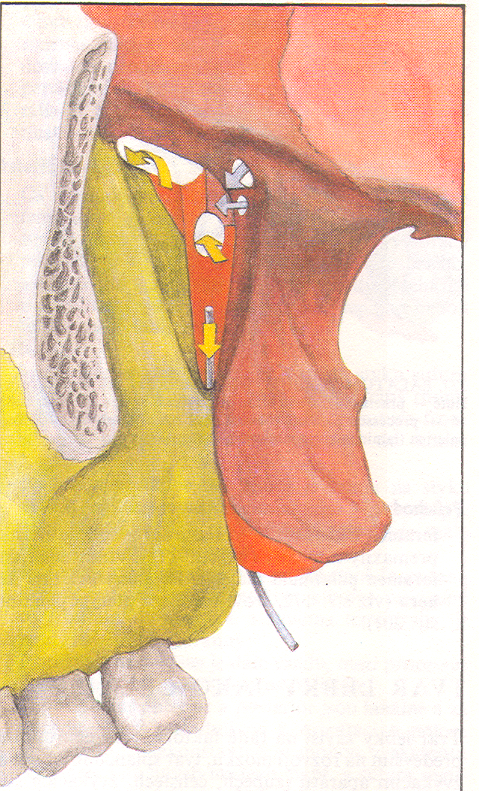

Course of facial canal in the pyramid – superior aspect

Simple diagram of the ethmoidal bone

