Levels of organisation of the human body

1. cells:

2. tissues:

3. organs:

4. systems:

5. organism

The cell performs all of the life functions:

+

Planes of the body and directional terms

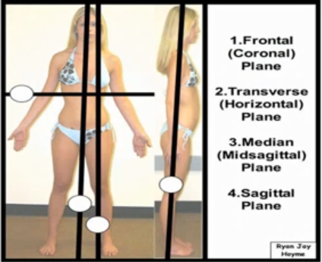

+ oblique

The directional terms are used to localise parts of the body.

‘The hand is distal to the forearm.’

Anatomical position – standing erect, facing the observer, arms are at the sides with palms facing forwards.

Superior (cranial) –

Inferior (caudal) –

Anterior (ventral) –

Posterior (dorsal) –

Medial –

Lateral –

ipsilateral
contralateral
bilateral

Proximal –

Distal –

Superficial –

Internal (deep) –

Prone –

Supine –

