Change the sentences so that the word in bold print becomes the subject of the sentence.
a. Salivary glands in the mouth produce enzymes.
b. Digestive juices ‘attack’ the bolus in the stomach.
c. In the small intestine, pancreatic juices and bile dissolve undigested fat.
d. The chyme then enters the large intestine which removes water from it.
e. Ultimately, peristalsis expels faeces from the body.
f. The constipated patient managed to empty his bowels.
g. We do not allow dogs to run around our hospital.
h. They explained the procedure to the patient in great detail.
i. The nurses are not doing enough to stop the spread of the infection.

j. We have not treated enough people with this new drug to understand its effects.
k. We will clean the toilet floors every single day from now on.
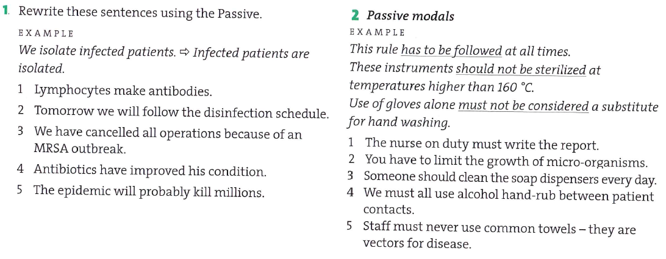

Rewrite the sentences starting with the suggested words as subjects.
Someone is looking after the patient with gastritis. The patient _________________________
Someone shot at the policemen. The policemen _____________________________________
The nurse took his blood sample. His blood sample __________________________________
They made Jane write the test again. Jane _________________________________________
They asked the doctors to work 12-hour shifts. The doctors ___________________________
CIA men invited Martin to see their headquarters. Martin _____________________________
A car hit the drunk when he was crossing the street. The drunk ________________________

The causative have/get…

