P 12 Clinical microbiology III – examination in urogenital infections
To study: special bacteriology from your own protocols

Urinary tract infections

Task 1: Sampling and transport of urine
According to the teacher’s explanation, tick which sentences concerning urine sampling and transportation are true/false.
Urine examination is recommended in non-complicated and necessary in complicated cystitis.  true  false
Microbiologists recommend the use of catheterized urine as a routine way of sampling the urine for bacteriology.  true  false
It is not important whether foreskin (prepuce – in men) or labia minora (in women) are in the way of urine stream during sampling the urine for bacteriology.  true  false
External orifice of urethra should be carefully washed and eventually also disinfected before sampling the urine for bacteriology.  true  false
The vessel into which the patient urinates should be sterile.  true  false
The test tube used for urine transportation to the laboratory should have a yellow cap.  true  false
If urine is not “routinely taken”, the order form should contain information whether it has been catheterized, punctured, or whether it is a specimen taken from a permanent catheter.  true  false
Urine from a permanent catheter is equally important for bacteriological diagnostics as the catheterized urine (just for examination).  true  false
Urine specimen should be delivered to the laboratory within 2 hours after sampling; if this is impossible, it should be kept in a refrigerator.  true  false
Urine sample is better than urethral swab in gonorrhoea diagnostics.  true  false

Task 2: Inoculation of sample of urine
Observe your teacher demonstrating for you inoculation of sample of urine (or video with the same topic, if available). Fill in empty places in the following text:
Urine sample is inoculated using calibrated loop, made of ______________________. The term “calibrated” means that it is set to specific volume, usually _______. The specimen of urine is inoculated to two media: __________________________ and ______________________________. Instead of the second medium we could also use ________________________________ or _____________________________. After inoculation, the specimen is incubated overnight in a thermostat at _____°C.

Task 3: Evaluation of semiquantitative cultivation of urine
After inoculation and incubation (see Task 2), the agar plates with result of urine specimen cultivation are evaluated. The number of colonies is counted (of estimated approximately) and recounted to number of bacteria in a mililitre of the original specimen of urine.
Number of colonies on agar | Number of bacteria in one microlitre of the original urine (µl) | Number of bacteria in one mililitre of the original urine (ml) | Interpretation
<10
10–100
>100
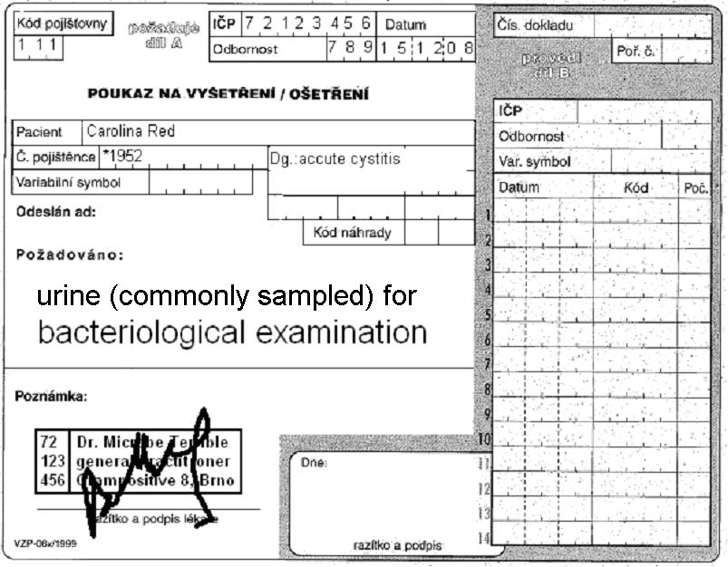
Form for results of Enterotest 16:
ONPG | 1H | 1G | 1F | 1E | 1D | 1C | 1B | 1A | 2H | 2G | 2F | 2E | 2D | 2C | 2B | 2A
+ | black | blue | red | blue | red | green | black | blue | blue | yellow | yellow | yellow | yellow | yellow | yellow | yellow
– | colourless | green | yellow | green | yellow | yellow | colourless | yellow | yellow | green | green | green | green | green | green | green
?
1 | 2 | 4 | 1 | 2 | 4 | 1 | 2 | 4 | 1 | 2 | 4 | 1 | 2 | 4 | 1 | 2
Code: |  |  |  |  |  | Identification |  |  |  |  |  | Probability % |  |  | T index

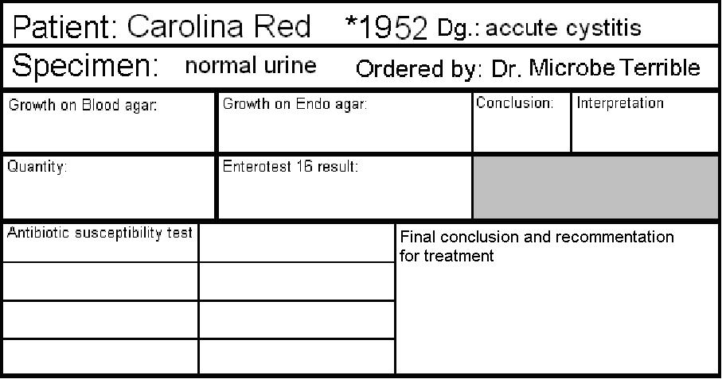

Task 4: Interpretation and treatment of UTI
In following table in each cell (except cells in the first column) one term is wrong. Add a dot to all terms you consider wrong. After that, check your choice with your teacher, and strike through all the really false terms.
Clinical situation | Most likely pathogens | Drug of choice for initial therapy | Alternative drugs (allergy etc.)
Asymptomatic bacteriuria (ABU)  pregnant women | Escherichia coli  Klebsiella pneumoniae  Streptococcus pyogenes  Enterococcus sp. | nitrofurantoin*  ofloxacin | amoxicillin  linezolide
Asymptomatic bacteriuria (ABU)  other situations |  | no therapy  nitrofurantoin | no therapy  cefuroxime
Acute non-complicated cystitis (community cystitis, that means „not-nosokomial“ one) | Clostridium sp.  Escherichia coli  Staphylococcus saprophyticus  Klebsiella pneumoniae | ciprofloxacin  nitrofurantoin | co-trimoxazole  (co-)amoxicillin  vankomycin  cefuroxime
Accute pyelonephritis | Escherichia coli  Bacteroides fragilis  Klebsiella pneumoniae  Proteus sp. | (co-)amoxicilin  cefuroxime  nitrofurantoin | co-trimoxazole  norfloxacin  imipenem
*except first trimester and the second haft of the third trimester

Infections of genital system

Task 5: Sampling methods in STIs and other infections of reproductive organs
Find suitable swabs or other sampling methods for following clinical situations (suspicions for individual diseases). For some of them more than one sampling method is suitable. Use numbers 1 to 6 and mark your choice to individual situations. Correct yourself with help of your teacher.

Bacterial vaginosis
Aerobic vaginitis
Vaginal mycosis
Gonorrhoea
Syphilis
Mycoplasma infection
Chlamydia infection
Papillomavirus infection

Numbers: 1 – Amies swab 2 – C. A. T. swab 3 – plain (dry) swab 4 – a smear on a slide 5 – clotted blood for indirect examination 6 – ulcus durum scraping for dark-field microscopy and PCR

Task 6: Evaluation of vaginal smears
In diagnostics of vaginal infections, one very important method is microscopy. Cultivation results may be positive even when the amount of bacteria (e. g. Gardnerella sp.) is not significant. Therefore, microscopy is better, because we can see the ratio between various morphotypes of bacteria, and also other structures (epithelial cells including those with adhered bacteria – so called “clue cells”; white blood cells; yeast cells etc.). Sometimes, two smears are sent to the laboratory: one is stained by Giemsa staining (almost because of Trichomonas vaginalis diagnostics, as T. vaginalis cannot be Gram stained very well) and the other by Gram (especially for bacteriology).
____________________________________
____________________________________
Nugent score for BV:
Observe a result of a vaginal smear and draw your result in the laboratory report. Try to count Nugent score of bacterial vaginosis with help of following table.
(“Morphotype Lactobacillus” = robust and long G+ rods; “morphotype Gardnerella” = subtle Gram-negative or Gram-variable straight rods; “morphotype Mobiluncus” = subtle Gram-negative curved rods. “Morphotype” means “bacteria that look in microscope the same as”, so not all representativess of “Gardnerella morphotype” really belong to Gardnerella genus.)
The Nugent scoring system (adapted):
Score | Lactobacillus Morphotype  per field | Gardnerella morphotype per field | Curved bacteria (Mobiluncus) per field
0 | >30 | 0 | 0
1 | 5-30 | <1 | 1-5
2 | 1-4 | 1-4 | >5
3 | <1 | 5-30 | -----
4 | 0 | >30 | -----
The criterion for bacterial vaginosis according to Nugent's criteria is a total score of 7 or more is labeled as Bacterial Vaginosis a score of 4 to 6 is called intermediate, and a score of 0 to 3 is considered normal.
Reliability of diagnosing bacterial vaginosis is improved by a standardized method of gram stain interpretation. R P Nugent, M A Krohn, and S L Hillier, J Clin Microbiol. 1991 February; 29(2): 297–301.

Task 7: Evaluation of vaginal swabs
Vaginal swabs are usually cultured on blood agar, Endo agar, agar with 10 % NaCl, special blood agar for Gardnerella vaginalis, eventually also VL agar (anaerobic culture). As a normal flora, we can observe lactobacilli: very tiny colonies with viridation. There exist many species of lactobacilli, with different relations with oxygen, although they use to be microaerofilic. Nevertheless, sometimes they are able to grow on blood agar in normal atmosphere, sometimes in Gardnerella agar in an incubator with elevated CO₂ concentration, and sometimes under anaerobic conditions only. Besides lactobacilli, normal finding may contain small amounts of staphylococci, Enterobacteriaceae and some other bacteria. Sometimes lactobacili are absent, especially in swabs taken from women after climacterium.
Write your findings and try to make a conclusion.
Blood agar  + Endo agar |  | Gardnerella agar
Agar  with 10 % NaCl |  | VL agar (anaerobic)
Conclusion:
We have seen normal vaginal microflora only – normal vaginal microflora + a pathogen: ________________
(delete as appropriate)

