- seminar

Basic anatomy of the nervous system

Nervous system
Divison, development
Neuron –types
REFLEX

Gray matter - nuclei
White matter – nerve tracts
- tractus
- fasciculus (lemniscus)
terms: aferent, eferent, ascendent, descendent
substantia alba x substantia grisea
nucleus motorius x terminationis
functional zones: sensory, motor, SS, VS, SM, VM, BM

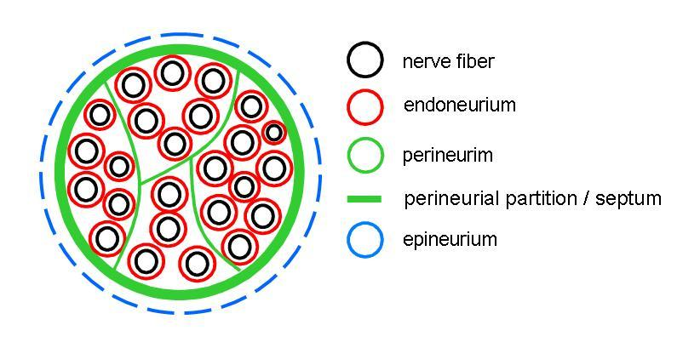

Anatomy of the spinal cord

decussatio pyramidum – L2 – conus medullaris – filum terminale
cauda equina
intumescentia cervicalis (C3-T2) & lumbosacralis (T9-L1)

Fissura mediana anterior
Sulcus medianus posterior
Sulcus anterolateralis
Sulcus posterolateralis
Sulcus intermedius posterior

Funiculus anterior
lateralis
posterior- pars medialis- fasciculus gracilis
- pars lateralis- fasciculus cuneatus

Substantia grissea
- cornu anterius, lateralis (substantia intermedia), posterius
- zona intermedia, zona centralis
- columna anterior, lateralis – missing in C region- formatio reticularis, posterior

- nuclei originis (motorii)
– nucl.intermediolateralis et intermediomedialis
– nucl.proprius
- nucl.thoracicus
- substantia gelatinosa Rolandi
- nucl.apicalis

Substantia alba
- funiculus ventralis, lateralis et dorsalis
- fasciculus gracilis et cuneatus
- tracts: - tr.spinothalamicus
- tr.spinocerebellaris post.et ant. - tr.spinoreticularis
- spinotectalis
- spinoolivaris
- tr.reticulospinalis
- tr.rubrospinalis
- tectospinalis
- olivospinalis,
- vestibulospinalis
- tr.corticospinalis lat.et ant.

