1, *Read*

glandula linguae, in gutta tincturae, cum herbis, ruptura calvae, fracturae vertebrarum, ligamenta rupta, spondyli laesi, pneumonia acuta, scatula adlata, vena portae, atherosclerosis modica, carcinoma mammae, haemorrhagia periculosa, hydrocephalia, diphtheria perniciosa

2, *Fill in the correct endings*

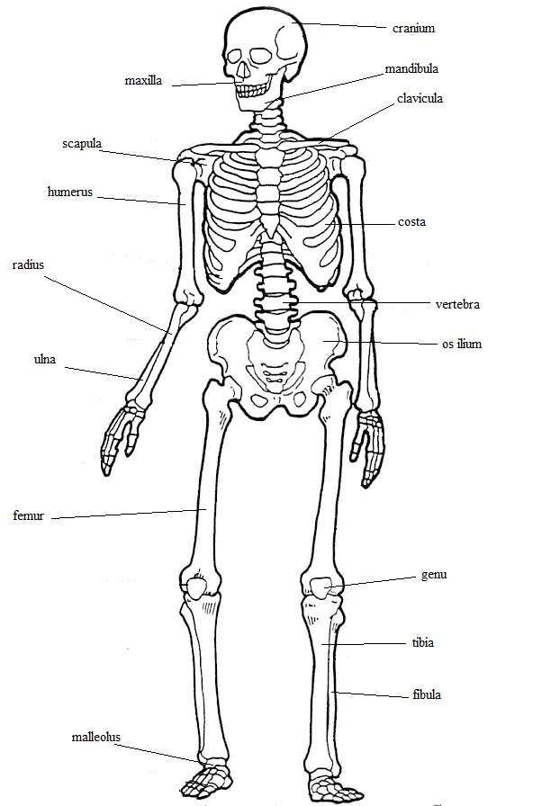fractura uln_, in aort_, ad scatul_, sine aqu_, rima palpebrar_, in glandul_ lingu_, sub aort_, fracturae complicat_, pneumonia aspiratori_, aqua menth_, arteri_ coronari_, vena port_, post pneumoni_ aspiratori_, ad scatul_ adlat_

3, *Add genitive ending and gender*

columna, __, _

lagoena, __, _

dispnoe, __, _

medulla, __, _

linea, __, _

rhaphe, __, _

4, Add genitive and gender of the Greek terms

diploe

chole

diabetes

dyspnoe

systole

ascites

5, *Read and translate*

lagoena aquae destillatae, causa diphteriae, sine allergia, fractura ulnae, secundum naturam, operatio necessaria, palatum durum, trachea inflammata, columna vertebrarum, fractura mandibulae, rhaphe mediana, tuba auditiva, tonsillae palatinae, tunica mucosa, vesica fellea, rima in costa spuria