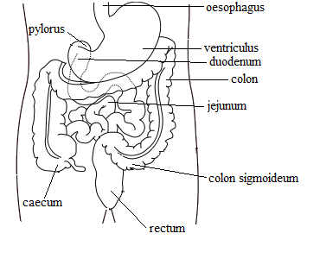1, *Decline*

praeventia

morbus

ganglion

virus periculosum

diabetes mellitus

methodus nova

2, *Fill in the correct endings*

fractura cost___ (pl), medicament_ contra scarlatin_, bacillus diphtheri_, muscul_ lingu_, period_ morb_, sine sept_ nas_, cum ven_ port_, ad rhaph_, propter anaemi_ periculos_, pro adult_, causa fractur_ complicat_, diamet_ transvers_ (Nom), propter fissur_ palat_ congenit_, sine ligament_ lat_ uter_, sub sign_ venen_ pernicios_, in tunic_ mucos_ (state), morb_ col_, sine insufficienti_ valvul_ dextr_

3, *Join the expressions meaningfully*

glandula, sub signo, ligamento, anomaliae, bulbus, post fracturam, medicamentum, in vesica, septum, sine insufficientia, digiti, colicae, columna, extractum, rami, intestino, unguentis, morborum, vena, acromion, rimae, ante therapiam, atrophia, in membranam, gutta, prope medullam, methodus

interosseam, nova, complicatae, oculi, musculorum, oblongatam, caeco, scapulae, valvulae, chronicorum, belladonnae, veneni, aquae, fellea, complicatam, medii, chirurgicam, thyroidea, portae, novum, nasi, congenitae, palpebrarum, nervorum, uteri, glycerini, vertebrarum

4, *Give the plural*

diameter obliquus, medicamentum pro adulto, rami dextri, periodo longa, sine periculo acuto, digiti medii, ad scapulam sinistram, ascites alvi, prope intestinum crassum, post therapiam operativam, sub olecranon ulnae, anguli costae, sutura cranii, propter fracturam costae verae

*5, Give Latin/Greek names of colours*

|  |  |
| --- | --- |
| white  black  green  blue  colourless | yellow  grey  pale  red  purple |

6, *Read and translate*

substantia compacta, tunica mucosa vesicae felleae, sine aqua destillata, pneumonia chronica, insufficientia vesicae urinariae postoperativa, virus periculosum, arteria nutricia humeri, ligamenta lata uteri, unguentum glycerini, medicamentum bonum pro aegrotis, in lagoenam sterilisatam, fractura complicata scapulae dextrae, in glandula linguae, ova in ovario, prope venam cavam, pneumonia adamantina, ostium tubae auditivae, olecranon ulnae, in loco frigido

7, *Translate into Latin*

little hollow, without caecum intestine, cancer of gullet, congenital fissure of palate, with a new medicament, right branch of veins, posttraumatic bleeding in the brain because of rupture of vein, thoracic vertebra, in thyroid gland, because of contagious disease, in acute danger, after complicated fracture of calf bone, with congenital anomaly of wrist, open fracture of ankle, near to pericardium, without pale lips