Topic XPZ07–8: Laboratory diagnostics of anaerobic bacteria, tuberculosis, actinomycosis and nocardiosis
To study: Clostridium; spore non-forming anaerobes, Mycobacterium, Actinomyces, Nocardia (from textbooks, www etc.)
From spring term: Microscopy, culture, biochemical identification, animal experiment, neutralization antibiotic susceptibility, PCR

Task 1: Microscopy of acid-fast and partially acid-fast microoorganisms
While entirely acid-fast microorganisms (Mycobacterium) cannot be stained at all according to Gram, only partially acid-fast ones (Actinomyces, Nocardia) can be Gram-stained, but they stain irregularly; they also tend to form branched filaments.

a) Staining of (negative) clinical material using Ziehl-Neelsen staining method
Ziehl-Neelsen staining is used for mycobacteria (M. tuberculosis, M. leprae) and also for some parasites (Cryptosporidium parvum, Cyclospora cayetanensis). The acid-fast organisms are stained only when heated during staining*, but then they are not decolorized even by so- called “acid alcohol” (mixture of alcohol with HCl or H₂SO₄). Decolorized background is then counterstained by a different dye.
________________________________________________________________________________
Stain the negative sputum according to the Ziehl-Neelsen method (methylene blue variant). The presence of acid-fast rods is unlikely. Observe in the microscope (immersion). Draw the results; you will see mainly the background, e.g. leucocytes, epithelia and other objects. Do not forget to describe your picture (use the lines)!
Describe also the staining procedure – fill in the following table with the names of the used reagents.
1. | During the staining the preparation is until
2. | This reagent consists of | and
3. | Instead of this reagent, it is also possible to use

b) Microscopy of a mycobacterial culture
________________________________________________________________________________
Examine microscopically (immersion 100× objective) the preparation from a mycobacterial culture stained by Ziehl-Neelsen staining method.
Evaluate the presence of red acid-fast rods. Draw the observed structures.
Do not forget to describe your picture (use lines)!

c) Microscopic examination of actinomycetes and nocardia strains
________________________________________________________________________________
Examine microscopically the Gram-stained slide. Describe and draw the observed objects. Notice high polymorphism of the microorganisms (from cocci through rods to filaments, often branched; Gram-positive, but in many cases staining partially Gram-negative).
Do not forget to describe your picture (use lines)!

Task 2: Mycobacteria, Actinomyces and Nocardia cultivation
The culture requirements of acid-fast and partially acid-fast bacteria are very different.
- For Mycobacterium tuberculosis, we use special media: in the CR liquid Šula medium and solid media Ogawa and Löwenstein-Jensen. The solid media are different from the majority of other solid media used in medical microbiology: they do not contain agar, they are “solid” because of coagulated egg proteins. Before culturing, the examined specimens should be rid of other microbes, usually by NaOH.
- For Nocardia, common blood agar is sufficient.
- For Actinomyces, we need anaerobic agar (e.g. VL agar) and culture in anaerostat/anaerobic jar (see P07), as these organisms are anaerobic (or microaerofilic, but with very low need for oxygen).
*Heating may be substituted by using highly concentrated both carbolfuchsine and phenol; this Kinyoun modification of Ziehl-Neelsen staining does not require heating.

a) Describe the media for mycobacterial cultivation
Medium name | Liquid/solid | Colour | Notes

b) Describe and draw the growth of Mycobacterium, Actinomyces and Nocardia on/in different media
Bacterium | Medium name | Presence/absence of growth, possibly also growth character  (use your own words to characterize the growth)
Mycobacterium
Actinomyces | blood agar
Actinomyces | VL agar
Nocardia | blood agar
Nocardia | VL agar

Task 3: Determination of antimicrobial drugs susceptibility
For the treatment of mycobacterial infections, it is necessary to use special drugs, called antituberculotics. The way of testing is different from other bacteria, too: antituberculotics are added directly to the culture media. On the other hand, Actinomyces and Nocardia are treated by common antibiotics and so the common diffusion disc test is used for the testing.

a) Determination of susceptibility to antituberculotics
By comparing with a control test-tube, read the results of antituberculotics susceptibility tests of Mycobacterium tuberculosis strain.
Antituberculotics |  |  |  | Growth control
Growth Y/N
Interpretation

b) Antibiotic susceptibility of Nocardia and Actinomyces
Perform in vitro susceptibility testing of Nocardia and Actinomyces to suitable antibiotics.
Complete the table with the abbreviations of the antibiotics according to the card and for all the tested strains, measure the diameter of the susceptibility zones. On your card, you have limit zones – according these, interpret the zones as susceptible (S), resistant (R) and dubious (D).
Strain →
Antibiotics  (full name) | Zone ∅ (mm) | Interpretation | Zone ∅ (mm) | Interpretation

Task 4: PCR in the TB diagnostics
As the culture of mycobacteria is rather prolonged (on average 6 weeks), PCR becomes a very important method in the diagnostics of TB.
Read a result of PCR TB diagnostics (from the slideshow), write down the results and interpret them.
Patient No. | Sample band | Control band | Interpretation
1
2
3
4

Task 5: Diagnostics of leprosy
Leprosy is a disease that still affects millions of people in underdeveloped countries. Its laboratory diagnostics is difficult because Mycobacterium leprae does not grow on artificial media. Fill in the following table.
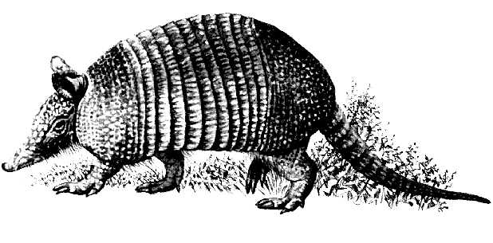 | The name of this animal is
 | It is used to produce
 | and this substance is used for

Picture source: http://www.1-costaricalink.com/costa_rica_fauna/nine_banded_armadillo.htm

Task 6: Indirect TB detection by means of QUANTIFERON©-TB Gold test
It is a test of induced interferon gamma release checking and by means of this, checking of the cell-mediated immunity. Test principle: It was proven that in TB, including latent TB, tuberculosis antigens activate T-lymphocytes and they produce big amounts of interferon gamma. Similarly those T-lymphocytes may be activated non-specifically by so called mitogenem; that is why mitogene is used as a positive control (MIT). As a negative control we use a test tube containing nothing (NIL). The test tube with proper TB antigen is labeled "TB". Interferon itself is detected by ELISA reaction.
Interpret the Quantiferon-TB Gold examination in four patients with use of interpretation table.

Anna: MIT = 4.8 TB = 1.2 NIL = 1.1 Your interpretation: _____________________

Berta: MIT = 5.3 TB = 4.8 NIL = 2.1 Your interpretation: _____________________

Cecil: MIT = 0.9 TB = 0.9 NIL = 0.8 Your interpretation: _____________________

Dimos: MIT = 8.4 TB = 8.3 NIL = 8.2 Your interpretation: _____________________

(all values are in IU/ml)

Interpretation table (according to test recommendations; simplified!)
NIL | TB minus NIL | MIT minus NIL | Final test interpretation | Presence of infection M. tuberculosis
≤ 8,0 | < 0.35 | ≥ 0.5 | negative | Not likely
≤ 8,0 | ≥ 0.35 | any value | positive | Likely
≤ 8,0 | < 0.35 | < 0.5 | unsure | Cannot be determined
> 8,0 | any value | any value | unsure | Cannot be determined

Table for major results of Task 11 to Task 14 (to be filled step by step):
Strain |  | K | L | M | N
Gram stain of a strain – Task 1b
(including information concerning possible spore formation)
Culture – task 3 2 | Blood agar (“KA”) growth Y/N
Culture – task 3 2 | VL agar (“VLA”) growth Y/N
Culture – task 3 2 | VL broth growth Y/N
Culture – task 3 2 | Description of colonies on BA/VLA*
FINAL CONCLUSION (result of Task 4 – ANAEROtest, or result of previous tasks for non-anaerobes)
*Use VLA (VL agar) for bacteria not growing on BA (blood agar)

Task 11: Microscopy of the clinical specimen and microscopy of the strain

a) Observation of a clinical specimen
Observe a Gram-stained smear.
________________________________________________________________________________
You will probably find a mix of various bacteria, as it is typical for anaerobic infections, in which usually not one particular microbe, but a combination of them is responsible for an infection. Besides bacteria, you might see leucocytes (mostly polymorphonuclears), possibly epithelial cells or tissue detritus and so on.
Do not forget to describe your picture (use the arrows)!

b) Microscopy of suspicious strains
Anaerobic bacteria can be cocci, bacilli or spirals, Gram-positive or Gram-negative, so in their shape, they are not different from other bacteria. On the other hand, anaerobes tend to be much more pleomorphic. In the Clostridium genus, the shape, dimension and localization of endospores are used as an important diagnostic sign. Try to find endospores in one of your strains (robust G+ rods).

Task 12: Anaerobic jar and anaerobic box
Anaerobiosis can be obtained using three ways in the laboratory:
a) For liquid media, paraffin oil is used as a barrier between the medium and the atmosphere.
b) Solid media are placed into an anaerobic jar, where oxygen is chemically replaced by a mixture of other gases.
c) Solid media may also be placed into an anaerobic box; the mixture of other gases comes from a cylinder.

Add your description to the pictures of an anaerobic jar and an anaerobic box (you will see a real anaerobic jar and pictures of both an anaerobic jar and an anaerobic box in the slideshow).
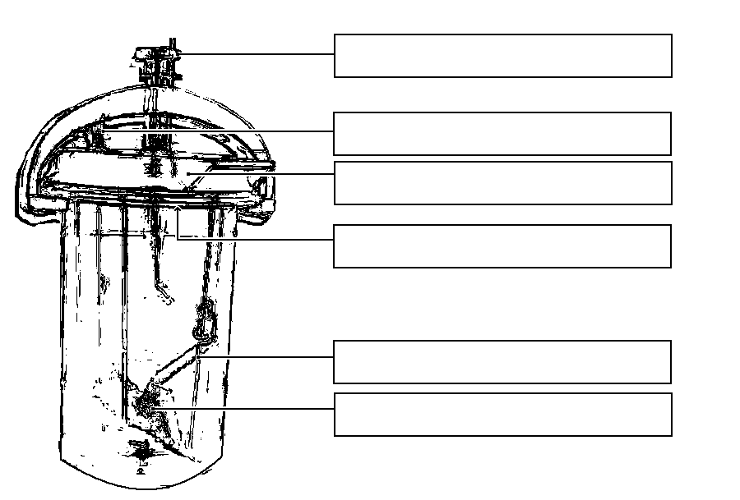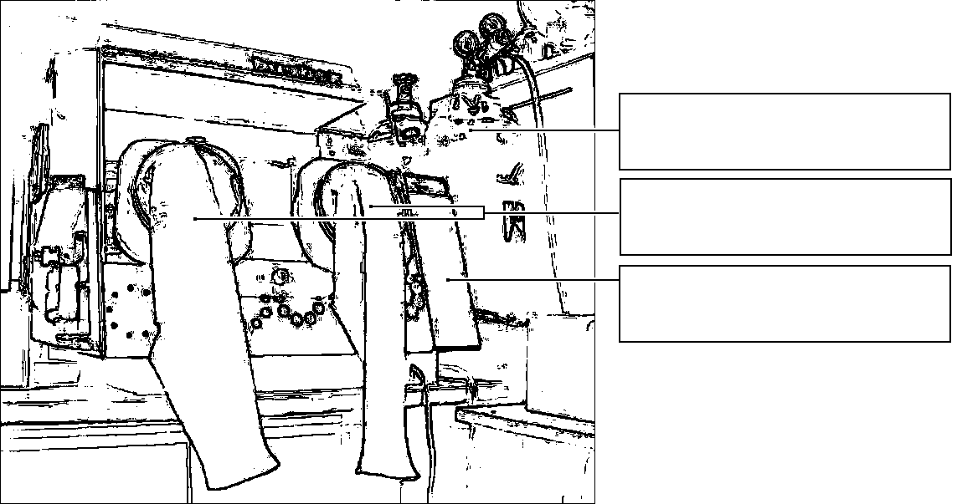

Task 13: Cultivation on agar media
Describe cultivation results of the presented strains on both aerobic and anaerobic media.

a) Aerobic culture on blood agar (BA)
Write down whether the bacteria grow on it or do not grow, and possibly describe the colonies.

b) Anaerobic culture on VL agar (VL blood agar)
VL (blood) agar is similar to blood agar, but it has a decreased redox potential and it is cultured either in the anaerobic jar or anaerobic box. Write down which strains are able to grow on it and describe those not growing on BA

c) Multiplication of anaerobic bacteria in VL broth
VL broth is used especially for the multiplication of rare anaerobic bacteria. Check the presence of turbidity (i.e. the growth) in VL broth, write it in the table and compare with the results of Part b)

Task 14: Species diagnostics of anaerobic bacteria using biochemical tests
In the strains found to be anaerobes we would use the biochemical microtest (ANAEROtest 23 Erba-Lachema) inoculated two days prior. The way of reading is similar to that of NEFERMtest 24, but the difference is that we use a four-part textbook. Therefore the test is not performed in this double practical session. Write just “G– anaerobic rods” or “G– spore forming anaerobic rods” as your final result.

Task 15: Susceptibility tests of anaerobic bacteria to antibiotics
Perform in vitro susceptibility testing of Gram-negative cocci to suitable antibiotics.
Evaluate the diffusion disc susceptibility tests to antibiotics in strains found to be anaerobic and which are pathogenic. Write the abbreviation of the antibiotics according to a card in the table and for all the tested strains, measure the susceptibility zones. On your card, you have limit zones – according to these, interpret the zones as susceptible (S), resistant (R) and dubious (D).
Strain →
Antibiotics  (full name) | Zone ∅ (mm) | Interpretation | Zone ∅ (mm) | Interpretation

Task 16: Detection of clostridial toxins
In clostridia, for toxin detection we use various tests.

a) Demonstration of the Clostridium perfringens toxin (lecithinase)
C. perfringens lecithinase is a toxin that can be neutralized by a specific antibody. One half of your yolk agar plate has been treated with the antiserum (anti-lecithinase), the other has not. The toxic effect of the lecithinase can be seen as a precipitation area around the examined strain; the particular toxin is neutralized by the antitoxin, other lecithinases are not. Draw the effect into the picture and add description.
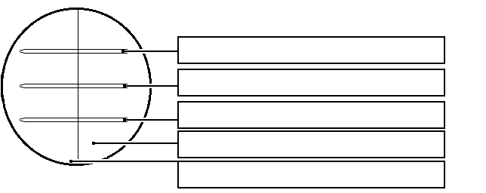

b) Demonstration of the Clostridium tetani toxin
In C. tetani the toxin is demonstrated by animal experiment on mice, especially the specific position of the extremities and of the tail. Dental students do not perform the task.

c) Detection of the Clostridium difficile A and B toxins
Pseudomembraneous colitis due to Clostridium difficile toxins is very serious, especially in hospitalized patients. The testing is performed by means of an immunochromatographic test which was already performed in the J09 practical. It is essential in practice to send a genuine piece of stool (NOT rectal swab) to the laboratory. Observe the result of the Clostridium difficile A + B toxins detection in stool specimens X and Y and write down the results:

Specimen X is positive – negative Specimen Y is positive – negative

