

**ACADEMIC WRITING COURSE AUTUMN 2014**

**SESSION 1 (selected activities)**



**Mgr. Robert Helán, Ph.D.**

**Mgr. Radomíra Bednářová**

***Masaryk University Language Centre***

**1. INTRODUCTION TO THE COURSE**

**2. FEATURES OF ENGLISH FOR GENERAL ACADEMIC PURPOSES**

**3. CHARACTER OF ACADEMIC WRITING IN ENGLISH**

**4. ABSTRACTS AND WRITING OF ABSTRACTS**

**5. INTRODUCTION SECTIONS OF RESEARCH ARTICLES (RA)**

**In the session the following areas will be covered:**

→ major characteristics of academic English

→ basic principles of academic writing in the context of graduate/postgraduate studies

→ discussion of students´ academic positions and their perceived needs in writing

→ governing principles of abstract and research article writing

**E-learning:**

**https://is.muni.cz/auth/el/1411/podzim2014/DSAJz01/index.qwarp**

**I. DISCUSSION QUESTIONS:**

1. Do you like writing? Do you prefer writing or typing?

2. What are your biggest problems with writing?

3. What writing skills do you need to be able to write well?

4. How important is it to plan what you write?

5. How important do you think writing in English is in today’s world?

6. How is your writing in English? Is writing in your language different from writing in English?

7. What advice would you give to a student who says he/she is no good at writing?

8. What questions would you like to ask a writing expert about writing?

9. E. L. Doctorow said: *"Writing is an exploration. You start from nothing and learn as you go.*" Do you agree?

**THE PROCESS OF WRITING**

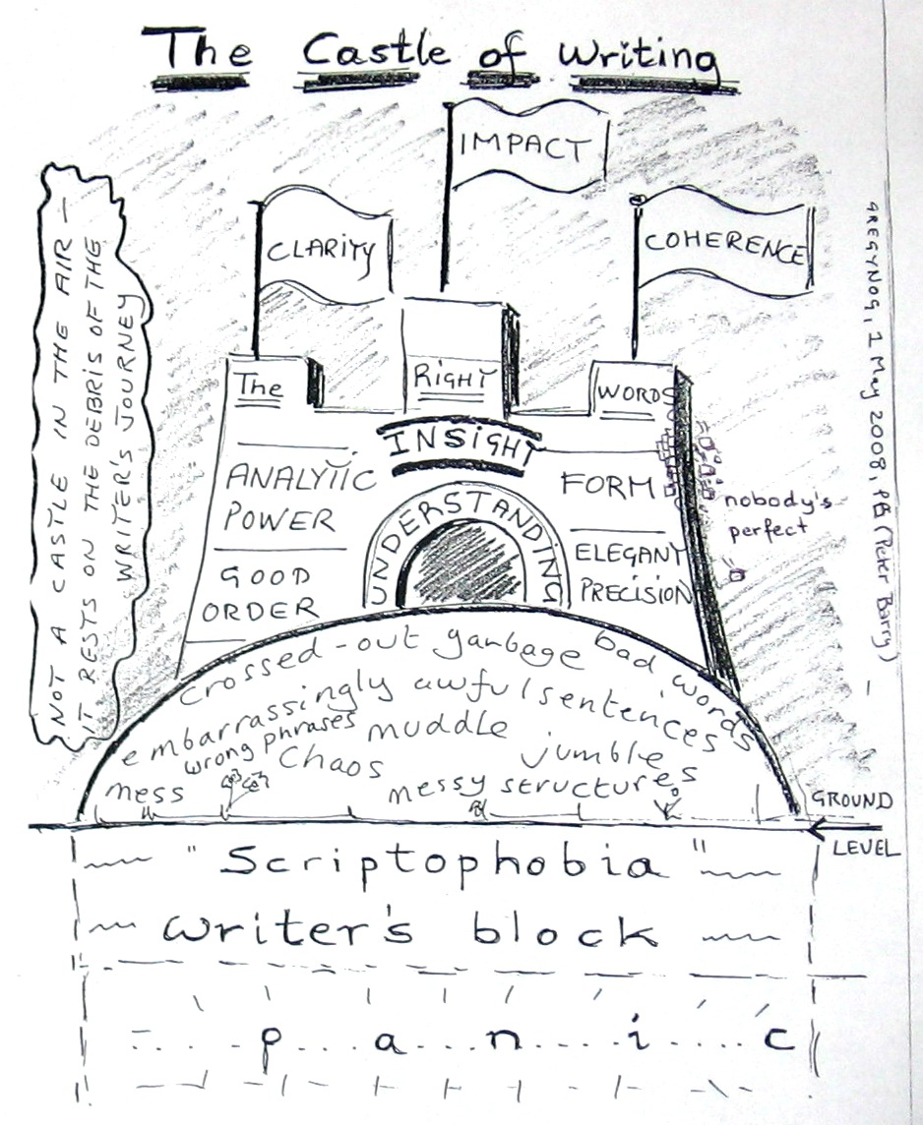

**II. ACADEMIC WRITING – INTRODUCTION:**

***1. List and discuss the main characteristics of academic writing. Consider the following levels of writing and give examples:***

- MICRO LEVEL: correct spelling

- MEZZO LEVEL

- MACRO LEVEL

***2. Discuss the following questions in connection with academic writing.***

|  |  |  |
| --- | --- | --- |
| Who?  *Who is writing?*  *Who is the audience?* | What?  *What is the writing about?*  *What type of writing is it?* | Why?  *Why is the writing done?* |
|  |  |  |

***3. Complete the following tables.***

|  |  |  |  |  |
| --- | --- | --- | --- | --- |
| **formal** | **informal** |  | **formal** | **informal** |
|  | seem |  | enquire |  |
|  | climb |  |  | end |
|  | help |  |  | tell |
| cease |  |  | obtain |  |
| commence |  |  | preserve |  |
|  | use |  | reject |  |
| decrease |  |  |  | free |
| demonstrate |  |  |  | mend |
| depart |  |  | require |  |
|  | want |  |  | live |

|  |  |  |  |  |
| --- | --- | --- | --- | --- |
| **formal** | **informal** |  | **formal** | **informal** |
|  | understanding |  |  | childish |
| deficiency |  |  |  | wrong |
| opportunity |  |  | inferior |  |
| perspiration |  |  | inexpensive |  |
|  | house |  |  | dim |
|  | sight |  | insane |  |
| amiable |  |  |  | laid back |
|  | whole |  | responsible |  |
| energetic |  |  |  | enough |
| fortunate |  |  |  | empty |

***4.***



***5.***



**III. ABSTRACTS AND WRITING OF ABSTRACTS:**

**Structure**

1. Background/introduction

2. Purpose

3. Methods/materials

4. Results/findings

5. Discussion/conclusion

***1.* *Each section answers some implied questions. Match the following questions with the sections above.***

a. What was discovered? Section ___

b. How was the research done? Section ___

c. What do we know about the topic and why is it important? Section ___

d. What do the findings mean? Section ___

e. What is this study about? Section ___

***2. Here is an abstract from a published paper. It is 178 words long. Read it through looking for the main function of each sentence (background, purpose, methods, results, and discussion).***

|  |
| --- |
| Warmer Climates Boost Cyanobacterial Dominance in Shallow Lakes[1]  **(1)** Dominance by cyanobacteria hampers human use of lakes and reservoirs worldwide. **(2)** Previous studies indicate that excessive nutrient loading and warmer conditions promote dominance by cyanobacteria, but evidence from global scale field data has so far been scarce. **(3)** In this paper we show that although warmer climates do not result in higher overall phytoplankton biomass, the percentage of the total phytoplankton biovolume attributable to cyanobacteria increases steeply with temperature. **(4)** Our analysis is based on a study of 143 lakes along a latitudinal transect ranging from subarctic Europe to southern South America. **(5)** Our results reveal that the percent cyanobacteria is greater in lakes with high rates of light absorption. **(6)** This points to a positive feedback because restriction of light availability is often a consequence of high phytoplankton biovolume, which in turn may be driven by nutrient loading. **(7)** Our results indicate a synergistic effect of nutrients and climate. **(8)** The implications are that in a future warmer climate, nutrient concentrations may have to be reduced substantially from present values in many lakes if cyanobacterial dominance is to be controlled. |

***3. Answer the following questions about the abstract.***

a. Are introductory statements general or specific?

b. Are they in first person or third person style?

c. What tense is used?

**Language for presenting the research/purpose**

* Third person style:

The / This paper analyzes, investigates, explores,

article examines, re-examines, outlines,

study describes, shows, introduces,

analysis evaluates, considers …

* First person style:

In this paper analyze, investigate, explore,

article examine, re-examine, outline,

study I / we[2] describe, show, introduce,

analysis evaluate, consider…

***4. Read the sentences below and fill in the gaps with one of the following verbs:***

|  |
| --- |
| **develops - calls - argues - provides - looks - consider** |

1. This paper _______________ an axiomatic basis for a representation of personal preferences in which ...
2. The authors _______________ a broad class of situations where a society must choose from a finite set of alternatives.
3. This paper ______________ that the analysis of these games involves a key technical issue.
4. This paper ____________ at the effectiveness of the Environmental Protection Agency (EPA) in reducing the time that manufacturing plants spend in a state of non-compliance.
5. This study ___________ into question the established view that lack of information on clean-up cost functions represents a serious problem ...
6. This paper _____________ a model of corporate hierarchy in which workers accumulate heterogeneous human capital suitable for different positions within the hierarchy.

***5. Sometimes, the Methods section sentences are expressed in the passive form. Rewrite the following sentences using the passive voice.***

1. We then monitored the physicochemical parameters of the lake water for 1 year.

__________________________________________________________________________

1. We collected samples for particulate toxin analysis from more than 140 lakes...

__________________________________________________________________________

1. We detected microcystins in nearly 50% of the samples.

__________________________________________________________________________

**Language for presenting the findings**

The results show, state, suggest, uncover,

findings indicate, imply, provide…

***6. Read the following sentences from different abstracts. Each sentence contains a problem in usage (grammar or vocabulary). Identify and fix the problems.***

a. In this contribution are described several problems with toxic cyanobacterial blooms in Brno Reservoir.

b. We are also focused on the implementation of new technologies for the management of harmful algal blooms.

c. The aim of the paper is to deal with the problematic of cyanobacterial influence on tourism.

d. It was tested by the study whether specific cyanobacteria would react to the applied strategies...

e. The paper is devoted to the analysis of problems with cyanobacteria.

f. Laboratory animals are not susceptible to these diseases, so research on them is hampered.

g. Our results are similar to previous studies.

**IV. PARAGRAPH SKELETON FOR INTRODUCTIONS**

**1.) *This excerpt comes from the beginning of an article, where a wide body of research is reviewed in an economical way so that the author can situate her own approach. Underline those phrases that you think you could use in your own writing. One example has been done for you.***

[1] **The study builds on and contributes to work in** critical linguistics (Coulthard, 1996; Chilton, 1982; Fairclough, 1989; Seidel, 1985; Van Dijk, 1989, 1991; Wodak, 1989). [2] Although studies in critical linguistics have examined the discursive construction of past events, there has not been an extended study of the construction of a projected event. [3] As such, this study provides additional insight into the constructive processes of language by explicating the linguistic and rhetorical processes through which a projected—future—event is constructed as a discrete and autonomous state of affairs. [4] The analytic focus on a projected event enables another contribution. [5] This study analyzes how the political and social interests underlying accounts of the Iraq/Saudi Arabia projected event were rhetorically managed in *The New York Times (NYT*) and *Washington Post (WP)*. [6] Although numerous studies (Bruck, 1989; Clayman, 1990; Fairclough, 1992c; Fowler, 1991; Van Dijk, 1988, 1989, 1993; Zelizer, 1989) have identified sourcing (i.e., using spokespersons representing so-called elite groups and institutions as sources for information) as a constructive social and ideological practice, little analytic attention has been paid to the implications of this finding for how texts are linguistically constructed within newspaper discourse, a discourse context guided by the professional canon of objectivity, balance and neutrality. [7] I address this issue by demonstrating how assertions about a hypothetical future event attributed to a specific group of spokespersons were transformed into unmediated and presupposed information.

**2.)** *Questions:*

* Which sentence locates her analysis within a specific discipline?
* How and where does she signal a gap?
* How and where does she signal the contribution her study will make to the field?

**3.) *These are the phrases forming the skeleton of the article. Can you think of synonyms which could be used for some of the words? One example has been done for you.***

work

research

paper

report

survey

article

1. The **study** builds on and contributes to work in ____________________.

2. Although studies in _______________ have examined _____________

there has not been a/an _______________________________________.

3. As such, this study provides additional insight into _________________.

4. The analytic focus on __________________ enables another contribution.

5. This study analyses _________________________________________.

6. Although numerous studies ( ) have identified __________

________________________________________________________ ,

little analytic attention has been paid to _________________________ .

7. I address this issue by demonstrating ____________________________

_________________________________________________________ .

**4.) *Use the paragraph skeleton and synonyms of your choice to write a short introduction of a research paper (research you have carried out or have already written about).***

|  |
| --- |
|  |

1. (Kosten, S. et al. (2012), Warmer climates boost cyanobacterial dominance in shallow lakes. Global Change Biology, 18: 118-126.)
2. Only in case there are more authors than one.