P11 Clinical microbiology II – examination in respiratory and GI infections
To study: Infections of various organs and organ systems (from textbooks, www etc.)
From the spring term: Microscopy, culture, biochemical identification

Examination in respiratory tract infections

Task 1: Search for respiratory pathogens in clinical microbiology
With the help of your teacher and the slideshow, describe the following picture. Use the knowledge from this picture in the Task 2 and Task 3.
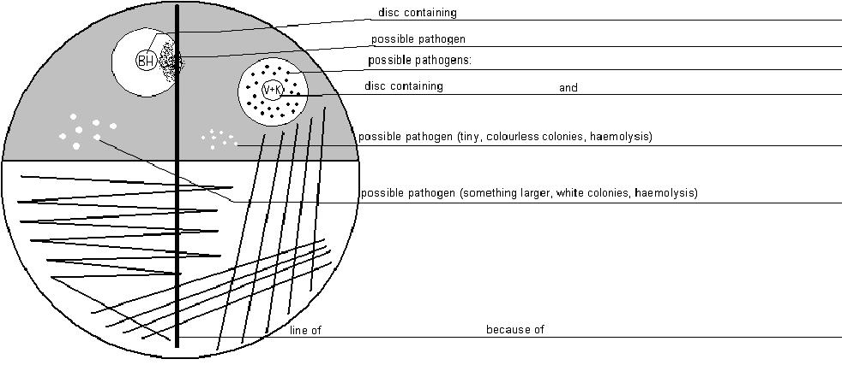
Common pharyngeal flora consists mostly of
a) _____________ appearance: ________________________
b) _____________ appearance: ________________________

Task 2: Examination in acute bronchopneumonia
For this casuistic, documented by the order form, try to examine the corresponding specimen (sputum), to find a possible pathogen, make a conclusion and interpret the result. Step by step, fill in the individual fields in “the screen of laboratory information system”.
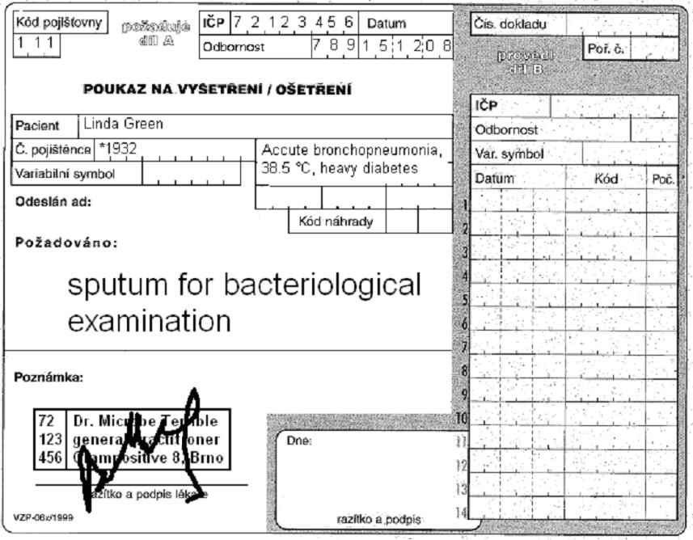

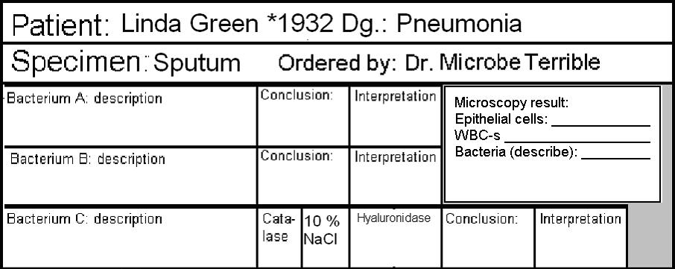
Antibiotic susceptibility test (bacterium C)
Cefoxitin (FOX)* | R < 22  S ≥ 22 |  | Co-trimoxazole (SXT) | R < 14  S ≥ 17
Erythromycin (E) | R < 18  S ≥ 21 |  | Tetracyclin** (TE) | R < 19  S ≥ 22
Clindamycin (DA) | R < 19  S ≥ 22 |  | Chloramfenicole (C) | R < 18  S ≥ 18
write S = susceptible, R = resistant, eventually I = intermediary
*interpreted as oxacillin and other beta-lactams
**result of this test is also valid for doxycycline
Final conclusion and recommendation for treatment: _______________________________________________

a) Microscopy of sputum
Look at the smear prepared from your specimen. Try to find the individual objects (bacteria, host cells). Fill in the field “Microscopy result”:
+++ = more than 10 objects in the observation area
++ = less than 10 objects in the observation area
+ = only rare objects (one or less per an observation area)
0 = none

b) Description of bacteria
On the blood agar, describe the size, colour and haemolytic properties of the grown bacteria. Do not describe other characteristics. Take into account that there was no growth visible on Endo agar. Bacteria A and B should be bacteria considered to be parts of normal flora. Bacterium C will be a pathogenic bacterium that will be tested in detail in parts c) and d)

c) Further tests
Fill in the results of the catalase test, hyaluronidase test and of the growth on blood agar with 10 % NaCl for Bacterium C.

d) Antibiotic susceptibility
Fill in the antibiotic susceptibility test for Bacterium C. Always write down the name of the antibiotics and “S” or “R” (susceptible or resistant). Reference zones are written on your table.

e) Final conclusion
Try to formulate several words for the general practitioner. Especially try to find out (with the help of your teacher) which antibiotics would be the best choice.

Task 3: Examination in acute tonsillitis
Similarly as in the previous case, there is an order form. Try to examine the corresponding specimen (throat swab) to find a possible pathogen, make a conclusion and interpret the results. Step by step, fill in the individual fields in “the screen of laboratory information system”. The way of doing it is the same as in the previous task.
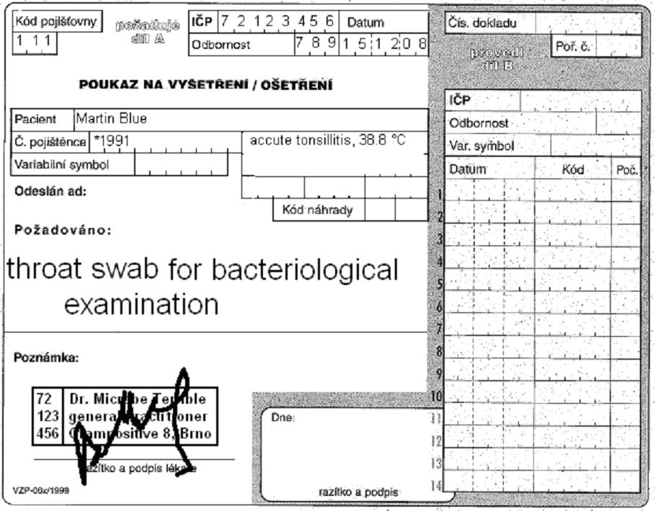

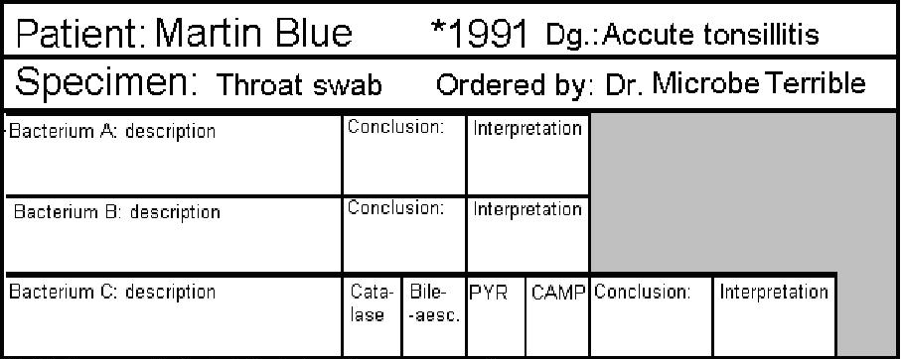
Antibiotic susceptibility tests (bacterium C)
Penicillin  (P) | R < 18  S ≥ 18 |  | Chloramfenicol (C) | R < 19  S ≥ 19
Erythromycin  (E) | R < 18  S ≥ 21 |  | Tetracyklin*  (TE) | R < 20  S ≥ 23
Clindamycin (DA) | R < 17  S ≥ 27 |  | Vancomycin (VA) | R < 13  S ≥ 13
write S = susceptible, R = resistant, eventually I = intermediary
*interpreted as oxacillin and other beta-lactams
**result of this test is also valid for doxycycline
Final conclusion and recommendation for treatment: _______________________________________________

Task 4: Suitable specimens for various respiratory infections
Using slideshow, find suitable way of examination for various clinical situations
Suspicion for | Type of specimen | Suspicion for | Type of specimen
rhinitis |  | bronchitis
sinusitis |  | acute pneumonia (expectoration of pus)
pharyngitis |  | subacute pneumonia (dry cough)
influenza |  | lung aspergilosis

Examination in gastrointestinal system

Task 5: Examination in acute diarrhoea
In this case, stool was sent to the laboratory. We have to know, that stool normally contains strictly anaerobic flora, but this cannot be found during normal examination, as normal examination is only aerobic. Even enterococci are only found in blood agar is used, and this is not part of routine examination of stool. On the other hand, members of Enterobacteriaceae family are often found in stool – both parts of normal flora (with some strains with elevated virulence, for example EPEC for E. coli) and obligatory pathogens (Salmonella). – The stool specimens are observed after 24 hours (direct result of Endo agar and XLD agar) and 48 hours (direct result of Campylobacter examination on CCDA agar and Yersinia examination on CIN agar, and subcultures from selenite broth on Endo agar and MAL agar). The 24 h examination was already performed in your case. Fill in results of 48 h examination and try to make a final conclusion.
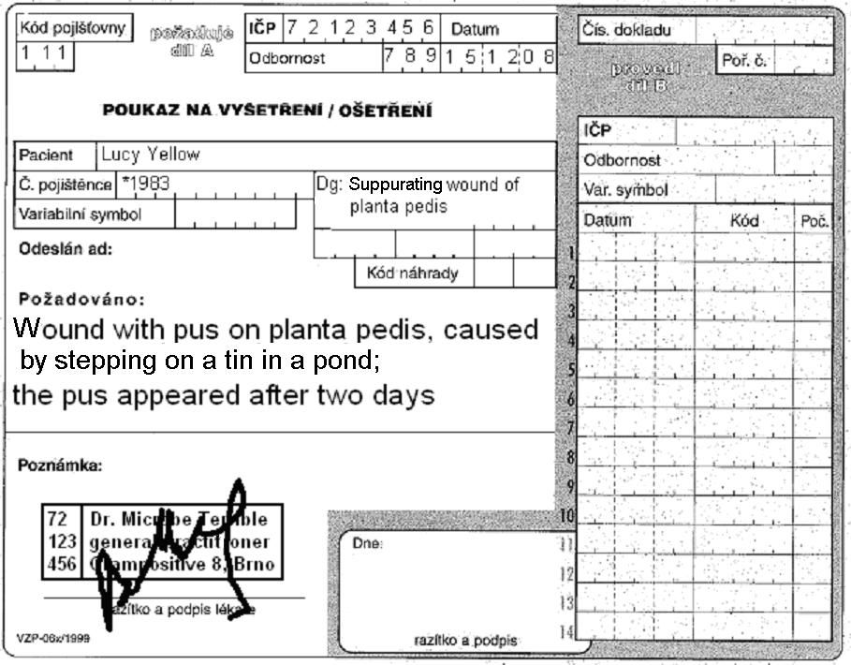
Stool for bacteriological examination
Cecilia Brown
Acute diarrhoea

Patient Cecilia Brown, *1984 Dg.: Accute diarrhoea
Endo agar  (24 h) | XLD agar  (24 h) |  | Endo agar  (subcultivation) | MAL agar  (subcultivation) | CIN agar  (48 h) | CCDA agar  (48 h)
E. coli | negative |  |  |  | Final conclusion and interpretation
More tests
HAJNA medium

Serotypisation

Task 6: Stool samples for different types of pathogens and toxins
For some purposes, it is possible to send rectal swabs, while for others, it is necessary to send a piece of stool, sometimes even refrigerated.
Fill in the next table.
Stool sent for | Type of specimen | Stool sent for | Type of specimen
bacteriology |  | virology – virus isolation
mycology |  | parasitology
virology – antigen detection |  | detection of the Clostridium difficile toxin

