**Complete the picture of the skeleton.**

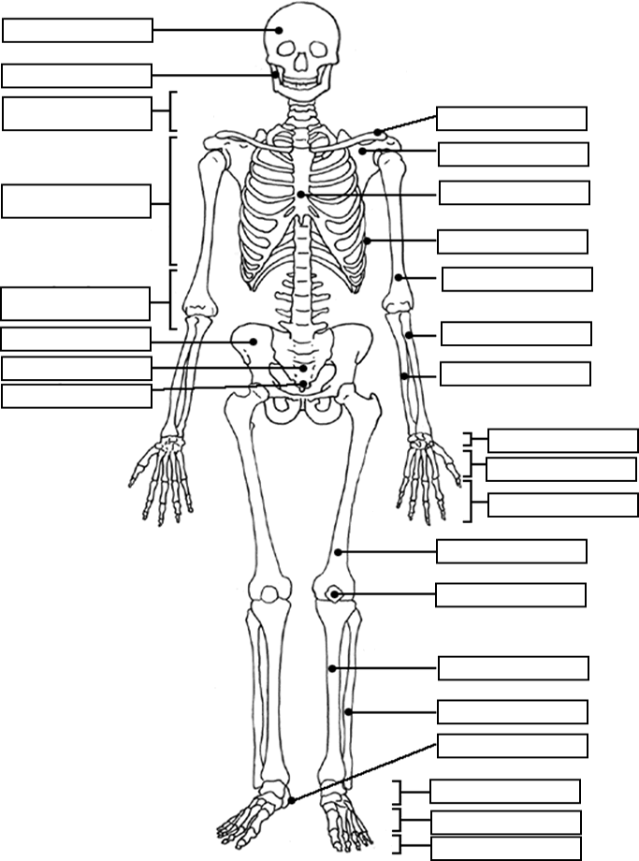

***Discuss the following:***

- parts of musculoskeletal system

- function of the musculoskeletal skeletal system

- parts of bones

- types of bones

- describe some of the bones of the skull

- types of vertebrae

- bones of arms x hands

- bones of legs x feet

***Match the bones with their common names.***

|  |  |  |  |
| --- | --- | --- | --- |
| **1** | coccyx | **a** | skull |
| **2** | clavicle | **b** | thigh bone |
| **3** | scapula | **c** | bones of fingers and toes |
| **4** | sternum | **d** | jaw bone |
| **5** | pelvis | **e** | breastbone |
| **6** | femur | **f** | hip bone |
| **7** | patella | **g** | collarbone |
| **8** | talus | **h** | tailbone |
| **9** | phalanges | **i** | shoulder blade |
| **10** | carpus | **j** | wrist bone |
| **11** | tibia | **k** | spine |
| **12** | mandible | **l** | ankle bone |
| **13** | cranium | **m** | shin bone |
| **14** | vertebral column | **n** | kneecap |

***Complete the text.***

The musculoskeletal system __________ of ­­bones, joints, and muscles. Bones are the principal organs of ­ __________ and protection for the body. Joints are the places where two bones meet or __________. Bones are unable to move __________ the help of muscles, __________ is provided by muscular tissue. Muscles are usually __________ to two bones, and during contraction, one bone is drawn toward __________. This way muscles produce movement by exerting a force on the bones to which they are attached. Movement of the body is enabled by bones acting as points of attachment for muscles, __________, __________, and __________. The larger bones contain bone __________ which is responsible for Blood cell formation, or __________. The bones serve as __________ for minerals, mainly phosphorus and calcium.