# Heart

**A Watch the video and number the terms in the order they are mentioned for the first time:**

__ Brachiocephalic ……………………………………………………………………………………………………………

__ Papillary muscles ……………………………………………………………………………………………………………

__ Pulmonary artery …………………………………………………………………………………………………………..

__ Cordae tendinae …………………………………………………………………………………………………………..

__ Pulmonary vein …………………………………………………………………………………………………………..

__ Aorta …………………………………………………………………………………………………………..

__ Tricuspid valve …………………………………………………………………………………………………………..

__ Bicuspid (mitral) valve ………………………………………………………………………………………………………….

__ Superior vena cava ………………………………………………………………………………………………………….

__ Septum ………………………………………………………………………………………………………….

**B Write the name of each numbered part next to each technical term.**

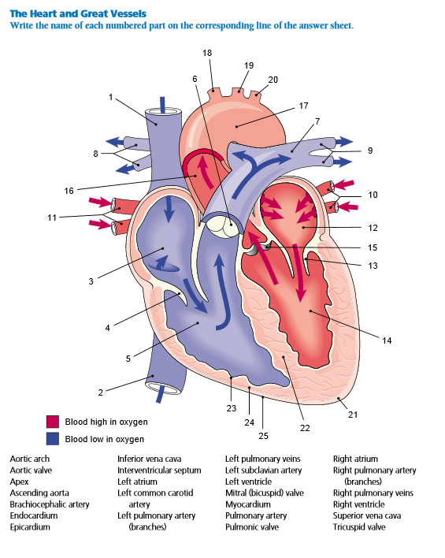

**C Answer the following questions while working with you partner.**

1. What is the cardiovascular system composed of?
2. What are the three layers of tissue that the heart consists of?
3. What are the four chambers the heart is divided into?
4. What is the function of the septum?
5. What is the fuction of the valves?
6. Which muscles hold the valves in place?
7. What is another name for the bicuspid valve?
8. Briefly describe the three types of blood vessels which carry blood.
9. How do the systemic and pulmonary circulations differ?

**NOTE-TAKING TASK – ANGINA PECTORIS and PERICARDITIS**

**Pre-reading 1: match the terms with their definitions**

1 etiological a) retention of waste products in the blood

2 clinical b) decrease in blood supply

3 friction rub c) dealing with causes of disease

4 effusion d) decrease in systolic BP

5 tamponade e) sound caused by the rubbing together of two serous membranes

6 paradoxic pulse f) an abnormal deposit of fat or lipids, e.g. in an arterial wall

7 neoplasm g) relating to the bedside treatment

8 uremia h) condition in which the heart is squeezed by fluid

9 ischemia i) abnormal growth of tissue

10 atheroma j) escape of blood into a part of the body

**Pre-reading 2:** work with the copy handed out; for the list of notes, **predict possible answers**. Later, work with one text our of two, **make more notes** and use the information later for a **mini-presentation** of the given pathology (see another copy).