READING – KEY

Reading – sentences

9D 10G 11B 12H 13F 14E 15A

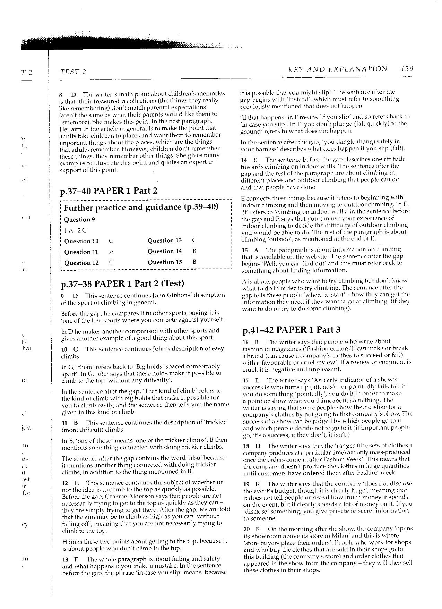

Reading – paragraphs

1D 2F 3A 4E 5B 6G

Reading – multiple choice

1C 2B 3D 4C 5A 6D 7B

Reading - matching

16D 17C 18A 19B 20B 21A 22D 23C 24D 25B 26/27A/C 28D 29B 30A

