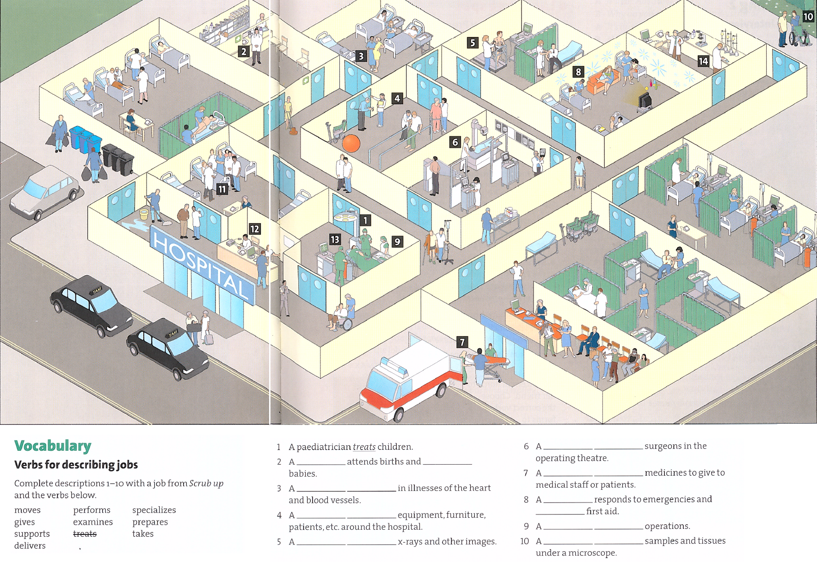

**Hospital staff**

anaesthetist

cardiologist

consultant

lab technician

midwife

paediatrician

paramedic

pharmacist

physiotherapist

porter

radiologist

receptionist

scrub nurse

dentist

surgeon

physician

GP (general practitioner)

obstetrician

**General**

inpatients

outpatients

consulting room

operating theatre

ward (e.g. isolation ward)

ward round

walker

crutches

wheel chair

ambulance

stretcher

drip feed

X-ray

ultrasound

trolley

**Departments**

A&E Accident and emergency

Anesthesiology

Cardiology

Dermatology

Ear nose and throat (ENT)

Gastroenterology

General surgery

Gynaecology

Haematology

ICU Intensive care unit

Neurology

Nutrition and dietetics

Obstetrics

Oncology

Ophthalmology

Orthopaedics

Paediatrics

Pathology

Pharmacy

Physiotherapy

Radiotherapy

Renal unit (Nephrology)

Urology

**1. Discuss these questions with your partner then watch the video again and complete the missing answers.**

1. Who is the scheduled patient and what is his/her health problem?
2. What is the condition of the two sisters in the wards?
3. What is the research project about in which Annika is taking part?
4. Where are the patient samples studied?
5. Who is the patient in ICU?
6. What is the cause for the code blue call?

**2. Match the relevant hospital staff to the numbers in the picture, there are two which you do not need.**

[əˈniːsθətɪst]

[ˌkɑːdiːˈɒlədʒɪst]

[kənˈsʌltənt]

[læb tekˈnɪʃən]

[ˈmɪdˌwaɪf]

[ˌpiːdɪəˈtrɪʃən]

[ˌpærəˈmedɪk]

[ˈfɑːməsɪst]

[ˌfɪzɪəʊˈθerəpɪst]

[ˈpɔːtə]

[ˌreɪdɪˈɒlədʒɪst]

[rɪˈsepʃənɪst]

[skrʌb nɜːs]

[ˈdentɪst]

[ˈsɜːdʒən]

[fɪˈzɪʃən]

[ˈdʒenrəl prækˈtɪʃənə]

[ˌɒbsteˈtrɪʃən]

Key:

Vocabulary - suggested answers

2. midwife (an obstetrician), delivers

3. cardiologist, specializes

4. radiologist, takes

5. scrub nurse, supports

7. pharmacist, prepares

8. paramedic gives

9. surgeon performs

10. lab technician, examines

Listening: see video, suggested answers:

1. five-month-old baby girl suffering from cataract

2. cystic fibrosis

3. national allergy research project

4. in the laboratory right in the hospital

5. a small boy who was diagnosed with brain stem tumour

6. a training exercise with a mannequin