You should be able to answer these questions:

1. What parts does the skeleton have? What do the parts consist of?

2. What are the main types of bones? Where can we find them?

3. Can you explain what ossification is?

4. What bones does the skull consist of?

5. How are upper extremities attached to the body?

6. What does the lower limb consist of?

7. What types of muscles do people have?

8. What function does smooth muscles have?

9. Can you explain what goose pimples are?

Ex.1. Complete the following verbs:

COMPOSE, CONSIST, COMPRISE, PROTECT, MAKE, CONTAIN, SERVE, DIVIDE

Skeletal system **consists** of about 206 bones. The bones **serve** as a shield and **protect** the vital internal organs from injury. They are **composed** of minerals, organic matter and water. In the bones, there is red and yellow bone marrow, the yellow marrow **contains** fat cells. The spinal column is **made** up of vertebrae and spinal discs and it is **divided** into several parts, e.g. cervical and thoracic. The upper limb **comprise**s humerus, ulna and radius.

Song

http://www.youtube.com/watch?v=uzxmKAWiN_U

Cranium the **skull**, eight bony plates will merge

Jawbone I have heard **mandible** is the word

The scapula and **clavicle**, shoulder – collarbone

Backbone is **vertebrae**

Then there is the **pelvis**, it is made up of three

Ilium and pubis, ischium helps legs swing

And together they help you run and play and

move **around** in night and day

Refrain:

Like a **framework** maybe it protects it

and gives body **shape**

Here are the parts of **skeletons**

Short, long, **flat**, irregular

They are hard, protect your **heart** and they’re inside you

Here are the parts of **skeletons**

From feet to face it is a system

**Joints** moving, la la la

They are inside you

Here are the parts, here are the parts

Hello my name is …

Humerus, arm

**Ulna** and radius

Where? In the **forearm**

Thigh bone is femur, **patella**, knee

Coccyx, it was once a **tail**

Tibia and fibula make up the **shin bone**

Tarsals are in the ankle, **metatarsals** are the foot bones

The **phalanges**, they are your toes

Yeah, just like your finger bones, like

Refrain

Here are the parts – **axial** skeleton

Made up of backbone, skull, **ribs** for the lungs

On imaginary line or around

Middle of us, here it is, the line’s down.

Here are the parts of **appendicular**

Made up of bones on both sides of the line

They help you dance like your legs and your arms

Namely your **shoulders** and pelvis, I’m done

Refrain

wrist, breast bone, chest/rib cage, upper jaw, neck, shoulder blade, backbone/vertebral column, knee, elbow (bone),

windpipe, collar bone, shin bone, finger, ankle bone, skull, lower jaw, thigh bone, gullet

thoracic, cranial, sacral, clavicular, fibular, femoral, costal

cubital, articular, coccygeal, patellar, bony, genicular, postural

Picture description:

make sure you know these words: slip, spill, twist=sprain, apron, pull a joint out of place, paving stone, avoid, trip over (=stumble over)

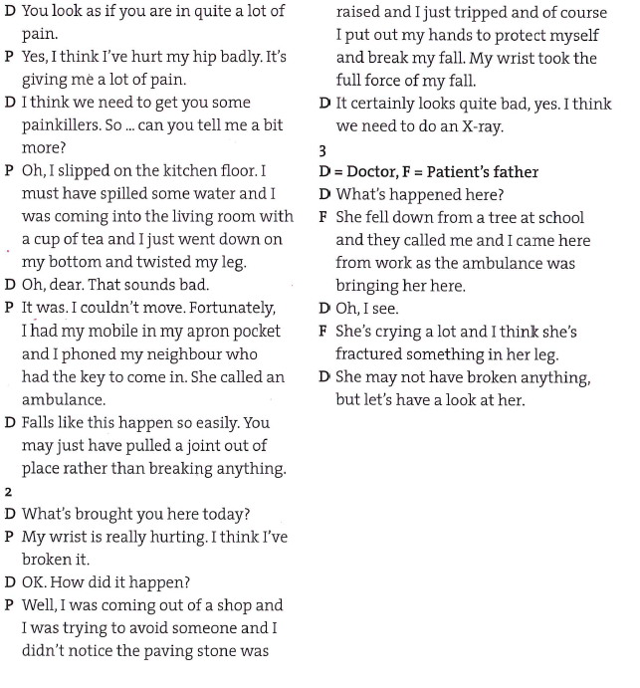

**Talking about the present**

1. So you ___have taken___ some painkillers, but they __don’t work_____, and your arm __is__ still __hurting__ you just here.

2. My toe ___is throbbing___ with pain. I don’t know what I___’ve done_______. It ___looks___ as if it’s broken.

3. He __has had___ several falls recently and he __has__ several fractures, but he ____isn’t crying____ a lot.

go, wash, want, sit, like, lie, travel, play, try, see

Present simple

Present continuous

Present perfect

1. We use this tense to talk about something that has happened recently and also to refer to a time span from any time in the past up to present (i.e. for description of an event in the past without a definite time).
2. We use this tense to describe an action or situation that is happening now, at the moment of speaking; for unfinished, continuing actions which are not happening at the moment of speaking; for changing situations. We don’t usually use it with certain verbs expressing thoughts and opinions, feelings, senses, and possession and existence.
3. We use this tense to describe a state or fact, to talk about habit or repeated action, to refer to timetable actions and sometimes to talk about plots of movies and books.

