MUSCULAR SYSTEM
Skeletal Muscles
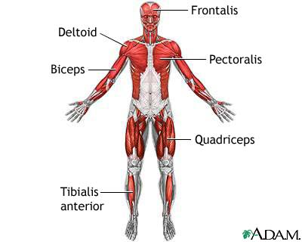
There are over 600 skeletal muscles that serve for body movement through contraction and relaxation. These muscles are voluntary (under conscious control), made up of striated muscle fibres (of two types: fast-twitch and slow-twitch), and attached to bones by tendons. The kinds of body movement include locomotion, facial expressions, posture, and other movements. Skeletal muscles also have muscle tone (partial contraction), maintained by ongoing signals from the nervous system, which helps maintain body posture and readiness for physical activity. Muscles account for approximately 40 per cent of body weight and the metabolism that occurs in this large mass produces the heat that is essential to the maintenance of body temperature.
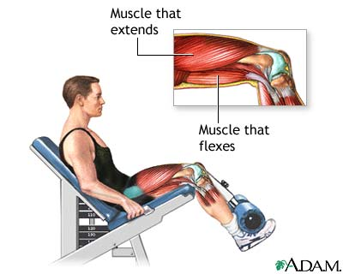
Skeletal muscles form largely a system of pairs of muscles that contract and relax to move or bend a joint. For instance, when the anterior thigh muscle (the quadriceps) contracts, the knee straightens whilst the posterior thigh muscle (the biceps) relaxes. In this instance, the quadriceps of the thigh is referred to as the agonist (or prime mover), i.e. the muscle in state of contraction producing the prime, first motion. To bend the knee back again and return it to its original bent position, the biceps of the thigh contracts (pulls) whilst the quadriceps relaxes. Then, the contracting biceps is termed the antagonist as it produces the opposing motion. Similar opposition is found in the upper arm between the biceps and the triceps (they bend the elbow joint). There are also synergists, muscles that help other skeletal muscles in their actions, and fixators, muscles that stabilise, or fix, ends of other muscles. Some skeletal muscles are also classified for their ability to straighten (extend) or bend (flex) joints, and thus whole limbs, as extensors and flexors, respectively.

The Cardiac Muscle
The cardiac muscle (or myocardium, the middle muscular layer of the heart) is found only in the heart and it forms the atria (sing. atrium) and ventricles, i.e. the walls of the organ. Like the skeletal muscles, the cardiac muscle contains striated fibres, but unlike the skeletal muscles it is involuntary (not under conscious control). The muscle cells of the myocardium maintain a consistent heartbeat (or heart rate). The heart rate as observed in the arteries of the body is termed pulse rate, and it is recorded as the number of beats per minute.
Smooth Muscles
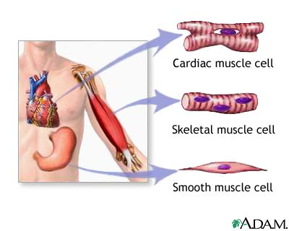
Smooth muscles are found throughout the body: in internal organs, blood vessels, and various glands. Similarly to the cardiac muscle, smooth muscles are involuntary, but in contrast to skeletal muscles and the cardiac muscle, they are not striated (or nonstriated). Smooth muscles within the walls of the digestive tract organs cause peristalsis (or vermiculation) which is the wave-like, worm-like movement of the intestine consisting of alternate circular contractions that aids in intestinal digestion and transport of food. Other examples of involuntary activities of smooth muscles are constriction (closing) of the bronchioles, pupils of the eye or skin contraction in cold conditions (called colloquially gooseflesh or goose pimples; also goose bumps in American English).

SKELETAL SYSTEM
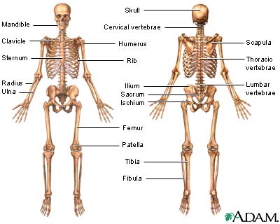
This system has circa 206 bones, plus associated structures like tendons and ligaments, and it serves many important functions. Since bones are rigid, they support the body, give it its shape, and protect its vital organs against injury. Bones provide points for muscle attachments, and, together with the movable joints, they form a system of levers upon which muscles act to produce contraction and thus body movement. A joint is a place where bones meet, or articulate. Bones also function as a site for mineral storage (mainly calcium and phosphorus) and blood cell formation (haematopoiesis). Tendons and ligaments are strong bands of fibrous connective tissue that attach, or link, muscles to bones (tendons), and bones to bones (ligaments).

Skeleton
The skeleton has two parts: the axial skeleton and the appendicular skeleton.
The axial skeleton includes the skull, the hyoid bone, the vertebral column, and the thorax. Its components are aligned along the axis of the body.
The appendicular skeleton includes the bones of the upper and lower extremities (or limbs), the pectoral (or shoulder) girdle, and the pelvic (or hip) girdle. Its components are outside the body main axis.
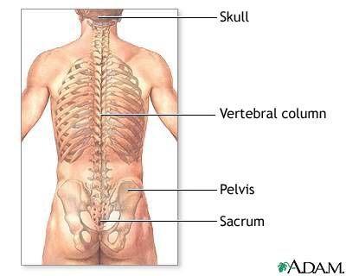
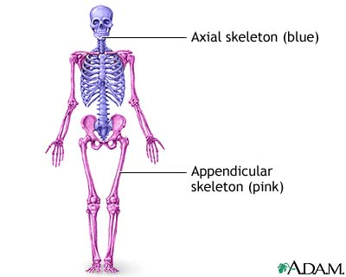
Bones
There are four main categories of bones: long, short, flat and irregular.
Long bones form the extremities (arms and hands, legs and feet) and consist of a diaphysis, two bulbous epiphyses (sing. epiphysis), articular cartilage and periosteum. Periosteum is a dense fibrous membrane of connective tissue covering the surface of bones (except at the joint ends where the bone is covered by cartilage) that contains numerous blood and lymph vessels, and nerves. Dense and hard compact bone is the main building material of long bones and in their hollow centre they contain yellow bone marrow. The epiphyses are mostly formed by spongy, or cancellous, bone material.
Short bones are of irregular, cubic shape and they are found in the wrists and ankles of the upper and lower limbs, respectively. Their core is typically made up of spongy bone.
Flat bones provide broad surfaces for attachment of muscles and protection for internal organs. Examples of flat bones are bones of the skull, ribs, shoulder blades, the breastbone and pelvis.
Irregular bones are all the others; for instance vertebrae (bones of the spine), and bones of the ear and face. They are of various shapes and sizes.
The cavities of the spongy bone in some flat and irregular bones contain red bone marrow, a kind of connective tissue in which blood cells are produced.
Ossification is the medical term for bone growth. Bone is a living tissue that is being renewed throughout life and three types of bone cells participate in this process: osteoblasts (bone-building cells), osteocytes (mature bone cells), and osteoclasts (bone-destroying cells).
The Skull
The skull (or cranium) is the bony framework of the head. Bones of the skull comprise cranial bones and facial bones. Cranial bones are flat, rounded (curved), and fused together to protect the brain which is situated in the brain case (or cranium in its restricted sense). The six cranial bones are the frontal (a), parietal (b), temporal (c), sphenoid (d), occipital (e), and ethmoid (f). These bones meet at zigzag lines called sutures which are in fact immoveable joints.
Of the bones of the face, the upper jaw (or maxilla; g), the lower jaw (or mandible; h), the zygomatic bone (or cheek bone), and the nasal bone are the most prominent. The maxilla, zygomatic and nasal bones are two in number (right and left), and the mandible is the only separate and moveable bone of the skull. Besides the brain case, a number of other cavities are found in the skull: eye-sockets (or orbits), the nasal cavity, and sinuses.
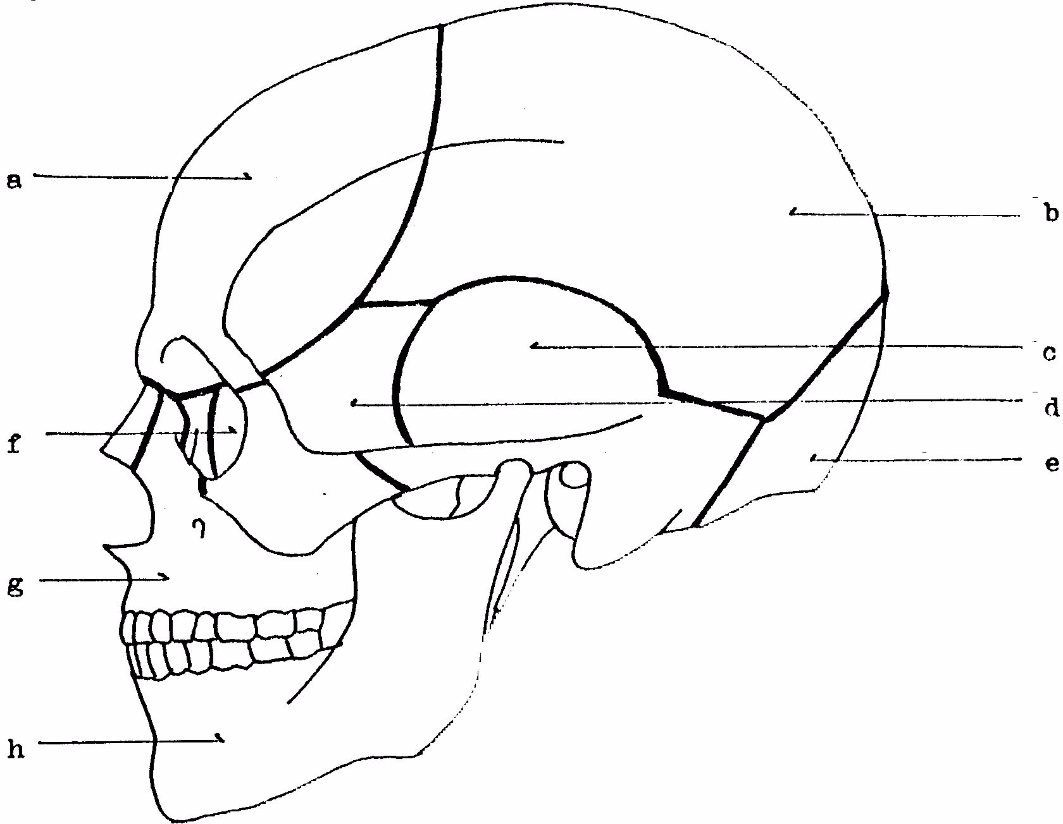
The Vertebral Column
The vertebral column (also called spinal column, spine, or backbone) is composed of 33 vertebrae (sing. vertebra). Its main function is the support of the skull and trunk (or torso) and protection of the spinal cord (or chord) located in the spinal canal. The spine also provides attachment sites for the ribs, and muscles of the trunk. In adults, three groups of vertebrae and two sets of fused bones form the backbone: seven cervical (neck) vertebrae, twelve thoracic (upper back) vertebrae, and five lumbar (lower back) vertebrae. Five (or sometimes four) fused vertebrae form the sacrum (sacral vertebrae) and from three to five fused small vertebrae form the coccyx (or tail bone; coccygeal vertebrae). The first cervical vertebra that articulates with the skull is called the atlas, the second cervical vertebra is called the axis. The atlas allows the head to nod, the axis allows it turn.
A typical vertebra consists of a body, arch and processes (or projections). The prominent upward projection of the axis is called the odontoid process due to its toothlike shape. The 26 moveable vertebrae are separated by intervertebral discs which function as shock absorbers. These discs contain a lot of water the content of which decreases with age, resulting in loss of height.
Looking at it from the side, the backbone has the form of a long S: there are four curves and two basic types of curvature. The congenital (inborn) backward (posterior) curvature of the thoracic and sacral spine is called kyphosis, whilst the natural forward (anterior) curvature affecting the cervical and lumbar spine develops during infancy and childhood, respectively; it is called lordosis. Scoliosis – one or more lateral curves of the spinal column – may also occur.
The Thorax
The thorax (or rib cage) is primarily built up of twelve pairs of ribs that articulate with the thoracic vertebrae posteriorly and the sternum (or breast bone) anteriorly. The 24 ribs are long, flat, curved bones that form, together with the sternum and thoracic vertebrae, a protective cage for the heart, lungs, and other internal organs. They give the chest its shape. There are three kinds of ribs: true ribs are the upper seven pairs; they attach directly to the breast bone. False ribs (the next three pairs below) are only indirectly attached to the sternum; in fact, they are interconnected by their common cartilage (called costal) and attached to the lowest pair of true ribs. The last two pairs of ribs are called floating ribs, as they are not connected to either the sternum or other ribs in front. The spaces between the ribs (intercostal spaces) are filled with muscles that help you breathe.
The Upper Extremities
The upper limbs are a part of the appendicular skeleton. They are attached to the axial skeleton by the pectoral girdle on each side, the bones of which include two scapulae (or shoulder blades; sing. scapula) and two clavicles (or collar bones). The scapula is located in the upper back and articulates with it by muscles and with the humerus in the shoulder joint. The clavicle is connected to the sternum and the whole shoulder girdle is fixed by muscles.
Beginning in the shoulder joint, the (upper) arm (or brachium) extends down to the elbow joint and is formed by a long single bone called the humerus. The upper epiphysis, or end, of the humerus is characterised by its hemispherical smooth joint head, fitting in the shoulder joint socket. The forearm begins at the elbow. The forearm is composed of two long bones, the radius on the thumb side, and the ulna on the little finger side.
The forearm articulates with the hand at the wrist (or carpus). The wrist consists of eight small bones arranged in two irregular rows called carpal bones (or just carpals). They are tightly bound together by ligaments. The five metacarpal bones (or just metacarpals) that form the framework of the palm project from the carpus. The bones of the fingers are referred to as phalanges (sing. phalanx). They articulate directly with the metacarpals and are three in number in each of the fingers, and two in the thumb. The individual names of the fingers are as follows: forefinger (or index finger), middle finger, ring finger, and little finger (or pinkie).
The Lower Extremities
The lower limbs, appendages of the axial skeleton, are attached to the trunk by the pelvic girdle. It is composed of two coxal (or hip) bones (also called coxae, sing. coxa, or innominate bones). In adults, each of the coxae consists of three fused bones: the pubis (or pubic bone), ilium and ischium. Together with the sacrum (pl. sacra) and coccyx (pl. coccyges), segments of the vertebral column, the coxal bones form the pelvis (pl. pelves). The pelvis is a bowl-shaped ‘basin’ of bones, broader in women, that protects and supports many internal, abdominal organs (or viscera, sing. viscus), and the spinal column.
The pelvic girdle articulates with the femora (sing. femur), or thigh bones, at the hip joint. The thigh bone is the longest, strongest and heaviest bone in the body, and one of the 30 bones that constitute a leg (an arm also consists of 30 bones), or lower extremity. The thigh (or upper leg) is the region of a leg above the knee (or knee joint), below the knee there is the shin (the anterior portion) and calf (pl. calves; the posterior portion). The framework of the lower leg is formed by the tibia (or shin bone) in front, and the fibula at the back. These two long bones articulate with the thigh bone at the knee which is protected anteriorly by the patella (or knee-cap).
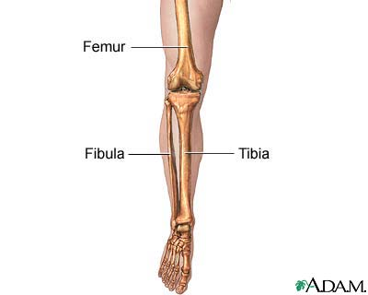
The feet (sing. foot) extend from the ankle downwards, so they are the inferior ends of the lower limbs. They bear the whole weight of the body and the strength of the foot bones corresponds to that fact. The seven tarsal bones (or just tarsals) are the bones of the ankle and the proximal region of the foot (they are the equivalent of the carpals in the hand). Amongst these, the calcaneus (pl. calcanei), or heel bone, and the talus (pl. tali), or ankle bone, are the largest and most prominent. The tarsal bones together with the metatarsal bones (or just metatarsals) form the instep, or the major arch of the foot; the bottom of the foot is called the sole. The toes, like the fingers of the hand, consist of bones called phalanges. The big toe has only two of them.

