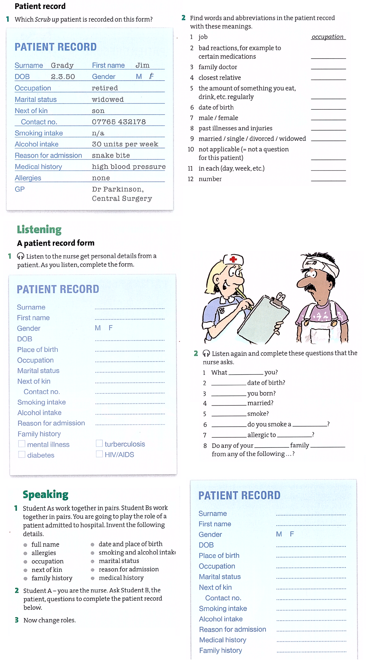

**In hospital**

***Translate the words in colour into your language.***

1. Does he have the results of his X-ray?

2. The doctor gave me an injection.

3. I needed four stitches to sew the wound.

4. I’ll just put a bandage on the burn.

5. This injury won’t leave much of a scar.

6. You’ll need an anaesthetic to relieve the pain.

7. They all suffered from a shock.

8. We work in the same ward, the intensive care.

***2. Hospital departments.*** *Match the departments with the ideas a-f below.*

1. emergency department (casualty ward) 2. children’s ward 3. operating theatre

4. intensive care 5. obstetrics (maternity ward) 6. outpatient’s department

a. She’s just had her first baby.

b. She cut her arm badly.

c. He’s having his operation.

d. Our ten-year-old has a very high temperature.

e. I had to go for a check up.

f. She is very ill, she needs constant attention.

***Complete the following exercises.***